HW #2
Name:
Section (circle one): 3P.M. 4.05P.M.

1. Which of the following means of communication demonstrate arbitrariness (tick ☑):

- Human Language
- Bee Dance
- Onomatopoeic words

2. Say T (true) or F (false):

- Using double negatives in English is representative of ‘Bad English’. ____
- A person’s inability to communicate in his language represents that the person is not competent in his language. ___
- Washoe demonstrates productivity as human languages do. ____
- Nim demonstrates language acquisition pattern similar to human beings. ___
- Primates use language without any motivation. ___
- Pinker compares ‘primates using language’ to ‘humans flying in Olympics’. ___
- Visual stimuli have an important role in speech perception. ___
- The word ‘association’ consists of 5 distinct consonant sounds. ___

3. Label the parts of the human speech organ:

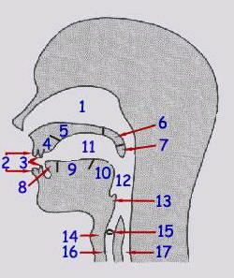
1. ______________________
2. ______________________
3. ______________________
4. ______________________
5. ______________________
6. ______________________
7. ______________________
8. ______________________
9. ______________________
10______________________
11._____________________
12._____________________
13._____________________
14._____________________
15._____________________

No need to answer 16 and 17.

4. What does Phonetics reveal about linguistic abilities of human beings? Discuss with the help of your readings in this class and classroom discussions. (80 to 100 words)

5. Give two sets of examples of Phonemes and their Allophones from a language you know. Also give justifications.

