Photoshop Review
- The Working Screen
- Rulers
- Savings Images
- Zoom Tool
- Undo and the History Palette
- Tool Palette

The Working Screen

These are the elements of the working screen.
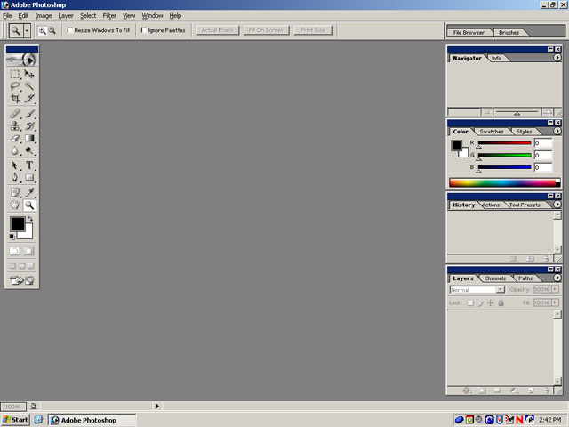
Menu Bar Tool Options Bar Palette

Palette
Group

Palette
Tab

Status Bar
Toolbox

The menu bar contains menus and submenus that allow you to use the various features of
Photoshop.
The tool options bar shows options available for the various tools.
Palettes are windows that allow quick access to some of Photoshop’s features. They can
also be accessed by going to Window on the menu bar.
The palettes are organized together with the palette groups.
The palette tab reveals the different palettes located within each group.
The toolbox contains basic tools used within Photoshop.
The status bar displays useful information about the image (magnification, file size) and
tools (brief instructions on usage).

The palettes can be minimized or maximized by clicking on the min/max button
They can be closed by clicking on the X button. 
If you ever close the palettes or move them around and want to restore the default
working screen (shown in the picture), just go to Window → Workspace → Reset palette locations.
The palettes and the toolbox can be hidden by pressing the [TAB] key. Pressing [TAB] again will show the palettes and toolbox.

Rulers

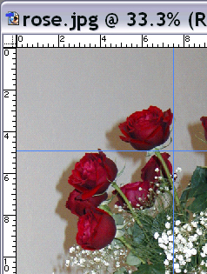
If you want to view the image with rulers, just go to View → Show Rulers [CTRL-R]. The rulers will appear on the top and left side of the image window. Markers that match the location of the point will also appear. You can also create temporary guides by clicking in the ruler and dragging the mouse onto the image. The guides do not appear when you print the image.
Guide
Rulers

Saving Images
To save an image, go to File → Save As.
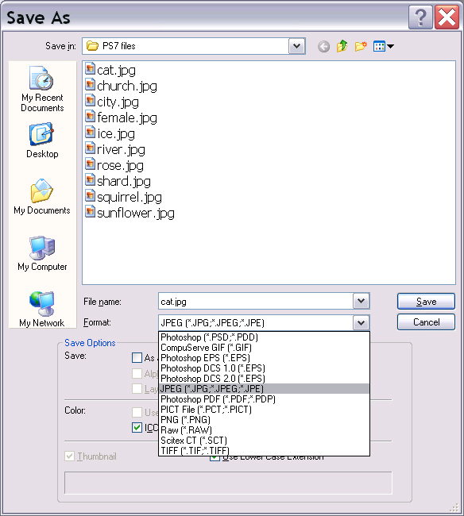
File Format
When saving an image, you can choose between several file formats. File format refers to the way Photoshop saves images. Certain file formats are better suited for certain uses.
Below is a table that explains a few of the most commonly used graphics formats.

PSD | PSD is the default format for Photoshop. It saves every piece of information from an image and is the only format that saves layers, masks, and channels. Photoshop saves and loads this format faster than other formats.
PICT | PICT is the Macintosh’s graphics format. It can support images of any size, mode, or resolution. It is good for on-screen, multimedia presentations.
TIFF | The TIFF format is useful when you plan to transfer images between Macintosh and IBM-compatible computers. It allows you to save the image as either a Macintosh or an IBM-compatible format.
BMP | The BMP format, or bitmapped image, is widely used in Microsoft Windows applications. If you plan to use your image in another painting application, such as Microsoft Paint, you can save in this format.
GIF | GIF is a compression format and is the most popular method for saving images that will be used as data transfer, such as the images found on the World Wide Web. Grayscale, Bitmap, and Indexed Color are the only modes that convert to GIF in Photoshop.
JPEG | JPEG is the best format to use if you want the highest image quality possible. You can choose from four levels of quality. This format also compresses the image files so that they are more compact.

Zoom Tool

Often, the images that we edit will to too small or too large. This is where the Zoom Tool comes in. There are many ways to use the Zoom Tool including a tool, using the mouse’s wheel scroll, menu command, and keyboard shortcut. When the magnifying glass has a plus sign in the center, clicking the mouse will result in zooming in. The image will be enlarged although the actual size of the image does not change. If you press the Alt key, the magnifying glass will have a minus sign appear. When you click in this mode, you will zoom out of the image. You can also click, hold down, and drag the mouse to zoom in on a certain area. Finally, pressing Ctrl-0 will result in the image automatically resizing itself to fit the screen.

Undo and the History Palette

The undo command allows to you undo the previous action. Most mistakes you make can be undone, so do not worry if you make an error while editing.
To access the undo, go to File → Undo <command>.
If you decide that you want to undo the “undo action,” there is a redo command.
This can be accessed by going to File → Redo <command>.

A more powerful version of Undo exists in the History Palette.
Create Document from Current State button

Create New Snapshot

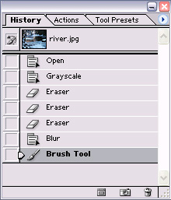
← The history palette can be used to revert the current image to a previous state, delete an image's states, and create a document from a state or snapshot.

Just click on the different states to see different versions. If you want to create a new image based on one of the states, just click on that state, and click on the ‘create document from current state button.’ In order to delete a state, just select that state and drag it to the trash can button.
The ‘create new snapshot’ button lets you create a temporary snapshot (a copy) of any state of the image. Snapshots are similar to the states listed in the History palette, but you can name a snapshot and can compare different snapshots easily.
Note: Snapshots are not saved with the image - closing an image deletes its snapshots.

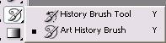

History Brush and Art History Brush

Extra: Photoshop has two special tools called the History Brush and Art History Brush. They will not be covered in this class, but feel free to experiment with it. A description for both is given below.
The History Brush tool lets you paint a copy of one state or snapshot of an image into the current image window. This tool makes a copy, or sample, of the image and then paints with it. For example, you might make a snapshot of a change you made with a painting tool or filter. After undoing the change to the image, you could use the History Brush tool to apply the change selectively to areas of the image.
The Art History Brush tool lets you paint with stylized strokes, using the source data from a specified history state or snapshot. By experimenting with different paint style, size, and tolerance options, you can simulate the texture of painting with different colors and artistic styles. Like the History Brush tool, the Art History Brush tool uses a specified history state or snapshot as the source data. The History Brush tool, however, paints by recreating the specified source data, while the Art History Brush tool uses that data along with the options you set to create different colors and artistic styles.

Tool Palette
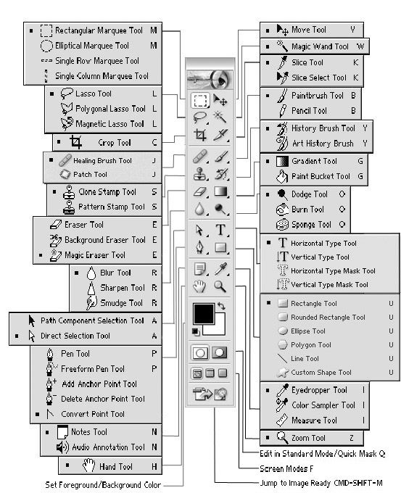
The Tool Palette Showing All Tools

Drawing and Painting Tools
Tool | Description | Alternate Method
 | Add Anchor Point Tool: Use the Add Anchor Point Tool to add anchor points to a path created by the Pen Tool. To access this tool, click-and-hold the Pen Tool, then choose the Add Anchor Tool from the pull-out menu. | Press [+].
 | Angle Gradient Tool: Use the Angle Gradient Tool to shade in a counterclockwise sweep around the starting point. To access this tool, click-and-hold the Linear Gradient Tool, then choose the Angle Gradient Tool from the pull-out menu. | Press [G].
 | Audio Notation Tool: You can add notes and audio annotations anywhere on a Photoshop image canvas. | Press [N]
 | Blur Tool: Use the Blur Tool to decrease the contrast between neighboring pixels to blur the focus of the image. | Press [R].
 | Burn Tool: Use the Burn Tool to increase the exposure and darken areas on an image. To access this tool, click-and-hold the Dodge Tool, then choose the Burn Tool from the pull-out menu. | Press [O].
 | Color Sampler Tool: Use the Color Sampler Tool to select up to four color samples from an image. These samples are saved and can be used as often as you like. To access this tool, click-and-hold the Eyedropper Tool, then choose the Color Sampler Tool from the pull-out menu. | Press [I].
 | Convert Point Tool: Use the Convert Point Tool to convert a smooth curve to a sharp curve or to a straight segment created by the Pen Tool. To access this tool, click-and-hold the Pen Tool, then choose the Convert Point Tool from the pull-out menu.
 | Crop Tool: Use the Crop Tool to trim an image by selecting the portion you want to keep as the finished product. To access the tool on the toolbar, click-and-hold the Marquee Tool, then choose the Crop Tool from the pull-out menu. | Press [C].
 | Custom Shape Tool: You create a shape layer using a shape tool or a pen tool. | Press [U]
 | Delete Anchor Point Tool: Use the Delete Anchor Point Tool to delete anchor points from a path created with the Pen Tool. To access this tool, click-and-hold the Pen Tool, then choose Delete Anchor Point Tool from the pull-out menu. | Press [-].
 | Diamond Gradient Tool: Use the Diamond Gradient Tool to shade from the starting point outward in a diamond pattern. To access this tool, click-and-hold the Linear Gradient Tool, then choose the Diamond Gradient Tool from the pull-out menu. | Press [G].
 | Dodge Tool: Use the Dodge Tool to lighten pixels in an image. | Press [O].
 | Eraser Tool: Use the Eraser Tool to change pixels in the image as you drag through them. | Press [E].
 | Eyedropper Tool: Use the Eyedropper Tool to sample a color from one area of an image to designate a new foreground or background color. | Press [I].
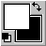 | Foreground Color, Background Color: Use the Foreground and Background Color controls to select and apply colors. | Press [D] to revert to default colors.
 | Freeform Pen Tool: Use the Freeform Pen Tool to draw a freeform line. To access this tool, click-and-hold the Pen Tool, then choose the Freeform Pen tool from the pull-out menu. | Press [P].
 | Healing Brush Tool: Use the Healing Brush Tool to repair an image while still preserving the original shading, tonality, and texture in the retouched area. | Press [J].
 | History Brush Tool: Use the History Brush Tool to paint with any selected state or snapshot of an image. | Press [Y].
 | Jump to Tool: Jumps to Image Ready 7.0 graphic editor. | Press [Control+Shift+M]
 | Line Tool: Use the Line Tool to create straight lines on an image. To access this tool, click-and-hold the Pencil Tool, then choose the Line Tool from the pull-out menu. | Press [N].
 | Linear Gradient Tool: Use the Gradient Tool to fill a selection of an image with a gradual transition of colors that begins with the foreground color and ends with the background color. | Press [G].
 | Magnetic Pen Tool: Use the Magnetic Pen Tool to draw a line that snaps to the edges of an image. To access this tool, click-and-hold the Pen Tool, then choose the Magnetic Pen Tool from the pull-out menu. | Press [P].
 | Measure Tool: Use the Measure Tool to calculate the distance between any two points in the work area. | Press [U].
 | Move Tool: Use the Move Tool to drag a selection or the entire image to another area. | Press [V].
 | Notation Tool: You can add notes and audio annotations anywhere on a Photoshop image canvas. | Press [N]
 | Paint Bucket Tool: Use the Paint Bucket Tool to fill a contiguous area of similarly colored pixels with the foreground color. | Press [K].
 | Paintbrush Tool: Use the Paintbrush Tool to paint soft lines that are not as hard-edged as those painted by the Pencil tool, but not as soft as those painted by the Airbrush. | Press [B].
 | Pattern Stamp Tool: Use the Pattern Stamp Tool to select part of an image and paint with the selection as a pattern. To access this tool, click-and-hold the Stamp Tool, then choose the Pattern Stamp Tool from the pull-out menu. | Press [S].
 | Pen Tool: Use the Pen Tool to draw straight lines and smooth flowing curves. | Press [P].
 | Pencil Tool: Use the Pencil Tool to paint hard-edge lines. | Press [N].
 | Radial Gradient Tool: Use the Radial Gradient Tool to shade from the starting point to the ending point in a circular pattern To access this tool, click-and-hold the Linear Gradient Tool, then choose the Radial Gradient Tool from the pull-out menu. | Press [G].
 | Rectangle Tool: You can create image map areas using an image map tool or a layer. | Press [U]
 | Reflected Gradient Tool: Use the Reflected Gradient Tool to shade by using symmetric linear gradients on either side of the starting point. To access this tool, click-and-hold the Linear Gradient Tool, then choose the Reflected Gradient Tool from the pull-out menu. | Press [G].
 | Rubber Stamp Tool: Use the Rubber Stamp Tool to paint a copy of an image or color onto another area of the image to correct flaws or to alter the image. | Press [S].
 | Sharpen Tool: Use the Sharpen Tool to sharpen soft edges to increase the clarity or focus of an image. To access the tool on the toolbar, click-and-hold the Blur Tool, then choose the Sharpen Tool from the pull-out menu. | Press [R].
 | Slice Tool: You can create user-slices with the slice tool, | Press [K]
 | Slice Select Tool: Selects active user slices. | Press [K]
 | Smudge Tool: Use the Smudge Tool to smear colors inside an image. To access this tool, click-and-hold the Blur Tool, then choose the Smudge Tool from the pull-out menu. | Press [R].
 | Sponge Tool: Use the Sponge Tool to subtly increase the saturation of an area in the image. To access the tool on the toolbar, click-and-hold the Dodge Tool, then choose the Sponge Tool from the pull-out menu. | Press [O].
 | Type Tool: Use the Type Tool to enter text horizontally in an image. | Press [T].
 | Type Mask Tool: Use the Type Mask Tool to create selection borders in the shape of horizontal text. | Press [T].
 | Vertical Type Tool: Use the Vertical Type Tool to enter text vertically in an image. | Press [T].
 | Vertical Type Mask Tool: Use the Vertical Type Mask Tool to create selection borders in the shape of vertical text. | Press [T].

Selection Tools
 | Direct Selection Tool: Use the Direct Selection Tool to select a path or segment of a path that was created by the Pen Tool, and shows all anchor points for the selection. | Press [A].
 | Edit In Quick Mask Mode Button: Use the Quick Mask mode button to create a mask after selecting an area of the image to be changed. | Press [Q].
 | Edit In Standard Mode Button: Use the Standard Mode button to exit the Quick Mask mode. Image areas selected in standard mode are distinguished by an animated broken line. | Press [Q].
 | Elliptical Marquee Tool: Use the elliptical Marquee Tool to create elliptical or circular selections. To access the tool on the toolbar, click-and-hold the Marquee Tool, then choose the elliptical Marquee Tool from the pull-out menu. | Press [M].
 | Lasso Tool: Use the Lasso Tool to make a freehand selection in the image. | Press [L].
 | Magic Wand Tool: Use the Magic Wand Tool to select portions of an image based on the color similarities of adjacent pixels. | Press [W].
 | Magnetic Lasso Tool: Use the Magnetic Lasso Tool to quickly select objects with complex edges set against high-contrast backgrounds. To access this tool, click-and-hold the Lasso Tool, then choose the Magnetic Lasso Tool from the pull-out menu. | Press [L].
 | Marquee Tool: Use the Marquee Tool to select rectangular or elliptical areas by dragging around an area on the image. | Press [M].
 | Polygon Lasso Tool: Use the Polygon Lasso Tool to create straight-edged freehand selection borders in an image. To access the tool on the toolbar, click-and-hold the Lasso Tool, then choose the Polygon Lasso Tool from the pull-out menu. | Press [L].
 | Single Column Marquee Tool: Use the Single Column Marquee Tool to create vertical selections that are each 1 pixel wide. To access the tool on the toolbar, click-and-hold the Marquee Tool, then choose the Single Column Marquee Tool from the pull-out menu. | Press [M].
 | Single Row Marquee Tool: Use the Single Row Marquee Tool to create horizontal selections that are each 1 pixel wide. To access the tool on the toolbar, click-and-hold the Marquee Tool, then choose the Single Row Marquee Tool from the pull-out menu. | Press [M].

Viewing Tools
 | Full Screen Mode With Menu Bar Button: Use the Full Screen Mode With Menu Bar button to display an image in a full screen with a menu bar. | Press [F].
 | Full Screen Mode Button: Use the Full Screen Mode button to display an image in a full screen without a menu bar. | Press [F].
 | Hand Tool: Use the Hand Tool to scroll through an image that does not fit in the active window. | Press [H].
 | Standard Screen Mode Button: Use the Standard Screen Mode button to display an image in a standard-size window, with a menu bar at the top. | Press [F].
 | Zoom Tool: Use the Zoom Tool to magnify or reduce the view of a selection or the entire image. | Press [Z].

Image Editing Shortcuts
Command | Shortcut
Access the Zoom Tool from other tool or open dialog box. | Press [CTRL+SPACEBAR].
Access the Zoom Tool from other tool or open dialog box. | Press [ALT+SPACEBAR].
Cancel a filter as it is being applied. | Press-and-hold [ESC].
Constrain a stroke to a straight line. | Press [SHIFT] + any painting/editing tool.
Cut a selection to the Clipboard. | Press [CTRL+X].
Copy a selection to the Clipboard. | Press [CTRL+C].
Paste a selection from the Clipboard. | Press [CTRL+V].
Include in the selection adjacent pixels that fall within the specified tolerance range. | Press [CTRL+G].
Turns the selection border off or on. | Press [CTRL+H].
Go to a 100% magnification. | Double-click the Zoom Tool.
Move a selection or border in 1-pixel increments. | Press the appropriate direction key.
Move a selection or border in 10-pixel increments. | Press [SHIFT+the appropriate direction key].
Use a precise pointer (cross-hair). | Toggle on/off with [CAPS LOCK].
Select All. | Press [CTRL+A].
Select None. | Press [CTRL+D].
Set tool opacity/pressure in 10 percent increments. | Press any number on keyboard + any painting/editing tool.
Zoom in or out. | Press [CTRL+Plus or Minus key].
Fit the image on the screen. | Press [CTRL+ZERO].

