Retouching with Photoshop

Disclaimer: all images used in this course were found online and believed to be free. I do not claim credit for any of the photos.
Hello! Welcome to Retouching with Photoshop. Please follow this manual for the class.
The screenshots from of the program were taken using a PC version of Photoshop. Mac versions may appear slightly different. If you would like a quick review/overview of Photoshop, download the Photoshop Review file from the website.

Session 1:
By now you should have received the introduction letter. If you have not, you can view the letter on the class website (http://plaza.ufl.edu/mkung/retouch/) in the Downloads section. All students should visit the class website and become familiar with the site. In addition, all students should go to the forum (http://psclass.topic-board.com/) and register. After registering, please post an introduction to yourself in the Introduction forum. If there are any problems, please let me know. The best way to contact me is by email or post to the forum.

“With its comprehensive set of retouching, painting, drawing, and Web tools, Photoshop helps you complete any image-editing task efficiently.” – From the Photoshop Help tutorial

Be prepared to learn how to retouch your photos!

Session 2:
Understanding the importance of retouching photos, Learning the auto adjustment features

Here’s a short piece I wrote about the important of retouching photos. Read through to get an idea of why everyone should learn to retouch photos.

Why Should We Learn to Retouch Photos
By: Michael Kung

Why should we care about retouching photos? Well, why shouldn’t we? Digital photos are only appearing just about everywhere. All those pictures you see in a magazine or in advertisements – most likely have been edited in some way, shape, or form. Most households have a digital camera now in some form or another. Digital cameras are everywhere – from being built into cell phones to being built directly computers (as webcams). They’re easy to use, range from everything to keychain cameras to professional SLRs, and have almost replaced the old film loading cameras.
However, even with all new technological innovations included in the cameras, it doesn’t mean that every picture taken will be perfect. While editing photos on film was rather difficult, it’s very simple to edit digital photos. Some people will argue that editing isn’t right, but sometimes it’s just so…convenient. Who wouldn’t want to have a pimple removed from a photo or a dark obscure photo lightened into a recognizable picture? Most people take photos for leisure and are only interested in preserving memories or showing off to friends.
Sometimes you feel you’ve taken the perfect photo, but nothing is more frustrating than seeing a blemish as you view it on your computer. Your photo is ruined, you might think to yourself. This is where photo retouching comes in. Photo retouching is used to make a photo more presentable. Photoshop will allow you to easily fix these problems as well as improve the original photo itself. Unless it is for professional reasons, photo editing is used mainly to get rid of minor imperfections. This might include red eye, wrinkles, dark circles under the eyes, pimples, scars, or an under or overexposed photo. Photo retouching can easily makes these minor problems go away. After learning how to retouch photos, you can impress your friends and even come to the rescue of your friends when they take a less-than-perfect photo!

For those concerned about the ethics of professional photo editing, below is a website where you can learn more about guidelines in photojournalism. http://www.digitalcustom.com/howto/mediaguidelines.asp

Learning the auto adjustment features

The auto adjustment features can be found by going to Image → Adjustments → Auto Levels, Contrast, Color

Auto Level – adjusts highlights and shadows
Auto Contrast – adjusts overall contrast and color
Auto Color – different approach to adjust color and contrast

When you choose one of these auto adjustment features, Photoshop will automatically scan the pixels in the image and do what it thinks will balance out the image. When it comes to automated processes, it’s often hit-or-miss, so remember to use your own judgment. While Photoshop will do its best, the image it produces may or may not be what you want. These auto adjustment features are meant to save you time. However, if you want to have more control over what you do, you can use the Variations tool (in the next session).
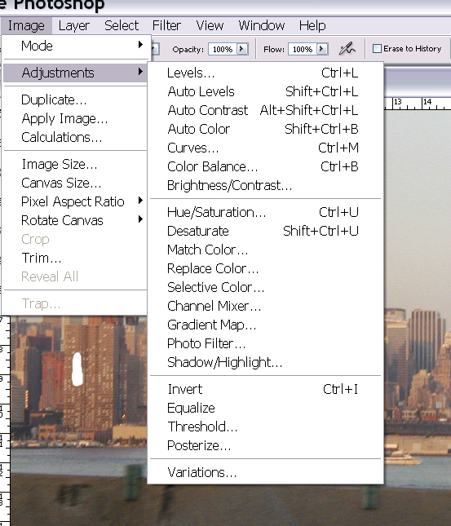
Auto Levels
Auto Contrast
Auto Color

Click here to see a video of how much difference these tools will make.

Here’s the original photo (class file home_orig.jpg)….
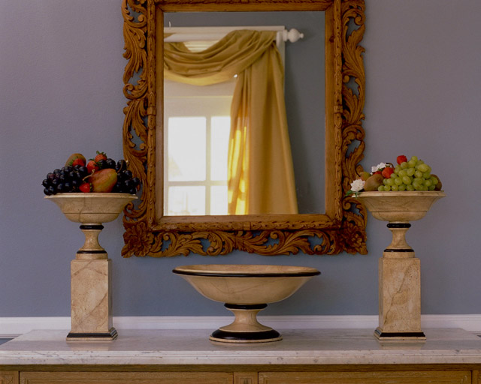

And the edited photo
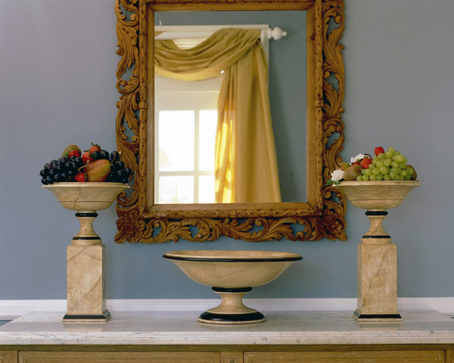

Simple, right? Now open files 2-1.jpg and 2-2.jpg from the class files. Apply the auto adjustments and save that file. Email the two edited photos to me when you are done.

Session 3: Learning to manually retouch a photo

In this lesson, you will learn to adjust the brightness/contrast, apply variations, and select photo filters to an image.

Brightness/contrast
Variations
Brightness/Contrast
Photo Filter
Shadow / Highlight

Click on Image → Adjustments → Brightness/Contrast

A new window will appear.
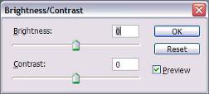

Sliding the Brightness cursor to the left or right will decrease/increase the brightness of the image. Brightness simply means how light or dark your image is. The same process applies to the contrast. Changing the contrast will allow you to change the difference between the bright and dark areas of a photo.

Maybe you have a photo where you’ve forgotten to turn on the flash or the flash wasn’t strong enough. This technique is useful for an image that is too dark.

Click here to see this in action.

Here’s the original photo (duck_orig.jpg):
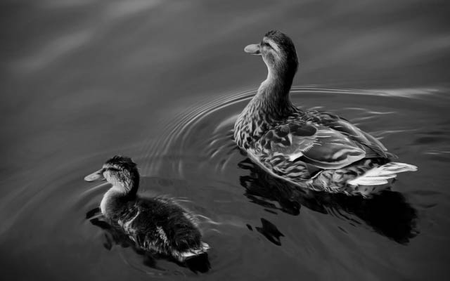
Here’s the edited photo:
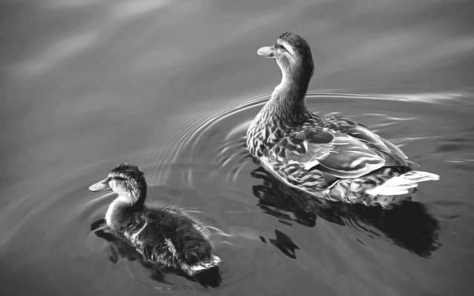

Which one do you think looks better?

Variations
Variations allow you to adjust the contrast and color of an image by using several preview thumbnails. This tool is more comprehensive and gives you more control over the image than the auto adjustment features. Believe it or not, this tool isn’t even the most precise way to edit photos. However, for this class, we won’t need to worry about this. For anyone interested in learning more, just contact me, and I can send you some more information.

To access the Variations, click on Image → Adjustments → Variations. A new window will appear.
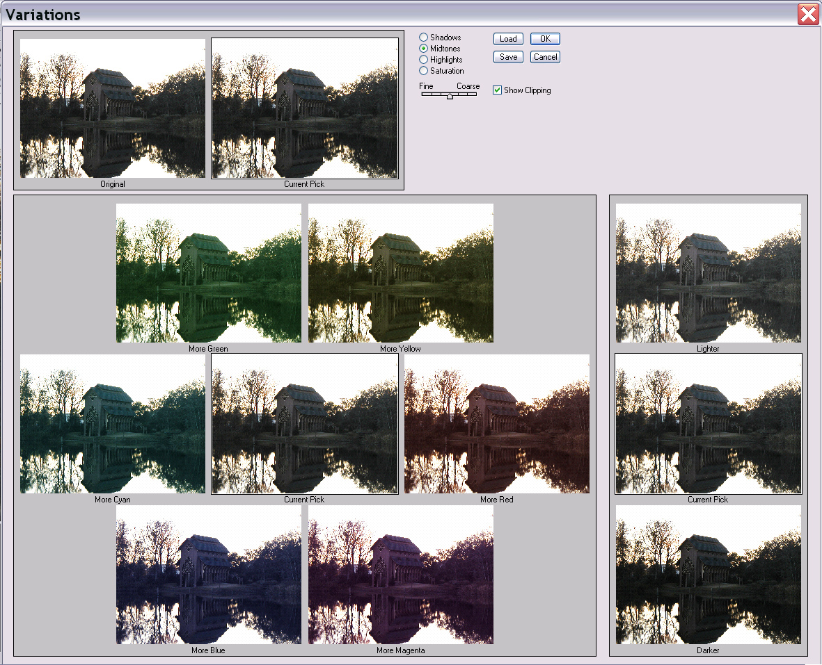
The Variations Dialog Box

Moving the Fine/Course slider over one notch doubles the amount of adjustment.

Point and click on each thumbnail until you are satisfied with the “current pick.”

Click here to see how to use Variations

Here’s a photo before (ship_orig.jpg)…
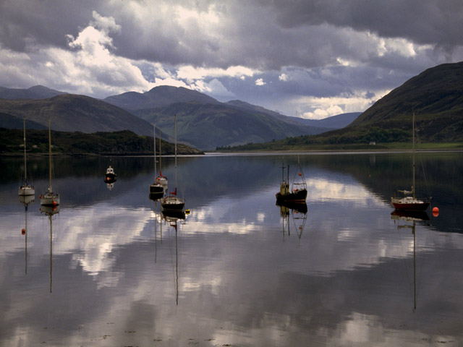

And after.

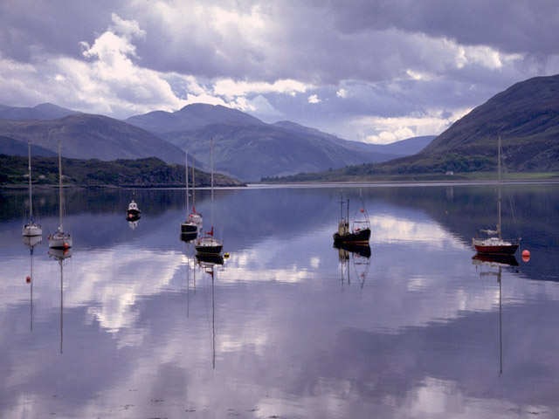

Photo Filters
Sometimes when you take a picture, you might feel that the image is too “hot” (with too many reds, yellows, and browns, etc). In this case, you could add a blue photo filter to help give the photo a “cooler” feeling. Using Photo Filters is similar to what a professional photographer does when he/she puts a colored lens filter on the camera. The entire image is coated with the desired color. This is done by going to Image → Adjustments → Photo Filter.

When you choose this, a new window will appear.
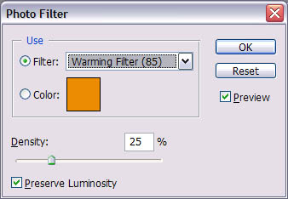

You can choose from several presets or choose your own colored photo filter. You can also choose how dense you want the color to be applied (how much of a color you want to appear).

Here’s how to use photo filters:

And a sample of an image before photo filters (water_orig.jpg)
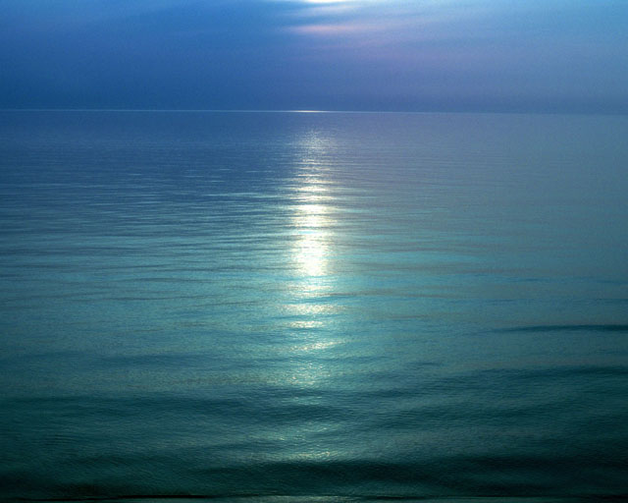

And afterwards.
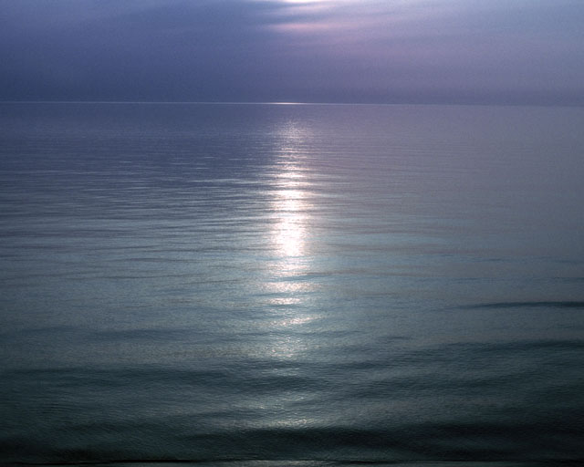

Now, open files 2-1.jpg and 2-2.jpg from the class files. Use a combination of the brightness/contrast feature, variations, and photo filters to make these images clearer and easier to view.

Session 4: Learn the healing brush tool

The healing brush function is one of the most useful tools when editing photos. It can be used to get rid of scars (as you can see from our example), wrinkles, blemishes, etc.

Photoshop’s definition of the healing brush sums up its ability nicely: “The healing brush tool lets you correct imperfections, causing them to disappear into the surrounding image. The healing brush tool also matches the texture, lighting, and shading of the sampled pixels to the source pixels. As a result, the repaired pixels blend seamlessly into the rest of the image.”

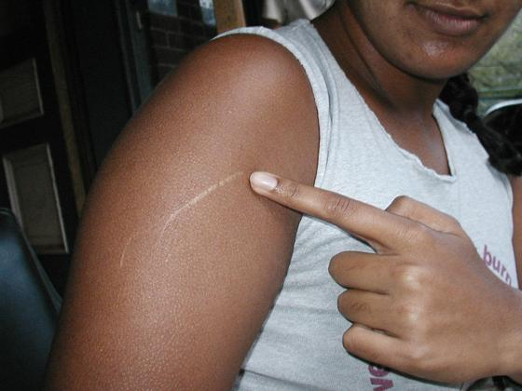

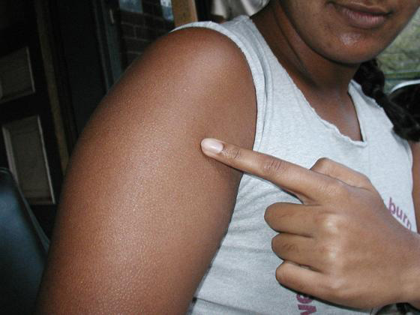

Based on the starting point, Photoshop will calculate the color information surrounding a point and do it’s best to fix the area based on the surrounding color information.

To use the healing brush tool :

  - First, define the starting point by holding the Alt key down and clicking the mouse button.
Notice how the cursor changes when you hold down the Alt key.
  - Next, hold down the mouse key and drag over the area to be repaired.

To see the healing brush work, click here for a video.

Now it’s your turn. Open files 4-1.jpg and 4-2.jpg. Practice your healing skills on these two photos.

Session 5: Learn the Shadow/Highlight tool
What happens if you take a picture and forget to use the flash? Not a problem – when you have the Shadow/Highlight tool.

The Shadow/Highlight tool is useful when an image is too dark (because of a strong background lighting) or too washed out (due to too much lighting). Just as the name implies, this tool is used to adjust the shadowy areas of a photo based on the pixels surrounding the area.

To access the Shadow/Highlight tool, go to Image → Adjustments → Shadow/Highlight.
A new window will appear. To adjust, just slide the cursor to the left or right. The automatic preview will show you what you image will look like.
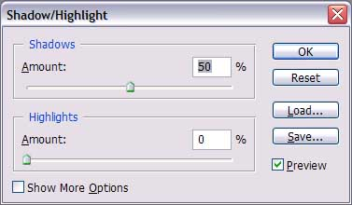

Here’s the link to view the Shadow/Highlight tool in action

Here’s the original (dark_orig.jpg):
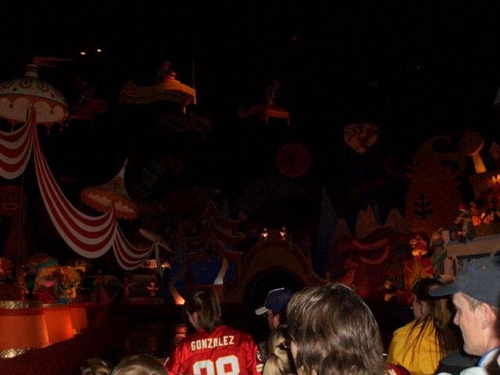

Here’s the edited version
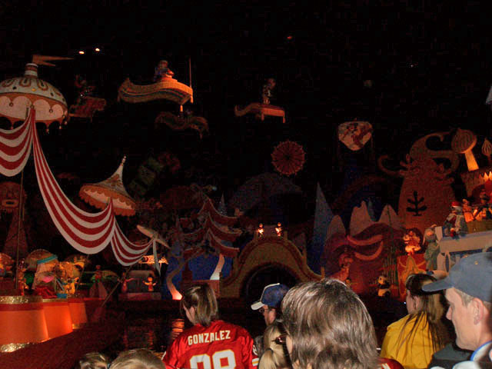

What was hidden in dark can now be seen!

Now, open files 5-1.jpg and 5-2.jpg and edit away!

Session 6: Review, Final assignment
For the last session, open files 6-1.jpg and 6-2.jpg. Use your best judgment and the skills you have learned from this course to fix these two pictures. Use a minimum of 4 techniques you have learned so far. After you are done with these, find a third image of your own that you think needs to be fixed. Once you have completed editing the pictures, please write an explanation of the techniques you used to edit the photos and why you chose to use each one.

So, for your final assignment you will send me 5 files: edited versions of files 6-1 and 6-2, the original and final version of a picture of your choosing, and your explanation. I encourage you to read through the study guide from the website to review the skills you have learned.

Once you have completed these, please take a couple minutes to download the survey file (from the Downloads section). Please fill it out and email it to me or post it in the forum. If you would like to remain anonymous, just sign into the forum as a guest and post the survey. I like knowing where I can improve so I would appreciate knowing your opinions!
Thank you and I hope you enjoyed this course!

If you would like to share your final creations or any other personal projects, feel free to post them to the discussion board. It’s a good way to compare techniques used with your classmates.

