The SWAMP-Where Winning Is a Lifestyle
Event Location:
Gator Theatre
1 Champ Street
Gainesville, FL 32611
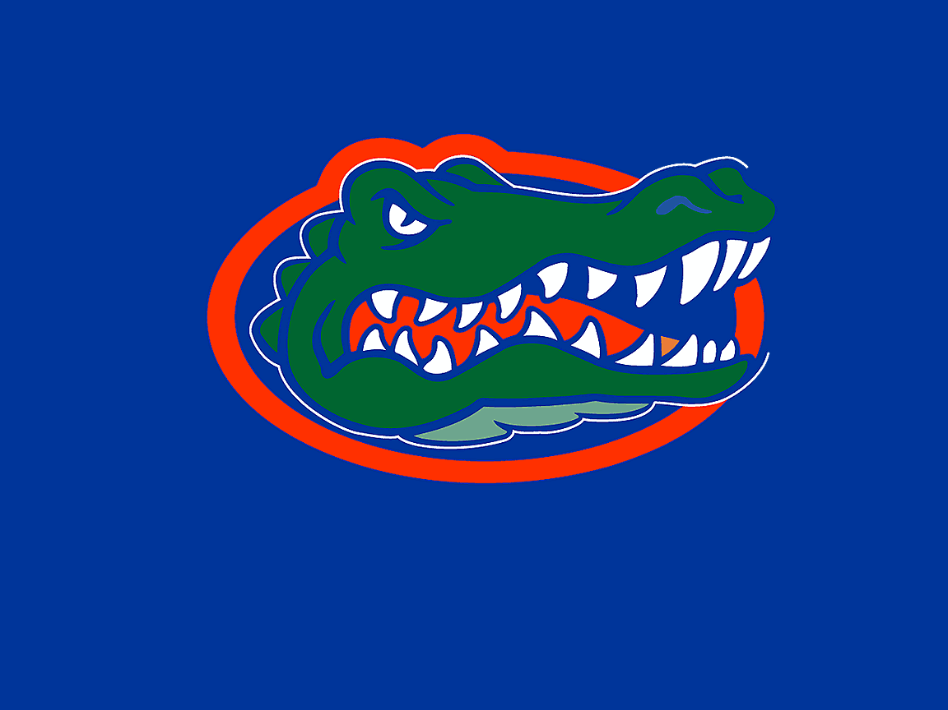
RELIVE THE 2006 FLORIDA GATORS’ CHAMPIONSHIP SEASON!
Guest Speaker: Heisman Trophy Winner, Tim Tebow
Featured Music: “We Are the Champions”

ENTER the heart and mind of a championship football team!
EXPERIENCE the thrill of victory-60 minutes of virtual throwing, catching, and blocking!
EXIT the theatre, feeling as though you yourself have kissed the crystal football!

Team 26
304 Project Avenue
Suite 26
Gainesville, Florida 37542
Ph: 555.555.0125
Web site address

