The Extinguisher

An Autonomous Robot by
John Miller III

EEL5666
Intelligent Machine Design Laboratory

Instructors:
Drs. A. Arroyo and E.M. Schwartz

Table of Contents

- Abstract
- Executive Summary
- Introduction
- Integrated Systems
- Mobile Platform
- Actuation
- Sensors
- Behaviors
- Experimental Layout
10) Conclusions
11) Documentation
12) Appendices

Abstract

This report discusses the creation and development of an autonomous agent. This robot is a modified tank that can create actions on its own by using sensors and microprocessor power together with algorithms implemented through code. The classes I have previously taken have enabled me to develop the idea of a tank that can sense fire and then drive to it, and finally put it out by water spray.

Executive Summary

Introduction

As mentioned in the abstract, this paper is intended to portray all development steps in the development of an autonomous tank that will locate a fire and then put it out by means of water. The need for this could be realized by larger robots putting out fires automatically in towns or even in wartime. This paper will begin by explaining the integrated system as a whole, outlining the major function blocks that when put together will realize my autonomous agent. A more specific approach will then be taken as I discuss the mobile platform being used, including any actuation and movement that will be used. I will then discuss the sensors and then how they will lead to the development of my intended behaviors. Finally I will portray an experimental design layout and provide conclusions.

Integrated Systems

The systems that will be used in this robot can broken down into 6 groups:

- Platform
- Propulsion
- Controls
- Sensor Suite
- Communication
- Feedback

These very distinct groups all serve very important purposes in the development of an autonomous tank. The platform is a gutted out tank, the propulsion is provided by a multi motor system, the controls are provided by the Atmel Atmega 128 and a motor driver motherboard, the sensor suite will be IR and other thermal detection, the communication will be primarily Bluetooth, and the Feedback will be via LCD displays.

Mobile Platform

The mobile platform will be a modified, and gutted out RC tank. The complexity of a tanks design and the movements such as the Turret, require me to do so in the allotted time given so that too much time is not wasted. I chose to use the 1/24 scale Radio Control R/C Airsoft US M1A2 Abrams RC Tank. This proved to be decent at maneuvering so I decided to go with it and I purchased two of them because of our dear friend Murphy. I have provided a picture of the tank below.

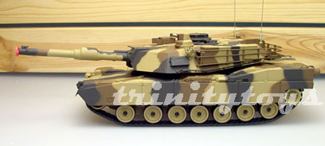

Actuation

The actuation system in the tank will consist of three motors and a pump. Two primary motors provide the propulsion in any direction that it is programmed to do. Because of the use of the tank, it can move in such a tight turn that it can sit on a point and spin. The third motor provides movement of the turret, which will enable the water hose to aim with a pivot of 320 degrees. The pump will be used to realize the water spray action, as it will be able to provide enough psi with a specialized nozzle in order to put out a fire.

The motors will be driven by a mother board that I am creating and an Atmel microcontroller. The Atmel will provide a PWM to the motor drivers to control the movement of the Tank according to code decisions and the sensors. The motors are cheap hobby motors that I believe will suffice as they have enough toque to drive the tank in RC mode. I have provided a picture below showing the propulsion motors.
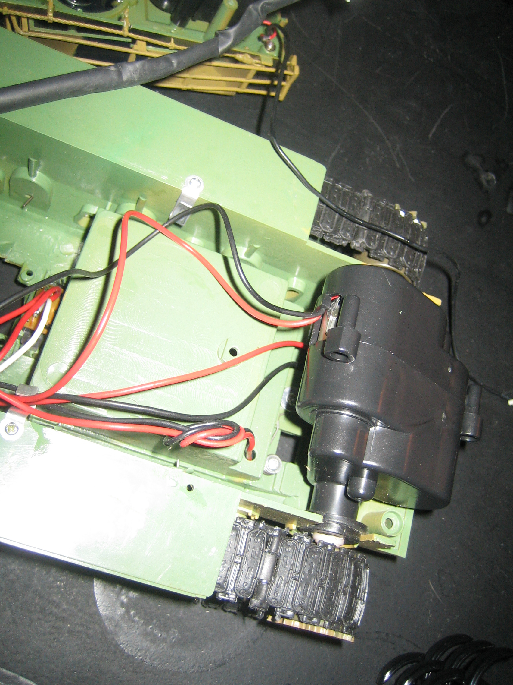

Sensors

The sensor suite will consist of mainly IR sensors of one sort or another. There will be 4 or 5 standard IR sensors that will provide digital output to achieve the obstacle avoidance. There will be a hacked IR motion sensor (which is IR) to identify a source of fire from 5 to 10 feet away. An ambient temperature sensor will be used to notify the Tank that it has reached the source of the fire. All of these sensors combined will help the tank identify a fire, drive to it, and then stop in front of it. After verification, it will then put the fire (probably a candle) out.

Behaviors

The behaviors of the tank, The Extinguisher, will be as proposed earlier. First, it will begin a random search maneuver, nominally straight, which will then employ the obstacle avoidance system. This includes the IR digital sensors, probably 30”, to locate a wall or object and then slightly steer away if seen, and then proceed to check as it travels continuously. This behavior can be used as the tank searches and then approaches a fire. The fire will be located by use of a hacked motion sensor. This sensor should be able to detect a relatively large candle flame. Next, an ambient temperature sensor will be used to notify the tank if it has reached the source of the fire. Then a pump will be turned on and water from a reservoir will be sprayed through a full cone nozzle (to increase accuracy) to put out the flame.

Experimental Layout

I do not have any drawings of the tank as I propose to have it built. The LCD will be fixated on the back in a case, and the control board will be located inside the turret. The ambient sensors will be place out in front of the tank to identify heat from a close proximity, and the motion detector can be placed anywhere on the front, probably with some sort of tunnel to provide tunnel vision for correct angle identification.

Conclusion

No conclusions at this time

Documentation

No documentation at this time

Appendices

