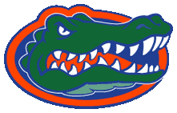
Presented by
Gator Video
“Welcome to Titletown”
DVD - Back Cover Art 2
The Florida Gators
2006 National Championship DVD
Hosted by Adam Sandler

Featuring:
- Hilarious commentary
- Hit music such as “My Hero” by the Foo Fighters and more!
- Action packed out of your seat excitement
- Up-close, on-field action
- Highlights from the fans and cheerleaders
- Post-game interviews
with players and coaches

DVD available in stores
March 9, 2008

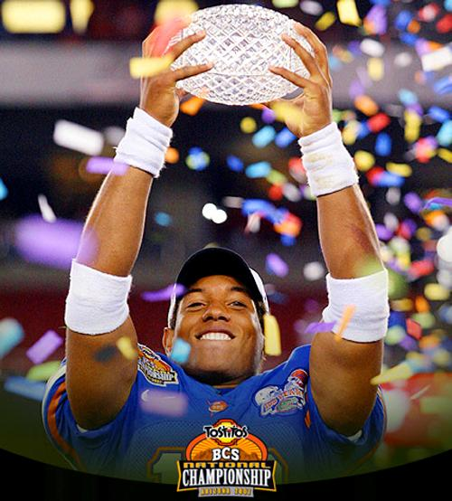
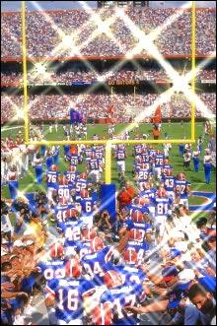
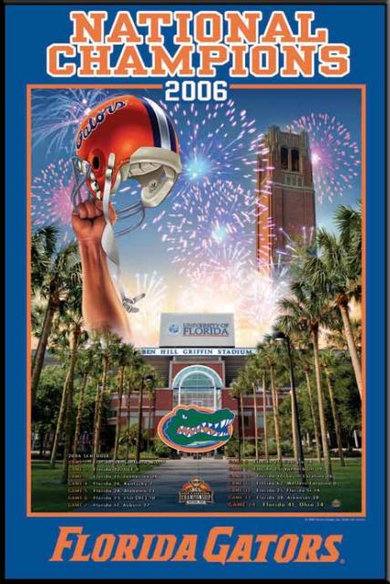
Erica Blake
Jennifer Ferris
Greg Lettre
Lisa Rehrmann
Robin Weston
Team
Chomp

You may have seen it in
real life…

but you have never seen it
like this!!

GET YOURS
MARCH 9TH

