Gator Video presents another electrifying sports film video:

Highlighting the 2006 National Champions:
University of Florida’s Gator Football Team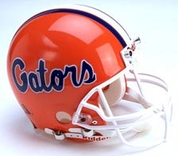
Featuring the music of:
Guns N’ Roses
Narrated by:
Ellen Degeneres


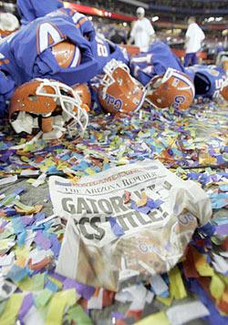
Relive the Victory!!

