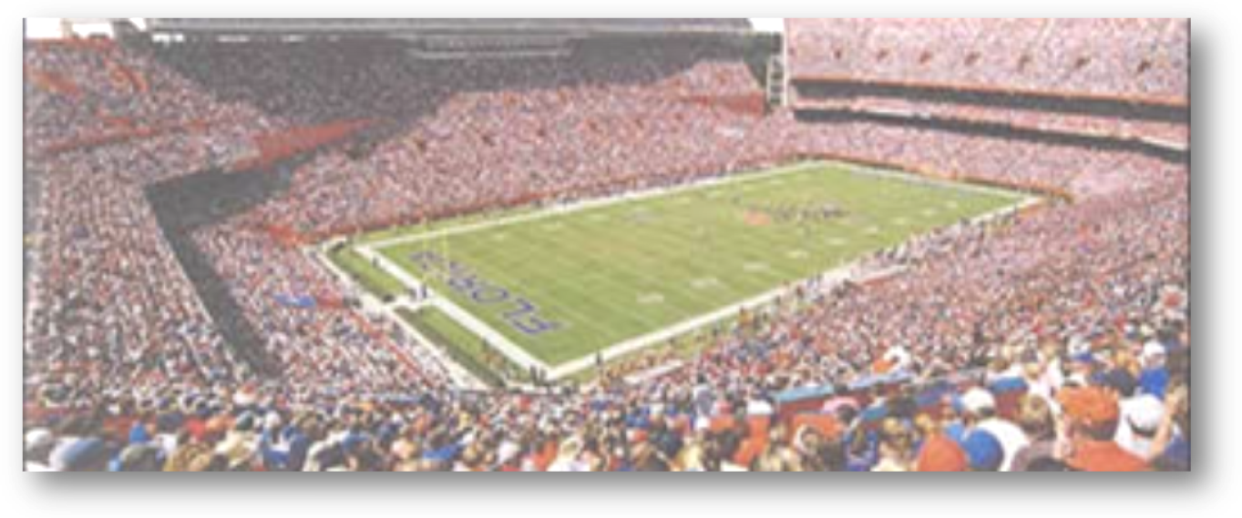


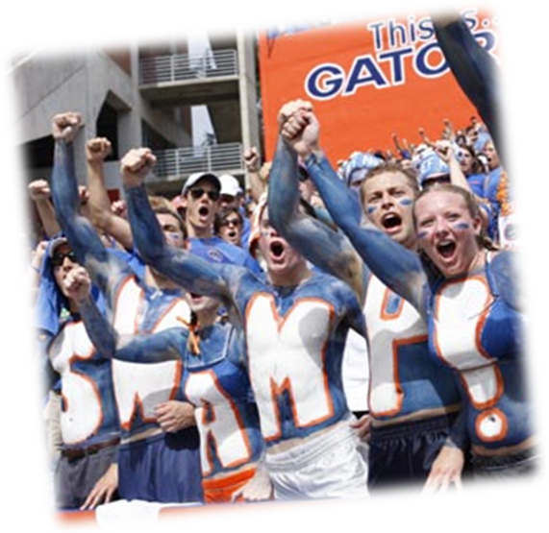
Take the journey of a lifetime as host Danny Wuerffel chronicles the path to the 1996 National title. Game making plays, behind the scenes footage, interviews with key players and music by POD make this a collector’s DVD that no Gator Fan should be without.
Gator Video
1111 University AVE
Gainesville, FL 32611
Store Hours:
10:00 A.M. – 5:00 P.M. (M - F)
9:00 A.M. – 6:00 P.M. (Sat. & Sun.)

Victory in
the Swamp

