A Multi-Channel Temperature Measurement System with Wireless Data Transmission

Summa Cum Laude Thesis
Dean R. Morrison
Bachelor of Science in Computer Engineering
Spring 2005
Table of Contents
Index of Tables 4
Index of Figures 5
Project Abstract 6
Introduction 6
Technical Objectives 6
Concept Screening Matrix 7
System Level Presentation 9
System Diagrams 9
Subassembly Diagrams 10
Software 16
Temperature Capture Assembly (TCA) 16
RF Repeater 18
PC Interface Assembly 19
USB Data Capture 20
PC Graphical User Interface 21
Testing and Verification 23
Temperature Capture Assembly 24
RF Repeater 24
PC Interface Assembly 24
PC GUI 25
Complete System 25
Final Product 26
Performance 26
Cost Estimation 27
Study Organization 29
References and Acknowledgements 30
APPENDIX I: Bill of Materials 32
APPENDIX II: Source Code 34
1. TCA: TCA_software.c 34
2. TCA: TCA_wireless_protocol.h 48
3. TCA, RFR, PCIA: kilnTemp_defs.h 50
4. RFR: RFR_software.c 52
5. RFR: RFR_wireless_protocol.h 58
6. PCIA: PCIA_software.c 60
7. USB: PCIA_main.c 67
8. USB: USB_LE_host.h 77

Index of Tables
Table 1: Requirements specifications 7
Table 2.0: Concept Screening Matrix – Definition of Concept Variables 7
Table 2.1: Concept Screening Matrix – Concepts A through E 8
Table 2.2: Concept Screening Matrix – Concepts F through J 8
Table 2.3: Concept Screening Matrix – Concepts K, L, Reference 8
Table 3: Differences between chosen concept and final product 9
Table 4: System specifications 26
Table 5: Prototype Cost 28
Table 6: Preliminary Task Schedule 29
Table 7: Final Task Schedule 30
Table 8: References and acknowledgements 30
Table 9.0: TCA bill of materials 32
Table 9.1: RFR bill of materials 33
Table 9.2: PCIA bill of materials 33

Index of Figures
Figure 1: Overall System Visualization 9
Figure 2: Assembly Interactions 10
Figure 3: TCA Block Diagram 11
Figure 4: TCA Circuit Diagram 12
Figure 5: RFR Block Diagram 13
Figure 6: RFR Circuit Diagram 14
Figure 7: PCIA Block Diagram 15
Figure 8: PCIA Circuit Diagram 16
Figure 9: TCA Microcontroller Software Flowchart 17
Figure 10: RFR Microcontroller Software Flowchart 18
Figure 11: PCIA Microcontroller Software Flowchart 19
Figure 12: USB Data Capture Software Execution 20
Figure 13.0: PC GUI – Tabular Data View 21
Figure 13.1: PC GUI – Graphical Data View 22
Figure 13.2: PC GUI – Calibration Sheet 22
Figure 14: Packet structure 24
Figure 15: Preliminary Gantt Chart 29
Figure 15: Final Gantt Chart 30

Project Abstract
The goal of this project was to design and build a multi-channel temperature measurement system with wireless data transmission. This system is intended to be used for various industrial process-monitoring applications with a particular focus on the cement and ceramics industries. There are three basic components to this system: (1) a low-power temperature acquisition module, (2) an array of RF repeater modules, and (3) a PC interface module. The data acquisition module will travel with or near the target industrial product, taking several temperature samples at different locations. This data is processed and sent wirelessly to the array of RF receivers. These receivers then forward the data to the PC interface module which, in turn, transmits the data to the PC. A graphical user interface allows the user to monitor the various temperature channels in real time. The system is reconfigurable for a variety of industrial environments and temperature ranges.
The challenge of this project is to compensate for the accumulation of measurement error through the various stages of data transmission. Amplification, analog-to-digital conversion, and signal transmission can all introduce errors in the measurement data, and the total error must be minimized and corrected.
The final outcome of this project is a fully-functional temperature acquisition system that meets and surpasses customer specifications. The versatility of this system is exemplified by its reconfigurable hardware and software components.

Introduction
The primary application of this product is for process-monitoring in the cement and ceramics industries. Secondary applications include virtually any type of industrial process-monitoring where real-time temperature data is desired and where wireless data transmission is necessary.
Most of the existing products in the cement and ceramics industries do not employ telemetry and therefore are either not real-time or are constrained in their range by cables. Making temperature measurement real-time in these industries will significantly increase productivity and reduce overhead. The combination of data logging with real-time measurements will help the industries recognize and predict trends in their process-monitoring and will aid in increasing efficiency.

Technical Objectives
The requirements specifications for this design are presented in Table 1 on the following page.
Table 1: Requirements specifications
Requirement number | Parameter | Conditions | Value |  |  | Unit
Requirement number | Parameter | Conditions | Min | Nominal | Max | Unit
1 | Detectable temperature | B-type | RT |  | 1820 | Celsius
1 | Detectable temperature | C-type | RT |  | 2320 | Celsius
1 | Detectable temperature | J-type | RT |  | 1200 | Celsius
1 | Detectable temperature | K-type | RT |  | 1372 | Celsius
1 | Detectable temperature | R-type | RT |  | 1768 | Celsius
1 | Detectable temperature | S-type | RT |  | 1768 | Celsius
1 | Detectable temperature | T-type | RT |  | 400 | Celsius
2 | Transmission period |  | 0 | 60 | 180 | seconds per packet
3 | Transmit-side supply voltage | Rechargeable batteries | 2.4 |  | 4.8 | Volts
4 | Transmit-side power consumption | Max load |  |  | 0.1 | Watts
5 | Transmission frequency |  | 2.4 | 2.4 | 2.524 | GHz
6 | Wireless transmission range |  |  | 10 | 20 | meters
7 | Temperature resolution |  |  | 2 | 5 | Celsius
8 | Electronics box width |  |  |  | 18 | cm
9 | Electronics box height |  |  |  | 18 | cm
10 | Electronics box length |  |  |  | 18 | cm
11 | Ambient temperature inside electronics box |  |  |  | 200 | Celsius
12 | Duration in kiln |  | 45 |  | 540 | minutes

Concept Screening Matrix
The matrix used to select the design concepts that were pursued during this project are shown below in Tables 2.0 – 2.3.
Table 2.0: Concept Screening Matrix – Definition of concept variables
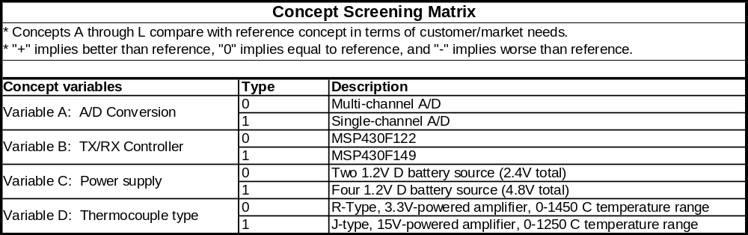
Table 2.1: Concept Screening Matrix – Concepts A through E
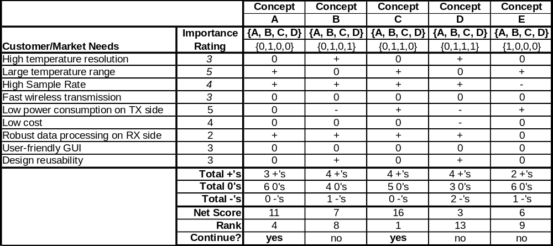
Table 2.2: Concept Screening Matrix – Concepts F through J
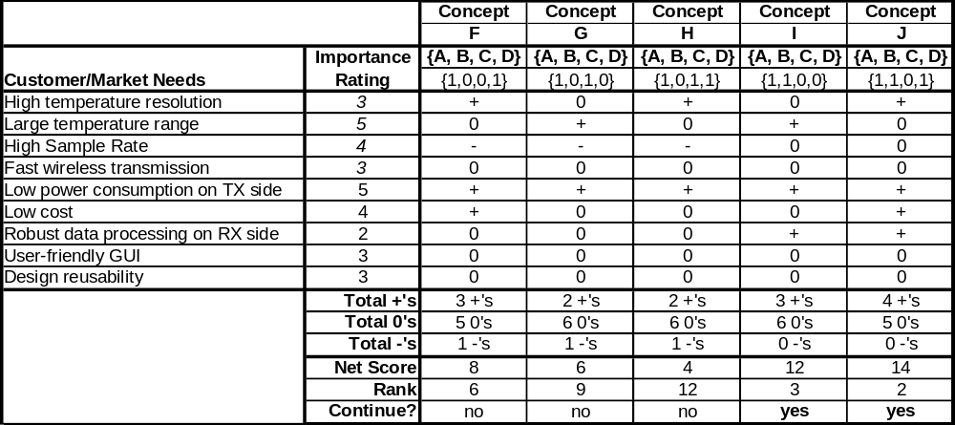
Table 2.3: Concept Screening Matrix – Concepts K, L, Reference
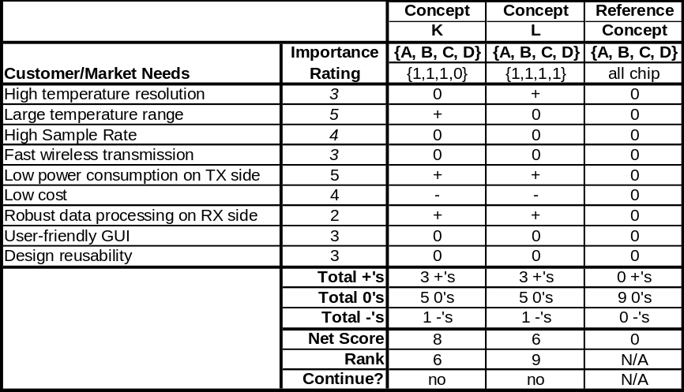
As the tables above show, Concept C ranked the highest among all of the proposed concepts. Throughout the development of this system, several modifications were made to Concept C in order to increase functionality and to better comply with the requirements. Table 3 outlines the differences between Concept C and the final product.
Table 3: Differences between chosen concept and final product
Variable | Concept C | Final Product | Justification for change
Voltage source | Four rechargeable D-size batteries | Four rechargeable AA-size batteries | Four AA batteries can provide the desired current and are significantly smaller than four D batteries.
Analog-to-digital conversion | Multi-channel | Single-channel | The multi-channel A-to-D implementation requires more hardware than the single-channel, and the latter implementation will still meet timing requirements.
Thermocouple type | R-type | B-, C-, J-, K-, R-, S-, and T-type | The benefits of designing for various thermocouple types outweighs the costs in added hardware.

System Level Presentation

System Diagrams
The product designed is shown below (Figure 1) in a visualization of its operating environment.
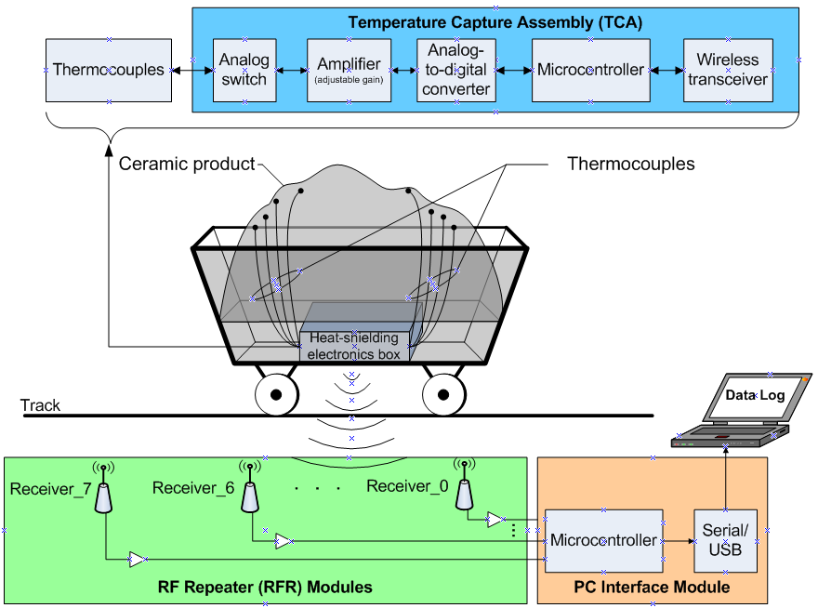
Figure 1: Overall system visualization
This system is made up of three assemblies: the Temperature Capture Assembly (TCA), the RF Repeater (RFR) array, and the PC Interface Assembly (PCIA). The functional relationships between these assemblies are depicted in Figure 2.
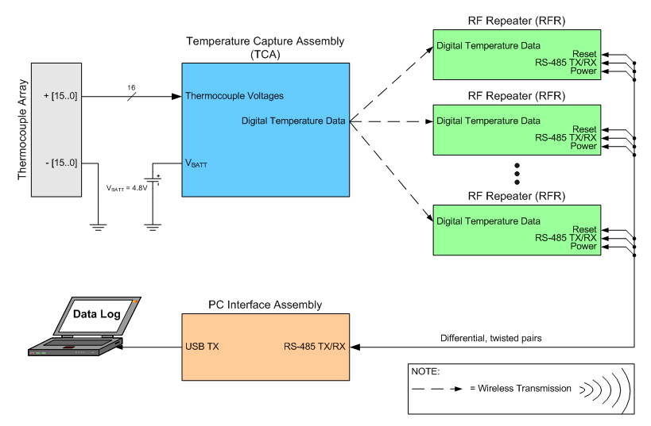
Figure 2: Assembly interactions

Subassembly Diagrams
The Temperature Capture Assembly (TCA) shown in Figure 2 has an internal functional structure that is depicted in Figure 3. Figure 4 shows the corresponding circuit diagram for the TCA. The main purpose of the TCA is to sample analog voltages that represent temperature readings from the 16 thermocouples attached to it. These voltages are amplified, digitized, and transmitted wirelessly via the onboard 2.4GHz transceiver. Among the data transmitted by the TCA is the ambient temperature inside the heat-shielding box where the TCA is housed. This temperature is measured by the microcontroller’s integrated temperature sensor. The TCA is powered by a 4.8V rechargeable battery source.
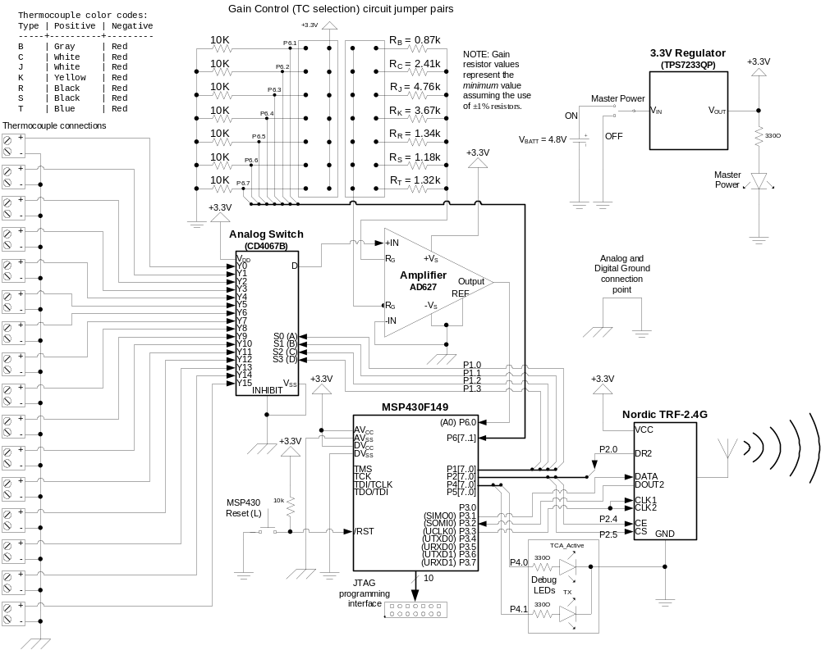
Figure 3: TCA Block Diagram
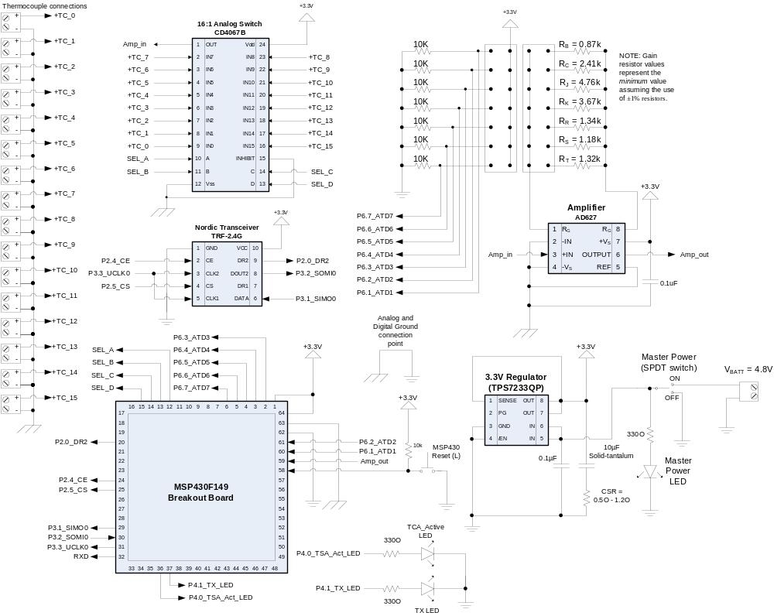
Figure 4: TCA Circuit Diagram
The RF Repeater (RFR) shown in Figure 2 has an internal functional structure that is depicted in Figure 5. Figure 6 shows the corresponding circuit diagram for the RFR. The main purpose of the RFR is to receive the temperature data that is wirelessly transmitted by the TCA and forward it to the PC Interface via an RS-485 serial interface. By utilizing RS-485 line drivers, the distance between each RFR and the PCIA can be up to 4000 ft. Each of the eight RFRs are powered by the PC Interface’s unregulated power supply, which is between 5V and 9V DC.
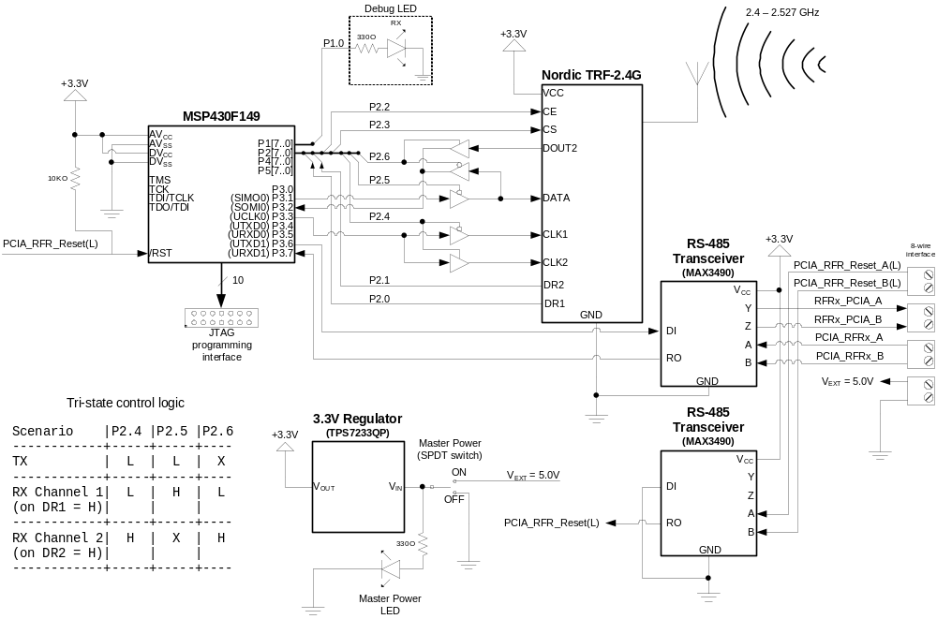
Figure 5: RFR Block Diagram
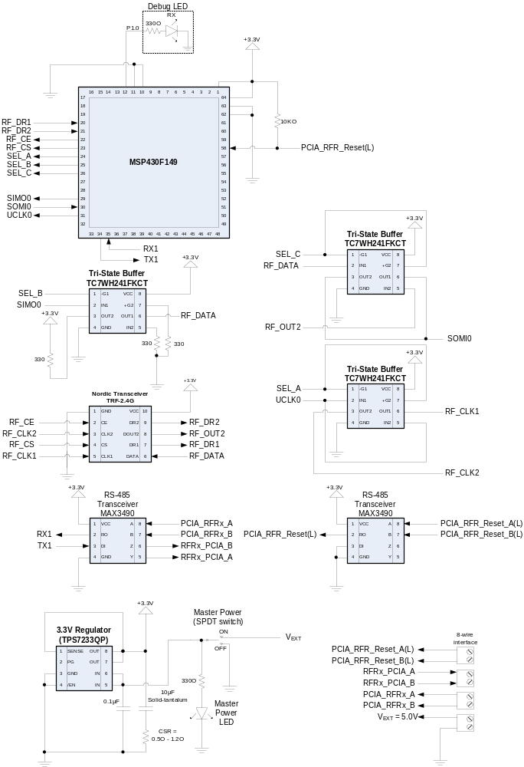
Figure 6: RFR Circuit Diagram
The PC Interface Assembly shown in Figure 2 has an internal functional structure that is depicted in Figure 7. Figure 8 shows the corresponding circuit diagram for the PCIA. The main function of the PCIA is to communicate between the array of up to eight RFRs via an RS-485 serial interface and to receive the temperature data that is transmitted by these RFRs. The PCIA then transmits the real-time temperature data to a data logger (PC, Laptop, etc.) via a USB interface. The PCIA is powered by a single 5V – 9V source that will be regulated to 3.3V.
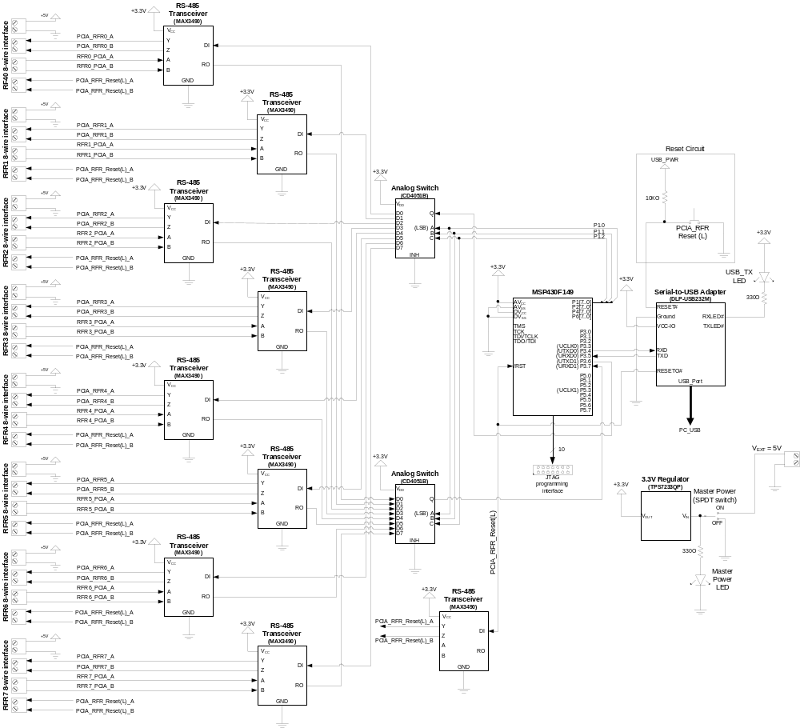
Figure 7: PCIA Block Diagram
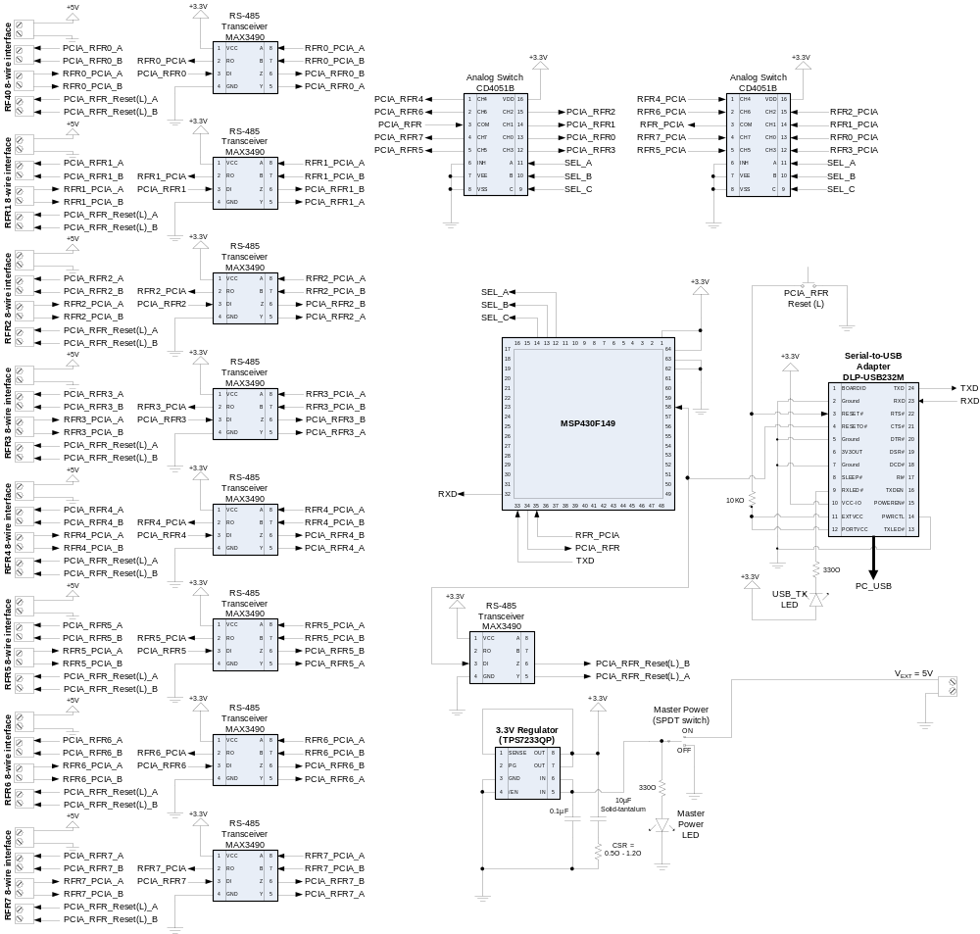
Figure 8: PCIA Circuit Diagram

Software

Temperature Capture Assembly (TCA)
The MSP430F149 Microcontroller on the TCA executes the C-code shown in Listing 1 of Appendix II (associated header files are shown in Listings 2 and 3). The main functions of this code include:
- Analog-to-digital conversion of thermocouple voltages and internal temperature
- Normalization of thermocouple and ambient temperature data
- 27-byte packet assembly
- Wireless data transmission via the Nordic TRF-2.4G wireless transceiver
Other operations performed by this software include capturing and transmitting the system status including thermocouple type in use, packet count, and overall system status. Figure 9 shows the flow of the program from a high-level perspective.
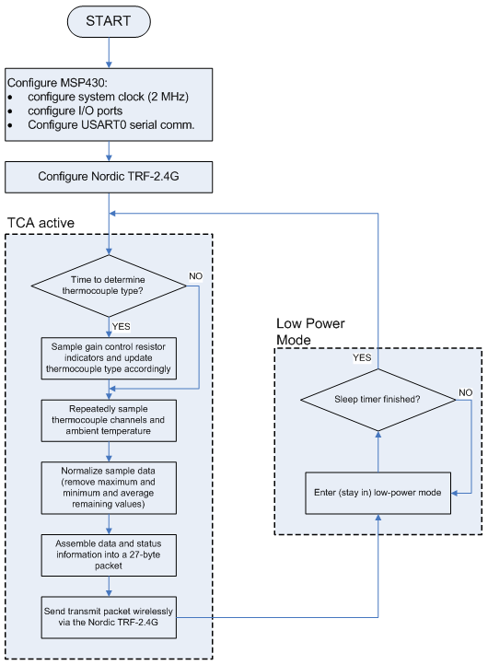
Figure 9: TCA Microcontroller Software Flowchart

RF Repeater
The MSP430F149 Microcontroller on the RFR executes the C-code shown in Listing 4 of Appendix II (associated header files are shown in Listings 2 and 5). The main functions of this code include:
- Receiving data packets from the TCA
- Responding to requests from the PCIA
- Forwarding data onto the PCIA upon request
- General communication with the PCIA
Figure 10 shows the flow of the program from a high-level perspective.
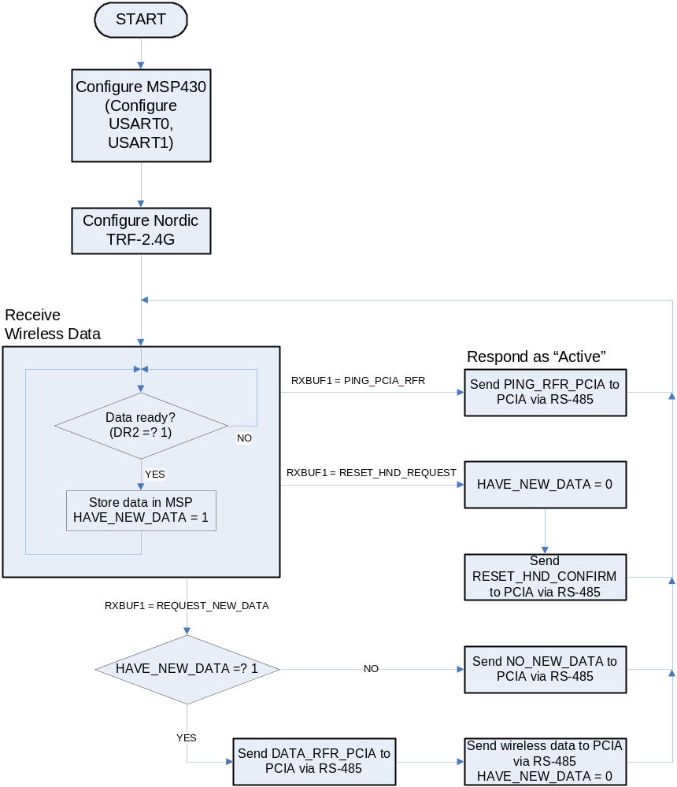
Figure 10: RFR Microcontroller Software Flowchart

PC Interface Assembly
The MSP430F149 Microcontroller on the PCIA executes the C-code shown in Listing 3 of Appendix II. The main functions of this code include:
- Communication between RF Repeater array
- Receiving data packets from the RF Repeaters
- Forwarding data onto the PC via a serial-to-USB interface
Figure 11 shows the flow of the program from a high-level perspective.
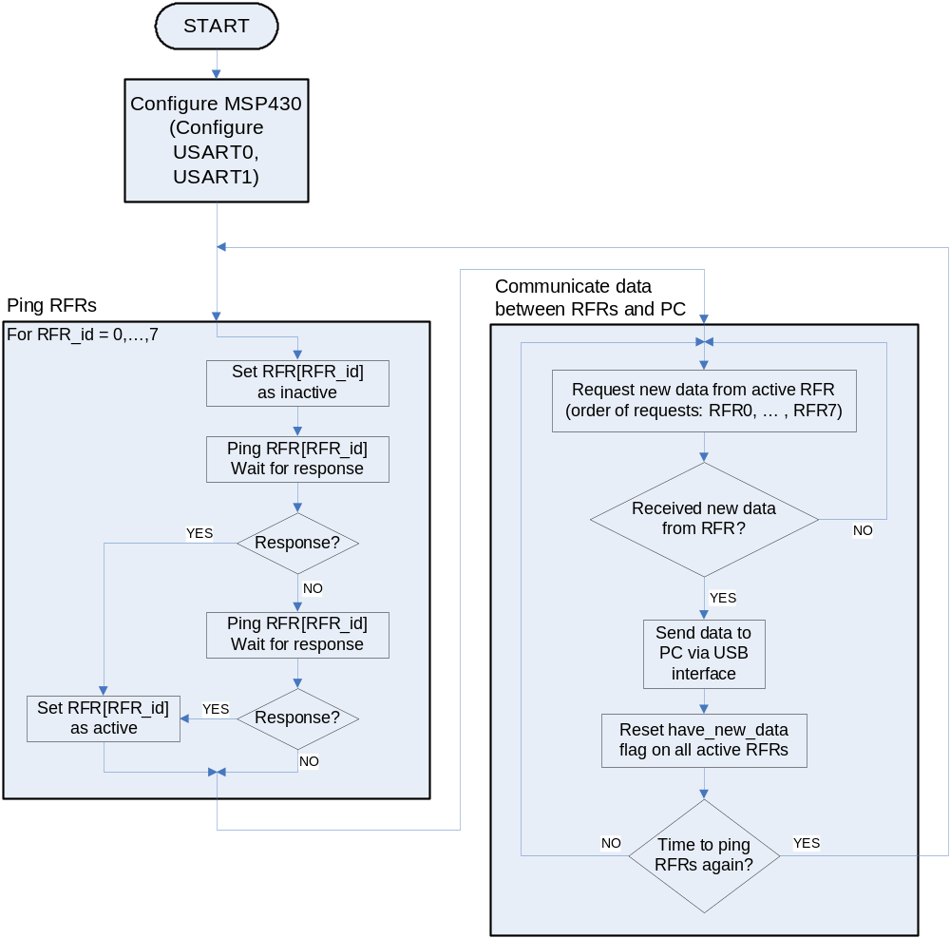
Figure 11: PCIA Microcontroller Software Flowchart

USB Data Capture
The user’s PC will execute the C-code shown in Listing 7 of Appendix II (associated header file is shown in Listing 8) in order to capture data from the USB port. The main functions of this code include:
- Receive and interpret data on the USB port
- Format and print the data to the screen in real time
- Format and print the data to two different files (one for normal use, one for backup)
- Recover from unexpected USB interruptions
Figure 12 shows an example of the execution of this program. The USB data capture software was designed to handle the possibility of a disconnection with the USB device. During such an event, the program notifies the user of the error, and waits for reconnection, at which point data capture resumes normally.
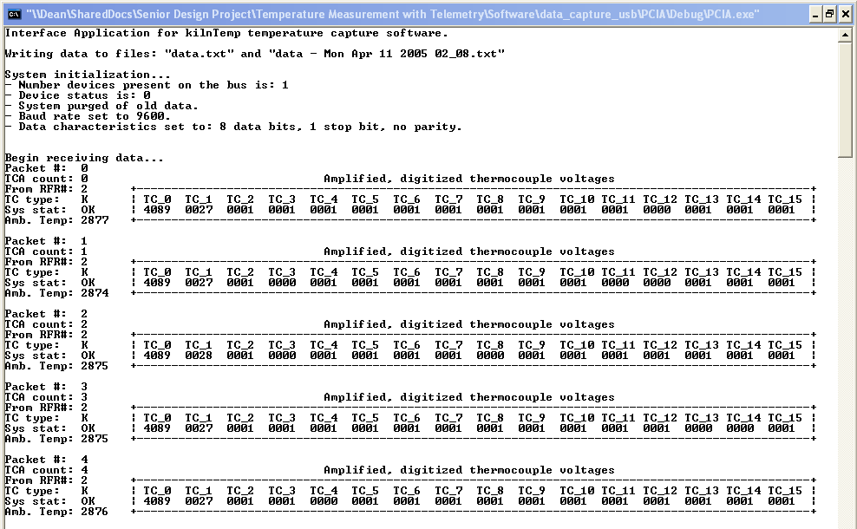
Figure 12: USB Data Capture software execution
As shown in Figure 12, the USB data capture software indicates the following status information about each packet:
- “Packet #” – The USB data capture program assigns a number to each packet it receives.
- “TCA count” – The TCA assigns a number (0 through 99) to each packet it sends. This makes it possible to determine the number of missed packets by comparing “Packet #” (modulo 100) with “TCA count.”
- “From RFR#” – When the PCIA forwards a packet on to the PC, it tells the USB data capture software which RFR sent that particular packet. This may be useful in detecting problematic RFRs, in determining the number of RFR modules necessary to achieve a desired miss rate, and in establishing the need to reposition the RFR array.
- “TC type” – Every so often the TCA will execute a subroutine to determine which thermocouple type is in use. This allows the user to change types during data capture. This status field represents the thermocouple type currently in use.
- “Sys stat” – The TCA also communicates a one-bit general system status that is displayed in this field (0 = “system ok”, 1 = “system not ok”).

PC Graphical User Interface
The PC GUI is implemented as a Microsoft Excel File called kilnTempvX.X.xls, where “X.X” is the version number. The main features of this GUI include:
- Real-time temperature plotting
- Thermocouple reference junction compensation
- Automated data importation
- Semi-automated linear system calibration
- File protection (allows the spreadsheet to act as an executable file)
- Data archiving and time-stamping

Figures 13.0 through 13.2 show images from the PC GUI. Figure 13.0 is an image of temperature data in a tabular format. Figure 13.1 is an image of temperature data in a graphical format. Figure 13.2 shows the semi-automated calibration functionality.

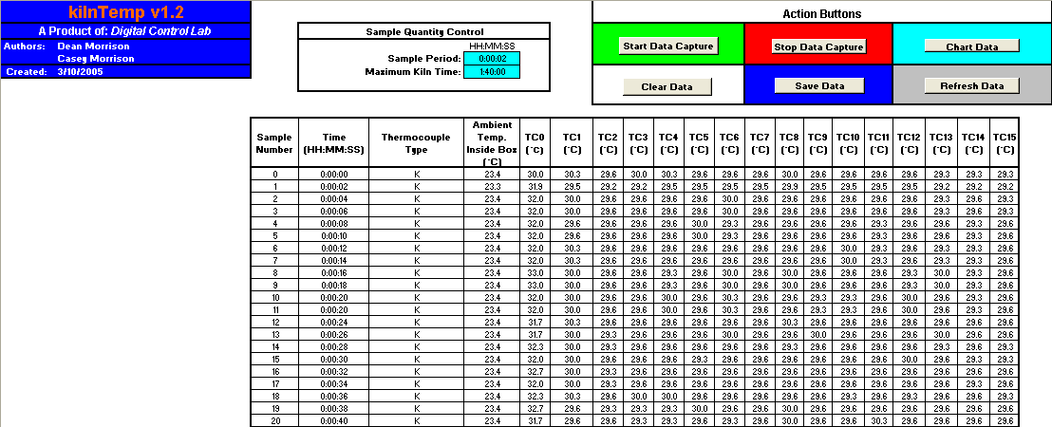
Figure 13.0: PC GUI – Tabular data view

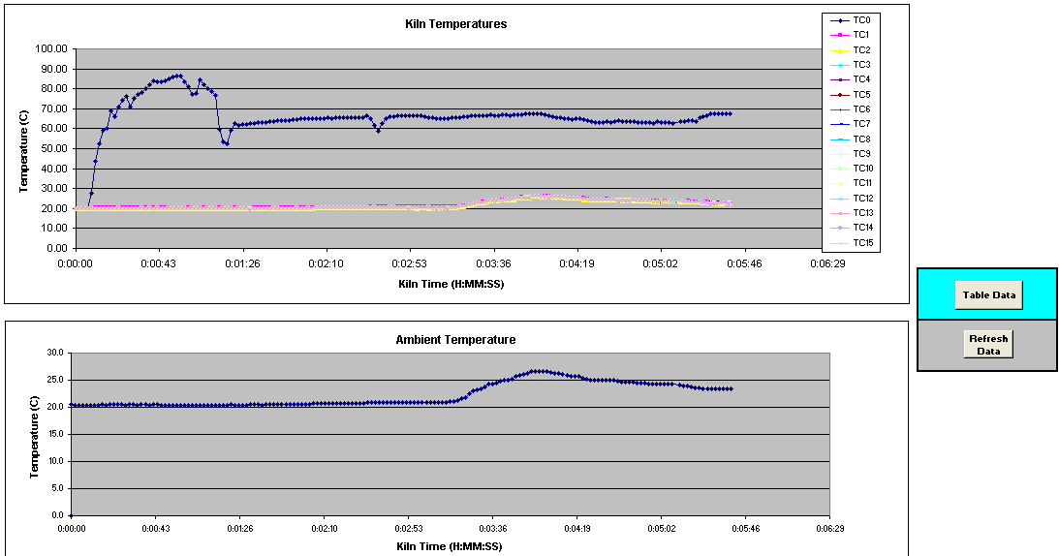
Figure 13.1: PC GUI – Graphical data view
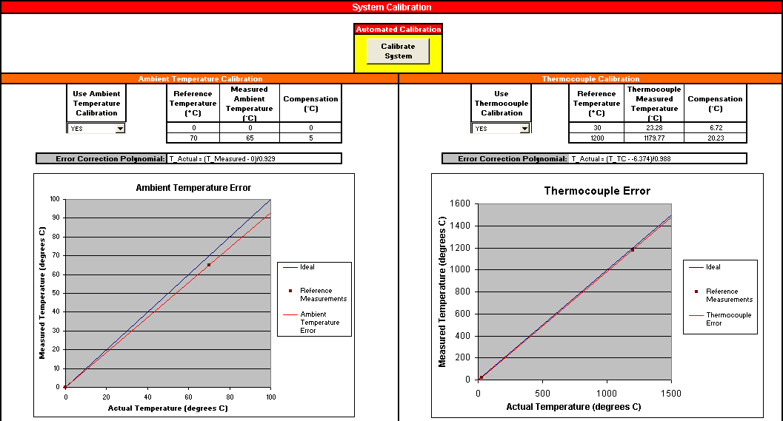
Figure 13.2: PC GUI – Calibration sheet

Cold-Junction Compensation in Software
The PC GUI handles the reference-junction compensation that is necessary when interpreting thermocouple measurements. Because thermocouples can only measure a temperature differential (between the measuring end and the reference end), steps must be taken to reference the non-measuring end of the thermocouple.
One way of accomplishing this is by submerging the reference junction in an ice bath. This will maintain that the temperature difference between the two ends is, in fact, the temperature of the measuring end.
A more practical method of compensation involves an alternate temperature sensor (i.e. a thermistor or a temperature-sensing IC). By combining the thermocouple voltage with the reference junction temperature in the manner depicted in Figure 14, the correctly compensated temperature can be achieved.
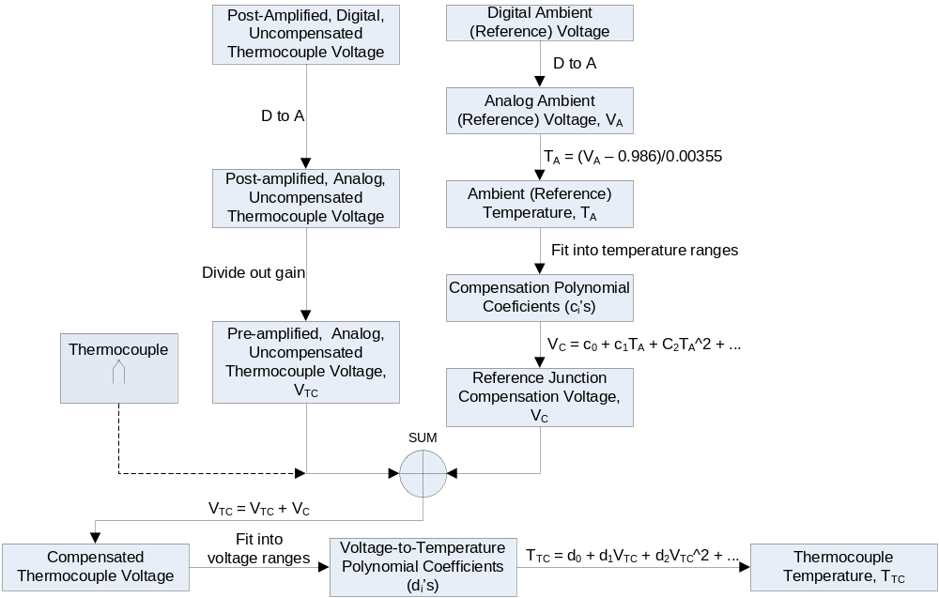
Figure 14: Thermocouple temperature generation flowchart
The PC GUI executes this data processing automatically. However, it relies on accurate thermocouple voltage and ambient temperature data. Accumulating errors in the processes of amplification, analog-to-digital conversion, digital-to-analog conversion (in software), and attenuation (in software) can skew the accuracy of the temperature measurements.

Testing and Verification
Design specifications and the overall functionality of the system were tested and verified by a series of test fixtures, first with isolated modules, and then with the complete system. The architectures of these test fixtures are detailed below.

Temperature Capture Assembly
Many test fixtures were designed and implemented to test and verify the TCA. The first test fixture was designed to test the hardware and software for temperature data capture and processing. The TCA was assembled with an FTDI USB Adapter instead of a Nordic wireless transceiver so that captured data could be written directly to a PC screen. Temperature data capture was tested and verified with the use of several reference temperatures. The actual temperature data was calculated manually from the digitized thermocouple voltages transmitted by the TCA using thermocouple conversion polynomials. This TCA test fixture verified the temperature data acquisition and digitization functionality of the TCA.
Another test fixture was then designed and implemented to test the Wireless transmission functionality of the TCA. The TCA was assembled completely and a wireless receiver circuit was constructed to receive the data being transmitted by the TCA. This receiver utilized an FTDI USB Adapter to store received data to the PC. The TCA was then run with software very similar to that of the final version. Temperature data was captured and transmitted to the receiver. The test fixture succeeded and helped verify the TCA as a whole.

RF Repeater
The RF Repeater design was partially tested in the second of two test fixtures for the TCA. The Nordic wireless transceiver and the MSP430 microcontroller were assembled together along with an FTDI USB adapter to allow the received data to be displayed by a PC. The receive portion of the RFR software was tested and verified by this test fixture.
Several experiments were conducted to determine optimal Nordic configurations. These experiments evaluated variables such as address length, checksum length, packet length, etc. The conclusions of this experiment lead to the packet structure shown in Figure 15 below.

System status |  |  |  |  | Ambient temperature |  |  |  | TC 0 |  |  |  | . . . |  |  |  |  | TC 15
215 |  | 204 |  |  | 203 |  | 192 |  | 191 |  | 180 |  | 179 |  |  | 12 |  | 11 |  | 0
Byte 26 |  |  | Byte 25 |  |  | Byte 24 |  |  | Byte 23 |  |  | . . . |  |  | Byte 1 |  |  |  | Byte 0
215 | 208 |  | 207 | 200 |  | 199 |  | 192 | 191 | 184 |  | 183 |  | 16 | 15 |  | 8 |  | 7 |  | 0
Figure 15: Packet structure
The second test fixture for the RFR involved assembling the complete RFR module and connecting it to the PCIA module via an RS-485 interface. This test could not be performed until the PCIA was assembled.

PC Interface Assembly
The serial to USB interface portion of the PCIA, both in terms of the hardware connections and the segment of software necessary to enable this interface, was verified in the test fixtures for both the TCA and the RFR. The remaining portion of the PCIA that needed to be tested and verified was the hardware and software to enable communication between eight RFRs.
A test fixture was designed to test and verify both the PCIA and the RFR designs. A complete PCIA was assembled as well as one RFR module. These assemblies were connected via four twisted-pairs RS-485. The verified TCA was set to capture and transmit temperature data to the RFR. The RFR was programmed to receive this data, and, upon request, transmit it to the PCIA. The PCIA was then programmed to communicate the data it received to the PC via the USB interface. Once this simplified version of the RFR and PCIA software was verified, the complete version of both programs (including periodic RFR pinging, data status checking, and speed maximization) was tested and verified.

PC GUI
The PC GUI “kilnTempvX.X” was tested during construction by using a static data file as the test input and manipulating the contents of this file to test and verify all the features and functionality of the GUI, such as system status notifications and data importation.
The PC GUI was later verified by running it with actual real-time dynamic data and iterating through all boundary conditions and possible improper use. The misuse and error handling was made robust in anticipation of an end user that is not familiar with this particular type of graphical interface.

Complete System
The complete system was tested and verified by connecting all three assemblies and running the PC data capture and display software. To test the accuracy of the thermocouple measurements, several tests were performed.
First, thermocouples we placed near a heat source and allowed to stabilize. After the temperatures had stabilized, the TCA board was placed near the heat source as well so that the MSP430 microcontroller on the assembly would begin to heat up. In order for the design to be functional and accurate, the thermocouple temperature calculations in the PC GUI should remain constant despite the warming of the microcontroller (which signifies the warming of the inside of the heat-shielding box, a phenomenon that is sure to take place as the TCA passes through a high-temperature kiln). The test was successful and the thermocouple temperatures remained constant.
Next, the accuracy of the thermocouple measurements was tested. Several reference temperatures were used to test the thermocouple measurement accuracy. A digital thermometer was used to measure the temperature of various heat sources to the nearest tenth of a degree Celsius. In addition, a thermocouple simulator was used to generate voltages corresponding to a wide range of temperatures.
Deviations between actual and measured temperature were offset by a linear calibration of the system (accomplished in software). After calibration, measured temperatures were observed within one or two degrees of the actual temperature throughout most of the range of a K-type thermocouple (room temperature to 1200 °C). The internal temperature sensor on the Microcontroller was also calibrated in software using two measurement points and linear calibration.

Final Product
The final prototype is a fully functional system that is accurate, robust, and user friendly. The prototype is tailored for industrial process monitoring in the ceramics industry and functions nicely according to the specifications that correspond to that application. It is also useful in many other environments and is designed to be reasonably versatile.

Performance
The measured performance specifications of the completed design are presented in Table 4 below.
Table 4: System specifications
Requirement number | Parameter | Conditions | Value |  |  | Unit
Requirement number | Parameter | Conditions | Min | Nominal | Max | Unit
1 | Detectable temperature | B-type | RT |  | 1820 | Celsius
1 | Detectable temperature | C-type | RT |  | 2320 | Celsius
1 | Detectable temperature | J-type | RT |  | 1200 | Celsius
1 | Detectable temperature | K-type | RT |  | 1372 | Celsius
1 | Detectable temperature | R-type | RT |  | 1768 | Celsius
1 | Detectable temperature | S-type | RT |  | 1768 | Celsius
1 | Detectable temperature | T-type | RT |  | 400 | Celsius
2 | Transmission period |  | Reconfigurable for any period in the range [0.07 sec., 32.8 min.] with resolution 0.03 sec. |  |  | seconds per packet
3 | Transmit-side supply voltage | Rechargeable NIMH batteries |  | 4.8 |  | Volts
4 | Transmit-side power consumption | Max load (sample period ≅ 0.06 sec) |  |  | 0.037 | Watts
5 | Transmission frequency |  | 2.4 | 2.4 | 2.524 | GHz
6 | Wireless transmission range | Clear line of sight |  |  | 15 | meters
7 | Temperature resolution | After calibration |  | 1 | 3 | Celsius
8 | Electronics box width |  | 3 |  |  | cm
9 | Electronics box height |  | 1.5 |  |  | cm
10 | Electronics box length |  | 5 |  |  | cm
11 | Ambient temperature inside electronics box |  |  |  | 100 | Celsius
12 | Duration in kiln |  | 45 |  | 540 | minutes
13 | RFR-PCIA separation |  |  |  | 4000 | feet
14 | Packet miss rate | Single RFR, 1 foot TX distance, 2 sec. TX period |  | 2%
After calibrating the system with a thermocouple simulator, measurement accuracy was observed to be in the range of one to two degrees Celsius. The system performance in terms of power consumption, sample rate, and usable temperature range significantly exceeded the original requirements.

Cost Estimation
The final cost of a prototype is detailed in Table 5. As the table shows, the maximum cost of the prototype is approximately $1,196.70. Although this price appears to be high, almost 75% of the total is comprised of the thermocouples alone. The type of thermocouples used in the cost calculation (R-type) contains platinum and were chosen because they are the type of thermocouple that would be used in the ceramics kiln application. Using different, cheaper thermocouple types would reduce the prototype cost significantly, but the range of measurable temperatures is determined by the type of thermocouple used.
It is difficult to find products with the same characteristics and application environments as this prototype. Honeywell International makes a line of Wireless Analog Input Transmitters that cost approximately $1190.00, very similar to the price of this prototype. The price of this product, however, does not include the temperature measuring device(s) necessary for its application. For the extreme temperature range that this product is designed for, temperature measurement devices are limited almost exclusively to R or S type thermocouples. As mentioned above, these thermocouples are relatively expensive and when added to the cost of the Honeywell product, the price would increase significantly. So, an existing product like the one offered by Honeywell International would not only be more expensive (after the purchase of the temperature measurement devices), but it is also unclear whether it provides the same functionality and features that this system provides.
Table 5: Prototype Cost
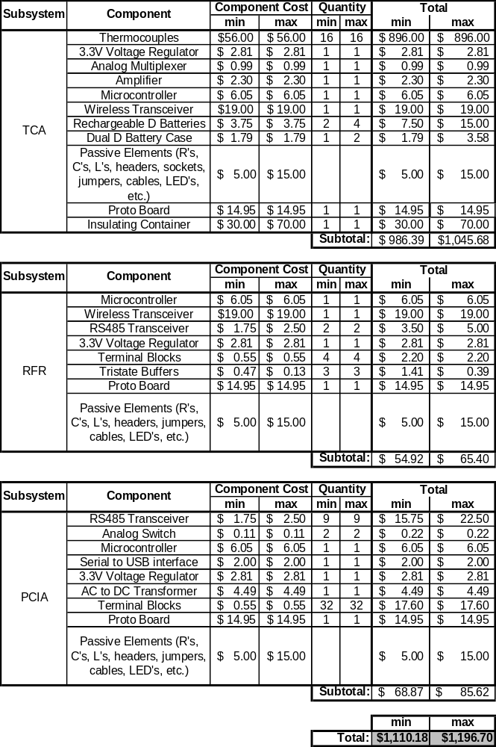

Study Organization
Table 6 and Figure 16 below show the Gantt chart used in the preliminary stages of the project design. Due to changing customer requirements, unexpected difficulties, and delayed parts acquisition, the project task schedule was eventually modified to that shown in Table 7 and Figure 17.
Table 6: Preliminary Task Schedule
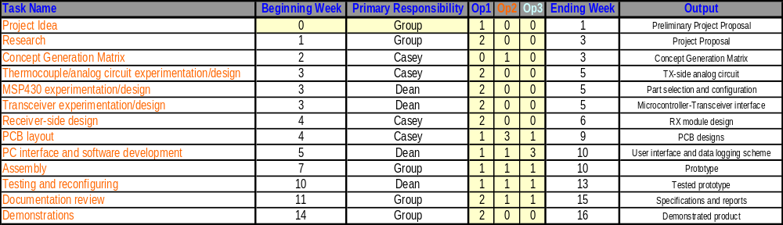
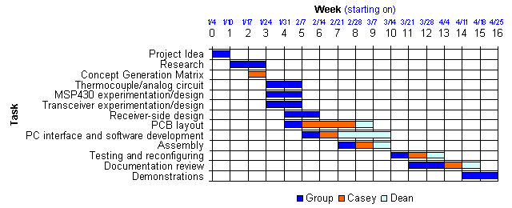
Figure 16: Preliminary Gantt Chart
Table 7: Final Task Schedule
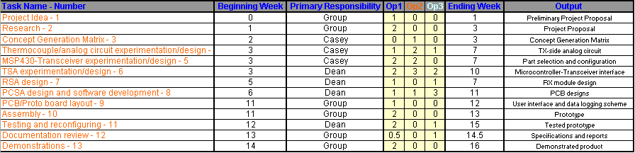
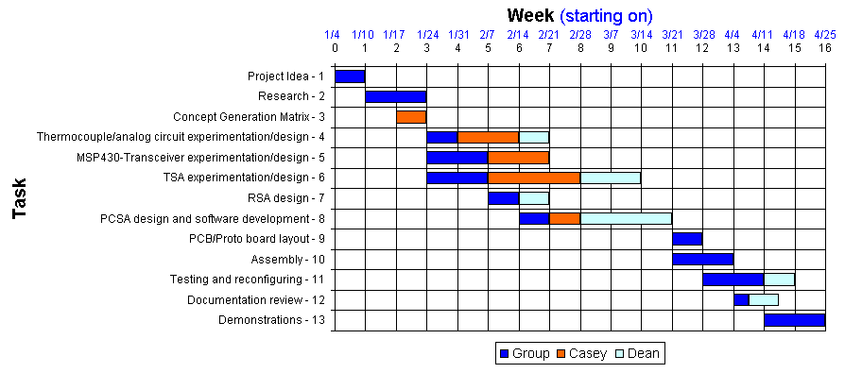
Figure 17: Final Gantt Chart

References and Acknowledgements
Table 8 lists the various resources that have been referenced during the development of this product.
Table 8: References and acknowledgements
Reference | Description | Reference capacity | Link to resource
Dr. Karl Gugel | Professor and owner of Digital Control Lab | Technical direction | gugel@ecel.ufl.edu
Tsang Wei Huang | Graduate student and Teaching Assistant | Technical support | twhuang@ufl.edu
Grzegorz Cieslewski | Graduate student, Teaching Assistant, Research Assistant | Technical support | grzegorz@ufl.edu
Spark Fun Electronics | Electronics distributor and development board manufacturer | Data sheets, product features, and pricing information for various transceivers and microcontrollers | www.sparkfun.com
Analog Devices | Integrated Circuit (IC) manufacturer | Data sheets, product features, and pricing information for various amplifiers, voltage regulators, and DC-to-DC converters | http://www.analog.com
Maxim Integrated Products | Integrated Circuit (IC) manufacturer | Data sheets, product features, and pricing information for various ICs | http://www.maxim-ic.com
US Department of Commerce | National Institute of Standards and Technology (NIST) | Coefficients for thermocouple reference-junction compensation polynomials | http://srdata.nist.gov/its90/download/download.html

APPENDIX I: Bill of Materials
Table 9.0: TCA bill of materials
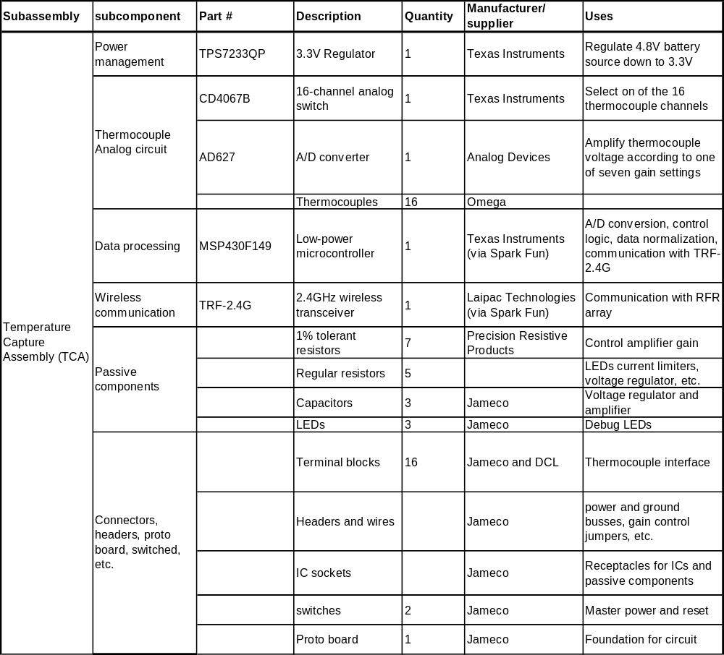
Table 9.1: RFR bill of materials
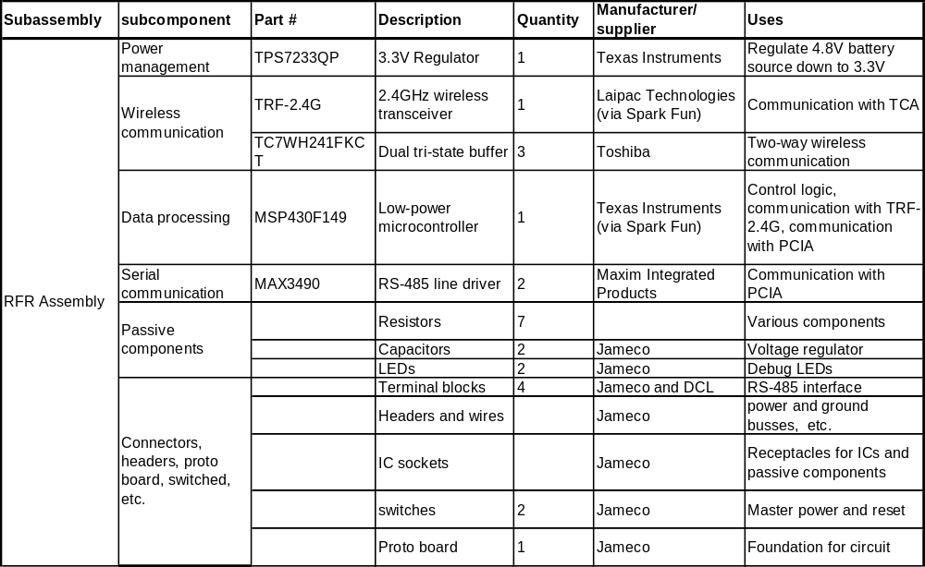
Table 9.2: PCIA bill of materials
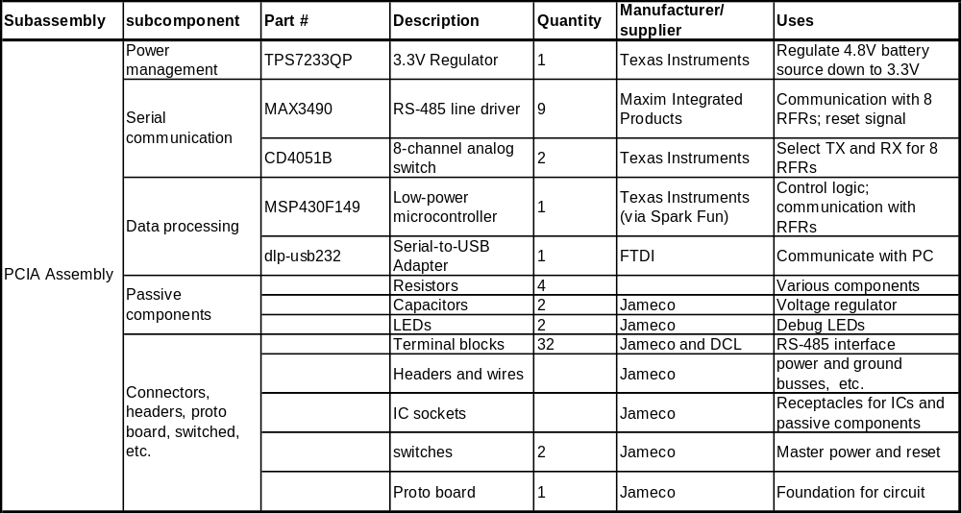

APPENDIX II: Source Code

TCA: TCA_software.c
//******************************************************************************
// File: TCA_software.c
// Authors: Casey Morrison, Dean Morrison
// Date Created: 03/07/2005
// Date Modified: 04/09/2005
//
// Description: This program handles the analog-to-digital conversions, packet
// assembly, and packet transmission for the TCA. Included in each
// packet is information about the system status, the type of
// thermocouple being used for the given time period, 16 thermocouple
// samples, and an internal temperature measurement (as well as other
// status information).
//
//
// MSP430F149
// -----------------
// | |
// | A0 |<---- TCVoltage
// | A1 |<---- GainControl_B
// | A2 |<---- GainControl_C
// | A3 |<---- GainControl_J
// | A4 |<---- GainControl_K
// | A5 |<---- GainControl_R
// | A6 |<---- GainControl_S
// | A7 |<---- GainControl_T
// | |
// +-----------------+
//
//
//******************************************************************************

#include "msp430x14x.h" // Standard MSP430 equations
#include "kilnTemp_defs.h" // System-wide definitions
#include "TCA_wireless_protocol.h" // Wireless protocol definitions

// Function prototypes
void initSys(void);
void initTRF(void);
void TX_TRF_mode(void);
void clkAddrBytes(unsigned int address_width);
void clkDataBytes(unsigned int data_width);
void Set_DCO (void);
unsigned int Normalize(unsigned int results[], int length);
void acquireData(void);
void updateThermocoupleType(void);
void clearPacket(void);
void delay(int delay_loops);

// Function prototypes for USB configuration only
void configUART0(void);
void sendUSB (unsigned int data_width);

// Data arrays
static unsigned int Tresults[16];
static unsigned int T0results[NUM_OF_RESULTS];
static unsigned int T1results[NUM_OF_RESULTS];
static unsigned int T2results[NUM_OF_RESULTS];
static unsigned int T3results[NUM_OF_RESULTS];
static unsigned int T4results[NUM_OF_RESULTS];
static unsigned int T5results[NUM_OF_RESULTS];
static unsigned int T6results[NUM_OF_RESULTS];
static unsigned int T7results[NUM_OF_RESULTS];
static unsigned int T8results[NUM_OF_RESULTS];
static unsigned int T9results[NUM_OF_RESULTS];
static unsigned int T10results[NUM_OF_RESULTS];
static unsigned int T11results[NUM_OF_RESULTS];
static unsigned int T12results[NUM_OF_RESULTS];
static unsigned int T13results[NUM_OF_RESULTS];
static unsigned int T14results[NUM_OF_RESULTS];
static unsigned int T15results[NUM_OF_RESULTS];

static unsigned int A0results[NUM_OF_RESULTS];
static unsigned int A1results[NUM_OF_RESULTS];
static unsigned int A2results[NUM_OF_RESULTS];
static unsigned int A3results[NUM_OF_RESULTS];
static unsigned int A4results[NUM_OF_RESULTS];
static unsigned int A5results[NUM_OF_RESULTS];
static unsigned int A6results[NUM_OF_RESULTS];
static unsigned int A7results[NUM_OF_RESULTS];
static unsigned int A8results[NUM_OF_RESULTS];
static unsigned int A9results[NUM_OF_RESULTS];
static unsigned int A10results[NUM_OF_RESULTS];
static unsigned int A11results[NUM_OF_RESULTS];
static unsigned int A12results[NUM_OF_RESULTS];
static unsigned int A13results[NUM_OF_RESULTS];
static unsigned int A14results[NUM_OF_RESULTS];
static unsigned int A15results[NUM_OF_RESULTS];

static unsigned int Tnormalized;
static unsigned int Anormalized[16];

// Packet data arrays
static unsigned int Byte[PACKET_SIZE];
static unsigned int status_batt;
static unsigned int status_count;
static unsigned int status_TC;
static unsigned int status_sys;
static unsigned int temp;
static unsigned int TC[16];
static unsigned int configByte[15];

// Global variables
unsigned int data_ready = FALSE;
unsigned int conversion_number = 0;
unsigned int sleepNumber = 0;
unsigned int packet_number = 0;
unsigned int TC_type = R_TYPE;

//------------------------------------------------------------------------------
void main(void) {
//------------------------------------------------------------------------------

WDTCTL = WDTPW+WDTHOLD; // Stop watchdog timer

// Configure MCLK (~1.9MHz)
BCSCTL1 |= DIVA_3; // ACLK= LFXT1CLK/8
Set_DCO(); // Set DCO

// Initialize the MSP430 system
initSys();

// Delay 1
delay(DELAY1);

//-------------------------------------------------------------------
// WIRELESS CONFIGURATION ONLY
// Initialize the TRF-2.4G
initTRF();
//-------------------------------------------------------------------

// Delay 2
delay(DELAY2);

//-------------------------------------------------------------------
// WIRELESS CONFIGURATION ONLY
// Configure for TX mode
TX_TRF_mode();
//-------------------------------------------------------------------

// Delay 3
delay(DELAY3);

// Set up sleep timer
CCTL0 = CCIE; // CCR0 interrupt enabled
CCR0 = SLEEP_AMT; // Number of SMCLK cycles the MSP will sleep for

// Set up analog multiplexer control bits (Port 1)
P1OUT = 0x00; // Clear P1.0-P1.3 --> start with TC[0]
P1DIR |= 0x0F; // Configure P1.0-P1.3 for output

// Set up Gain Control inputs
P6SEL &= 0x01; // Configure P6.1-P6.7 for I/O
P6DIR &= 0x01; // Configure P6.1-P6.7 for input

// Data acquisition and transmission
packet_number = 0;
for(;;) {
clearPacket();

if(packet_number%CYCLES_BTW_GAIN == 0) {
// Resample gain control channels to update thermocouple type
updateThermocoupleType();
}

// Sample thermocouples and internal temperature and assemble packet
acquireData();

// Transmit data
P4OUT |= TX_LED; // Toggle TX LED
P2OUT |= TRF_CE; // Enable module 1: active mode

//-------------------------------------------------------------------
// WIRELESS CONFIGURATION ONLY
// Clock in ADDR_W number of address bytes
// NOTE: If you do not want all address bytes to be equal,
// then you must manually clock in ADDR_TXa, ADDR_TXb, etc.
clkAddrBytes(ADDR_W);

// Clock in data
clkDataBytes(DATA_W);
//-------------------------------------------------------------------

//-------------------------------------------------------------------
// USB CONFIGURATION ONLY
// Send data via USB
//sendUSB(DATA_W);
//-------------------------------------------------------------------

P2OUT &= ~TRF_CE; // Setting CE low completes transmit
P4OUT &= ~TX_LED; // Indicate end of transmission

// Sleep to save power
sleepNumber = 0;
P4OUT &= ~TSA_ACT_LED; // Indicate that TSA is asleep
TACTL = TASSEL_2 + MC_1; // SMCLK, upmode
_BIS_SR(LPM0_bits + GIE); // Enter LPM0 w/ interrupt
}
} // end main()

// *****************************************************************************
// Subroutines *
// *****************************************************************************

//------------------------------------------------------------------------------
void delay(int delay_loops) { // Generic delay loop
//------------------------------------------------------------------------------
int index = DELAY_AMT;
int loop;
for(loop = 0; loop < delay_loops; loop += 1) {
while(index > 0) {
--index;
}
index = DELAY_AMT;
}
}// end delay()

//------------------------------------------------------------------------------
void initSys(void) { // Initialize MSP430 System
//------------------------------------------------------------------------------

// Default configurations for I/O ports
P1SEL = 0x00; // configure P1 for I/O
P1OUT = 0x00; // Clear P1.x
P1DIR = 0xFF; // Configure P1 for output

P2SEL = 0x00; // configure P2 for I/O
P2OUT = 0x00; // Clear P2.x
P2DIR = 0xFF; // Configure P2 for output

P3SEL = 0x00; // configure P3 for I/O
P3OUT = 0x00; // Clear P3.x
P3DIR = 0xFF; // Configure P3 for output

P4SEL = 0x00; // configure P4 for I/O
P4OUT = 0x00; // Clear P4.x
P4DIR = 0xFF; // Configure P4 for output
P4OUT |= TSA_ACT_LED; // Turn TSA_Active on

P5SEL = 0x00; // configure P5 for I/O
P5OUT = 0x00; // Clear P5.x
P5DIR = 0xFF; // Configure P5 for output

P6SEL = 0x00; // configure P6 for I/O
P6OUT = 0x00; // Clear P6.x
P6DIR = 0xFF; // Configure P6 for output

//-------------------------------------------------------------------
// USB CONFIGURATION ONLY
// Set up UART0
//configUART0();
//-------------------------------------------------------------------

_EINT(); // Enable interrupts
}// end initSys()

//------------------------------------------------------------------------------
void Set_DCO (void) { // Set DCO to selected frequency
//------------------------------------------------------------------------------

#define DELTA 488 // Target DCO = DELTA*(4096) ~= 2MHz

unsigned int Compare, Oldcapture = 0;

CCTL2 = CM_1 + CCIS_1 + CAP; // CAP, ACLK
TACTL = TASSEL_2 + MC_2 + TACLR; // SMCLK, cont-mode, clear

while (1) {
while (!(CCIFG & CCTL2)); // Wait until capture occured
CCTL2 &= ~CCIFG; // Capture occured, clear flag
Compare = CCR2; // Get current captured SMCLK
Compare = Compare - Oldcapture; // SMCLK difference
Oldcapture = CCR2; // Save current captured SMCLK
if (DELTA == Compare) break; // If equal, leave "while(1)"

else if (DELTA < Compare) {
DCOCTL--;
if (DCOCTL == 0xFF) { // DCO is too fast, slow it down
if (!(BCSCTL1 == (XT2OFF + DIVA_3)))
BCSCTL1--; // Did DCO role under?, Sel lower RSEL
}
}
else {
DCOCTL++; // DCO is too slow, speed it down
if (DCOCTL == 0x00) {
if (!(BCSCTL1 == (XT2OFF + DIVA_3 + 0x07)))
BCSCTL1++; // Did DCO role over? Sel higher RSEL
}
}
}

CCTL2 = 0; // Stop CCR2
TACTL = 0; // Stop Timer_A
}// end Set_DCO()

//------------------------------------------------------------------------------
void configUART0(void) { // This method is for USB configuration only
//------------------------------------------------------------------------------
P3SEL |= 0x30; // P3.4,5 = USART0 TXD/RXD

ME1 |= UTXE0; // Enable USART0 TXD
UCTL0 |= CHAR; // 8-bit character, SWRST = 1
UTCTL0 |= SSEL1 + SSEL0 + URXSE; // UCLK = SMCLK, start edge detect
UBR00 = 0xD0; // 9600 from 2Mhz
UBR10 = 0x00;
UMCTL0 = 0x00; // No modulation
UCTL0 &= ~SWRST; // Initialize USART state machine
//IE1 |= URXIE0; // Enable USART0 RX interrupt
}// end configUART()

//------------------------------------------------------------------------------
void sendUSB (unsigned int data_width) { // For USB configuration only
//------------------------------------------------------------------------------
// Clear data_ready flag
data_ready = FALSE;

// Transmit packet byte-by-byte
int i;
for(i = data_width - 1; i >= 0; i -= 1) {
while(!(IFG1 & UTXIFG0)); // USART0 TX buffer ready?
TXBUF0 = Byte[i];
}

// Increment packet number (modulo MAX_PACKET_NUMBER)
packet_number = (packet_number + 1)%MAX_PACKET_NUMBER;
}// end sendUSB()

//------------------------------------------------------------------------------
void initTRF(void) { // Initialize the TRF-2.4G system
//------------------------------------------------------------------------------
/*
description: Initializes the SPI port for TRF module and configures for shock-
burst mode. default is active transmit mode.

------------+ +---------
P3.1/SIMO0|--------------------->|Data1
MSP430 P3.2/SOMI0|<---------------------|Data2 TRF-2.4G
P3.3/UCLK0|--------------------->|CLK1=CLK2
P2.4|--------------------->|CE
P2.5|--------------------->|CS
P2.0|<---------------------|DR2 (this is so you can use
| | Port 2 as interruptable pin)
------------+ +---------

Active = /CS + CE
Config = CS + /CE
Stdby = /CS + /CE
*/

P2DIR &= ~TRF_DR2; // Configure Port 2.0 for input direction
P2OUT &= ~(TRF_CE+TRF_CS); // Clear output on P2.4, P2.5
P2DIR |= TRF_CE+TRF_CS; // Set P2.4, P2.5 to output direction
P3SEL |= 0x0E; // Select SPI option on P3.1, P3.2, P3.3

U0CTL = CHAR+SYNC+MM+SWRST; // 8-bit, SPI, Master
U0TCTL |= CKPH+SSEL1+STC; // Polarity __/--, SMCLK, 3-wire
U0BR1 = BAUDDIV0H; // SPI0CLK = SMCLK/BAUDRATE0
U0BR0 = BAUDDIV0L;
U0MCTL = 0x000; // No modulation
ME1 |= USPIE0; // Module enable
U0CTL &= ~SWRST; // SPI enable

// Assemble bytes of configuration word
configByte[0] = (DATA_W*8) & 0xFF; // 0x08
configByte[1] = (DATA_W*8) & 0xFF; // 0x08
configByte[2] = ADDR_RXa & 0xFF; // 0x01
configByte[3] = ADDR_RXb & 0xFF; // 0x01
configByte[4] = ADDR_RXc & 0xFF; // 0x01
configByte[5] = ADDR_RXd & 0xFF; // 0x01
configByte[6] = ADDR_RXe & 0xFF; // 0xC8
configByte[7] = 0x01 & 0xFF; // 0x01
configByte[8] = 0x01 & 0xFF; // 0x01
configByte[9] = 0x01 & 0xFF; // 0x01
configByte[10] = 0x01 & 0xFF; // 0x01
configByte[11] = 0x01 & 0xFF; // 0x01
configByte[12] = (((ADDR_W*8)<<2) | (CRC_L<<1) | (CRC_EN)) & 0xFF; // 0x43
configByte[13] = ((RX2_EN<<7) | (CM<<6) | (RFDR_SB<<5) | (XO_F<<2) | (RF_PWR)) & 0xFF; // 0xCF
configByte[14] = (((RF-2400+8)<<1) | (AM_TX)) & 0xFF; // 0x74

P2OUT |= TRF_CS; // Enable TRF config mode

// Transmit configuration bytes
unsigned int TX_index;
for(TX_index = 0; TX_index <= 14; TX_index += 1) {
while(!(IFG1 & UTXIFG0)); // USART0 TX buffer ready?
TXBUF0 = configByte[TX_index];
}
while(!(U0TCTL & TXEPT)); // Wait til TXreg is empty

P2OUT &= ~TRF_CS; // Disable TRF config mode
}// end initTRF()

//------------------------------------------------------------------------------
void TX_TRF_mode(void) { // Configure system for transmit
//------------------------------------------------------------------------------

U0TCTL |= CKPH; // Set SPI Polarity __/--
P2OUT |= TRF_CS; // Turn on configuration mode

while(!(IFG1 & UTXIFG0)); // USART0 TX buffer ready?
TXBUF0 = ((RF-2400+8)<<1) | (AM_TX);// 0x74;

while(!(U0TCTL & TXEPT)); // Wait til TXreg is empty

P2OUT &= ~TRF_CS; // Turn off config mode
}// end TX_TRF_mode

//------------------------------------------------------------------------------
void clearPacket(void) {
//------------------------------------------------------------------------------
// Clear the packet
unsigned int i;
for(i = 0; i < PACKET_SIZE; i += 1) {
Byte[i] = 0;
}

status_batt = 0;
status_count = 0;
//status_TC = 0;
status_sys = 0;
temp = 0;

unsigned int j;
for(j = 0; j < 16; j += 1) {
TC[j] = 0;
}
} // end clearPacket()

//------------------------------------------------------------------------------
void clkAddrBytes(unsigned int address_width) { // Clock in address bytes
//------------------------------------------------------------------------------

int i;
for(i = 0; i < address_width; i += 1) {
while(!(IFG1 & UTXIFG0)); // USART0 TX buffer ready?
TXBUF0 = ADDR_BYTE;
}
}// end clkAddrBytes()

//------------------------------------------------------------------------------
void clkDataBytes(unsigned int data_width) { // Clock in data bytes
//------------------------------------------------------------------------------

// Clear data_ready flag
data_ready = FALSE;

int i;
for(i = data_width - 1; i >= 0; i -= 1) {
while(!(IFG1 & UTXIFG0)); // USART0 TX buffer ready?
TXBUF0 = Byte[i];
}
while(!(U0TCTL & TXEPT)); // Wait until TXreg is empty

// Increment packet number (modulo MAX_PACKET_NUMBER)
packet_number = (packet_number + 1)%MAX_PACKET_NUMBER;
}// end clkDataBytes()

//------------------------------------------------------------------------------
void updateThermocoupleType(void) {
//------------------------------------------------------------------------------
/*
MSP430F149
+-----------------+
| A0 |<---- TCVoltage
| A1 |<---- GainControl_B
| A2 |<---- GainControl_C
| A3 |<---- GainControl_J
| A4 |<---- GainControl_K
| A5 |<---- GainControl_R
| A6 |<---- GainControl_S
| A7 |<---- GainControl_T
+-----------------+
*/

// Determine which thermocouple type is selected
// Step 1: Read P6.1 through P6.7
unsigned int Port6;
Port6 = P6IN;
TC_type = UNDET_TYPE; // default
unsigned int GainControlError = FALSE;
if(Port6 & 0x02) {
// channel 1 (B_TYPE) on
TC_type = B_TYPE;
}
if(Port6 & 0x04) {
// channel 2 (C_TYPE) on
if(TC_type != 0) {
// multiple channels selected
GainControlError = TRUE;
}
else {
TC_type = C_TYPE;
}
}
if(Port6 & 0x08) {
// channel 3 (J_TYPE) on
if(TC_type != 0) {
// multiple channels selected
GainControlError = TRUE;
}
else {
TC_type = J_TYPE;
}
}
if(Port6 & 0x10) {
// channel 4 (K_TYPE) on
if(TC_type != 0) {
// multiple channels selected
GainControlError = TRUE;
}
else {
TC_type = K_TYPE;
}
}
if(Port6 & 0x20) {
// channel 5 (R_TYPE) on
if(TC_type != 0) {
// multiple channels selected
GainControlError = TRUE;
}
else {
TC_type = R_TYPE;
}
}

if(Port6 & 0x40) {
// channel 6 (S_TYPE) on
if(TC_type != 0) {
// multiple channels selected
GainControlError = TRUE;
}
else {
TC_type = S_TYPE;
}
}
if(Port6 & 0x80) {
// channel 7 (T_TYPE) on
if(TC_type != 0) {
// multiple channels selected
GainControlError = TRUE;
}
else {
TC_type = T_TYPE;
}
}

// Set thermocouple type
if(GainControlError == FALSE) {
status_TC = TC_type;
}
else {
status_TC = UNDET_TYPE;
status_sys = SYS_NOT_OK;
}
}// end updateThermocoupleType()

//------------------------------------------------------------------------------
void acquireData(void) {
//------------------------------------------------------------------------------
/*
MSP430F149
+-----------------+
| A0(INCH_0)|<---- TCVoltage
| (INCH_10)|<---+
| | |
| Internal_temp|----+
+-----------------+
*/
// Configure for two channels of conversions
// (one for TC conversions and one for internal temperature conversion)
data_ready = FALSE; // Reset data_ready flag
P6SEL = 0x01; // Enable A/D channel input P6.0
ADC12CTL0 = ADC12ON+MSC+SHT0_10+REFON;// ADC12ON --> Turn on ADC12
// SHT0_8 --> Sample-and-hold time = 256 clock cycles
// SHT0_10 --> Sample-and-hold time = 512 clock cycles
// REFON --> Internal 1.5V reference for internal temp.

ADC12CTL1 = SHP+CONSEQ_1+CSTARTADD_0; // Use sampling timer, sequence-of-channels, single-conversion

conversion_number = 0; // Start with 0th conversion, end with 15th

ADC12MCTL0 = INCH_0; // ref+=AVcc, channel = A0 (Thermocouple voltage)
ADC12MCTL1 = INCH_10+SREF_1+EOS; // ref+=1.5V, channel = Internal temperature

ADC12IE = 0x02; // Enable ADC12IFG.1

ADC12CTL0 |= ENC; // Enable conversions
_EINT(); // Enable interrupts
ADC12CTL0 |= ADC12SC; // Start conversion
_BIS_SR(LPM0_bits + GIE); // Enter and stay in LPM0

while(data_ready == FALSE) {
// wait for data to be ready
}
}// end acquireData()

//------------------------------------------------------------------------------
unsigned int Normalize(unsigned int results[], int length) {
//------------------------------------------------------------------------------
int min_index = 0;
int max_index = 0;
unsigned int average = 0;

// find min
for (int i = 1; i < length; i++) {
if (results[i] < results[i-1]) min_index = i;
}

// find max
for (int i = 1; i < length; i++) {
if (results[i] > results[i-1]) max_index = i;
}

// average
for (int i = 0; i < length; i++) {
average += results[i];
}
average -= results[min_index];
average -= results[max_index];
average = average/(length - 2);

return average;
}// end Normalize()

//------------------------------------------------------------------------------
#pragma vector=ADC_VECTOR
__interrupt void ADC12ISR (void) {
//------------------------------------------------------------------------------
static unsigned int index = 0;
//
//ADC12CTL0 &= ~ENC; // Disable conversions
//ADC12CTL0 &= ~ADC12SC; // Stop conversion

// Obtain conversion data
if(conversion_number == 0) {
A0results[index] = ADC12MEM0; // Move A0 results, IFG is cleared
T0results[index] = ADC12MEM1;
}
else if(conversion_number == 1) {
A1results[index] = ADC12MEM0; // Move A1 results, IFG is cleared
T1results[index] = ADC12MEM1;
}
else if(conversion_number == 2) {
A2results[index] = ADC12MEM0; // Move A2 results, IFG is cleared
T2results[index] = ADC12MEM1;
}
else if(conversion_number == 3) {
A3results[index] = ADC12MEM0; // Move A3 results, IFG is cleared
T3results[index] = ADC12MEM1;
}
else if(conversion_number == 4) {
A4results[index] = ADC12MEM0; // Move A4 results, IFG is cleared
T4results[index] = ADC12MEM1;
}
else if(conversion_number == 5) {
A5results[index] = ADC12MEM0; // Move A5 results, IFG is cleared
T5results[index] = ADC12MEM1;
}

else if(conversion_number == 6) {
A6results[index] = ADC12MEM0; // Move A6 results, IFG is cleared
T6results[index] = ADC12MEM1;
}
else if(conversion_number == 7) {
A7results[index] = ADC12MEM0; // Move A7 results, IFG is cleared
T7results[index] = ADC12MEM1;
}
else if(conversion_number == 8) {
A8results[index] = ADC12MEM0; // Move A9 results, IFG is cleared
T8results[index] = ADC12MEM1;
}
else if(conversion_number == 9) {
A9results[index] = ADC12MEM0; // Move A10 results, IFG is cleared
T9results[index] = ADC12MEM1;
}
else if(conversion_number == 10) {
A10results[index] = ADC12MEM0; // Move A11 results, IFG is cleared
T10results[index] = ADC12MEM1;
}
else if(conversion_number == 11) {
A11results[index] = ADC12MEM0; // Move A12 results, IFG is cleared
T11results[index] = ADC12MEM1;
}
else if(conversion_number == 12) {
A12results[index] = ADC12MEM0; // Move A13 results, IFG is cleared
T12results[index] = ADC12MEM1;
}
else if(conversion_number == 13) {
A13results[index] = ADC12MEM0; // Move A14 results, IFG is cleared
T13results[index] = ADC12MEM1;
}
else if(conversion_number == 14) {
A14results[index] = ADC12MEM0; // Move A15 results, IFG is cleared
T14results[index] = ADC12MEM1;
}
else if(conversion_number == 15) {
A15results[index] = ADC12MEM0; // Move A16 results, IFG is cleared
T15results[index] = ADC12MEM1;
}
else {
// This should not occur
status_sys = SYS_NOT_OK;
}

if(index >= (NUM_OF_RESULTS - 1)) {
// A single TC (or internal temp) has been sampled NUM_OF_RESULTS times
// Configure to convert next TC
conversion_number = (conversion_number + 1)%16;

if(conversion_number == 0) {
// A complete set of data has been acquired
// Set normalized values
Tresults[0] = Normalize(T0results, NUM_OF_RESULTS);
Tresults[1] = Normalize(T1results, NUM_OF_RESULTS);
Tresults[2] = Normalize(T2results, NUM_OF_RESULTS);
Tresults[3] = Normalize(T3results, NUM_OF_RESULTS);
Tresults[4] = Normalize(T4results, NUM_OF_RESULTS);
Tresults[5] = Normalize(T5results, NUM_OF_RESULTS);
Tresults[6] = Normalize(T6results, NUM_OF_RESULTS);
Tresults[7] = Normalize(T7results, NUM_OF_RESULTS);
Tresults[8] = Normalize(T8results, NUM_OF_RESULTS);
Tresults[9] = Normalize(T9results, NUM_OF_RESULTS);
Tresults[10] = Normalize(T10results, NUM_OF_RESULTS);
Tresults[11] = Normalize(T11results, NUM_OF_RESULTS);
Tresults[12] = Normalize(T12results, NUM_OF_RESULTS);
Tresults[13] = Normalize(T13results, NUM_OF_RESULTS);
Tresults[14] = Normalize(T14results, NUM_OF_RESULTS);
Tresults[15] = Normalize(T15results, NUM_OF_RESULTS);

Tnormalized = Normalize(Tresults, 16);

Anormalized[0] = Normalize(A0results, NUM_OF_RESULTS);
Anormalized[1] = Normalize(A1results, NUM_OF_RESULTS);
Anormalized[2] = Normalize(A2results, NUM_OF_RESULTS);
Anormalized[3] = Normalize(A3results, NUM_OF_RESULTS);
Anormalized[4] = Normalize(A4results, NUM_OF_RESULTS);
Anormalized[5] = Normalize(A5results, NUM_OF_RESULTS);
Anormalized[6] = Normalize(A6results, NUM_OF_RESULTS);
Anormalized[7] = Normalize(A7results, NUM_OF_RESULTS);
Anormalized[8] = Normalize(A8results, NUM_OF_RESULTS);
Anormalized[9] = Normalize(A9results, NUM_OF_RESULTS);
Anormalized[10] = Normalize(A10results, NUM_OF_RESULTS);
Anormalized[11] = Normalize(A11results, NUM_OF_RESULTS);
Anormalized[12] = Normalize(A12results, NUM_OF_RESULTS);
Anormalized[13] = Normalize(A13results, NUM_OF_RESULTS);
Anormalized[14] = Normalize(A14results, NUM_OF_RESULTS);
Anormalized[15] = Normalize(A15results, NUM_OF_RESULTS);

// Assemble data packet
// Status word
//status_batt initialized to BATT_OK
status_count = packet_number;
//status_TC already set
//status_sys already set

// Data
temp = Tnormalized;

unsigned int i;
for(i = 0; i < 16; i += 1) {
TC[i] = Anormalized[i];
}

Byte[26] = (((status_batt << 7) & 0x80) | (status_count & 0x7F)) & 0xFF;
Byte[25] = ((((((status_TC << 1) & 0xE) | (status_sys & 0x1)) & 0x00F) << 4) | ((temp >> 8) & 0xF)) & 0xFF;
Byte[24] = temp & 0x0FF;

unsigned int tc_index = 0;
int j;
for(j = 23; j >= 2; j -= 3) {
Byte[j] = (TC[tc_index] >> 4) & 0xFF;
Byte[j-1] = (((TC[tc_index] & 0x00F) << 4) | ((TC[tc_index+1] >> 8) & 0xF)) & 0xFF;
Byte[j-2] = TC[tc_index+1] & 0x0FF;
tc_index += 2;
}

// Transmit data
data_ready = 1;

// Reconfigure for next set of data
P1OUT = TC0;
ADC12CTL1 = SHP+CONSEQ_1+CSTARTADD_0;
}
else if(conversion_number == 1) {
P1OUT = TC1;
ADC12CTL1 = SHP+CONSEQ_1+CSTARTADD_0;
}
else if(conversion_number == 2) {
P1OUT = TC2;
ADC12CTL1 = SHP+CONSEQ_1+CSTARTADD_0;
}
else if(conversion_number == 3) {
P1OUT = TC3;
ADC12CTL1 = SHP+CONSEQ_1+CSTARTADD_0;
}
else if(conversion_number == 4) {
P1OUT = TC4;
ADC12CTL1 = SHP+CONSEQ_1+CSTARTADD_0;
}
else if(conversion_number == 5) {
P1OUT = TC5;
ADC12CTL1 = SHP+CONSEQ_1+CSTARTADD_0;
}
else if(conversion_number == 6) {
P1OUT = TC6;
ADC12CTL1 = SHP+CONSEQ_1+CSTARTADD_0;
}
else if(conversion_number == 7) {
P1OUT = TC7;
ADC12CTL1 = SHP+CONSEQ_1+CSTARTADD_0;
}
else if(conversion_number == 8) {
P1OUT = TC8;
ADC12CTL1 = SHP+CONSEQ_1+CSTARTADD_0;
}
else if(conversion_number == 9) {
P1OUT = TC9;
ADC12CTL1 = SHP+CONSEQ_1+CSTARTADD_0;
}
else if(conversion_number == 10) {
P1OUT = TC10;
ADC12CTL1 = SHP+CONSEQ_1+CSTARTADD_0;
}
else if(conversion_number == 11) {
P1OUT = TC11;
ADC12CTL1 = SHP+CONSEQ_1+CSTARTADD_0;
}
else if(conversion_number == 12) {
P1OUT = TC12;
ADC12CTL1 = SHP+CONSEQ_1+CSTARTADD_0;
}
else if(conversion_number == 13) {
P1OUT = TC13;
ADC12CTL1 = SHP+CONSEQ_1+CSTARTADD_0;
}
else if(conversion_number == 14) {
P1OUT = TC14;
ADC12CTL1 = SHP+CONSEQ_1+CSTARTADD_0;
}
else if(conversion_number == 15) {
P1OUT = TC15;
ADC12CTL1 = SHP+CONSEQ_1+CSTARTADD_0;
}
else {
// This should not occur
status_sys = SYS_NOT_OK;
}
}

if(data_ready == FALSE) {
// Restart conversions
ADC12CTL0 |= ENC; // Re-enable conversions
ADC12CTL0 |= ADC12SC; // Restart conversion
}

// Increment results index (modulo NUM_OF_RESULTS)
index = (index+1)%NUM_OF_RESULTS;

_BIC_SR_IRQ(LPM0_bits); // Clear CPUOFF bit from 0(SR)
}// end ADC ISR

//------------------------------------------------------------------------------
#pragma vector=TIMERA0_VECTOR
__interrupt void Timer_A (void) {

// Check if we've slept long enough
if(++sleepNumber >= NUM_OF_SLEEPS) {
// Stop and clear Timer A
TACTL = TACLR;

// Wake up
_BIC_SR_IRQ(LPM0_bits); // Clear CPUOFF bit from 0(SR)
P4OUT |= TSA_ACT_LED; // Indicate that TSA is active
}
}
//------------------------------------------------------------------------------

TCA: TCA_wireless_protocol.h
/******************************************************************************
File: TCA_wireless_protocol.h
-----------------------------------------------------------------------------
Project : Multi-channel Temperature Measurements with Telemetry
Author : Casey T. Morrison, Dean R. Morrison
Created : 03/16/2005
Last modified : 04/11/2005
-----------------------------------------------------------------------------
Description : This is an include file for TCA_software.c that defines
defines constants for wireless communication.
-----------------------------------------------------------------------------
Copyright :
The author retains all rights to this application. Please do
not distribute this code in any form, shape or way.
*******************************************************************************/

//------------------------------------------------------------------------------
// Constants
//------------------------------------------------------------------------------

#define TRF_DR2 0x01 // Data ready 2 (P2.0)
#define TRF_DATA 0x02 // Data channel 1 P3.1 or P5.1
#define TRF_DATA2 0x04 // Data channel 2 P3.2 or P5.2
#define TRF_CLK 0x08 // Clk P3.3 or P5.3
#define TRF_CE 0x10 // Chip enable P2.4
#define TRF_CS 0x20 // Chip select P2.5
#define UART_TX1 0x40 // UART1 TX P3.6
#define UART_RX1 0x80 // UART1 RX P3.7

// Shockburst parameters:
// 1. Address length
#define ADDR_W 2 // Number of bytes for RX addrs (5 bytes max)

// 2. Receive channel address
#define ADDR_BYTE 0x01
#define ADDR_RXa ADDR_BYTE // RX addr = 01.01.01.01.01
#define ADDR_RXb ADDR_BYTE
#define ADDR_RXc ADDR_BYTE
#define ADDR_RXd ADDR_BYTE
#define ADDR_RXe ADDR_BYTE

// 3. Transmit channel address
#define ADDR_TXa ADDR_BYTE // TX addr = 01.01.01.01.01
#define ADDR_TXb ADDR_BYTE
#define ADDR_TXc ADDR_BYTE
#define ADDR_TXd ADDR_BYTE
#define ADDR_TXe ADDR_BYTE

// 4. Data length
#define DATA_W 27 // Number of data bytes (25 bytes max?)

// 5. CRC
#define CRC_L 1 // '0' = 8-bit CRC (not recommended)
// '1' = 16-bit CRC (highly recommended)
#define CRC_EN 1 // '0' = disabled (not recommended)
// '1' = enabled (highly recommended)

// 5. General device parameters
#define RX2_EN 1 // '0' = one ch. receive
// '1' = two ch. receive
#define CM 1 // '0' = Direct mode
// '1' = ShockBurst mode (recommended)
#define RFDR_SB 0 // '0' = 250kbps
// '1' = 1Mbps
#define XO_F 3 // 16MHz crystal built-in (default)
#define RF_PWR 3 // 0dBm (changeable for smaller output and current consumption)

// 6. Active modes
#define AM_TX 0 // Transmit
#define AM_RX 1 // Receive

// 7. Frequency channel
// 2400MHz <= RF <= 2524MHz
// receive chan 1 = RF <--- never send data to
// receive chan 2 = RF+8 <--- interested in!!
#define RF 2450
//#define RF 2467

// TX period settings
// Approximate equations for TX period (in seconds):
// TX_period_in_seconds = 0.0317 * NUM_OF_SLEEPS + 0.0635
// NUM_OF_SLEEPS = (TX_period_in_seconds - 0.0635)/0.0317
// ***SELECT ONLY ONE DEFINITION FOR SLEEP_AMT AND NUM_OF_SLEEPS

// TX period ~= 0 seconds
//#define SLEEP_AMT 10 // Cycles to sleep for each loop
//#define NUM_OF_SLEEPS 1 // Number of sleep loops

// TX period ~= 2.00 seconds
#define SLEEP_AMT 60000 // Cycles to sleep for each loop
#define NUM_OF_SLEEPS 61 // Number of sleep loops

// TX period ~= 3.01 seconds
//#define SLEEP_AMT 60000 // Cycles to sleep for each loop
//#define NUM_OF_SLEEPS 93 // Number of sleep loops

// TX period ~= 4.01 seconds
//#define SLEEP_AMT 60000 // Cycles to sleep for each loop
//#define NUM_OF_SLEEPS 124 // Number of sleep loops

// TX period ~= 14.99 seconds
//#define SLEEP_AMT 60000 // Cycles to sleep for each loop
//#define NUM_OF_SLEEPS 471 // Number of sleep loops

// TX period ~= 30.02 seconds
//#define SLEEP_AMT 60000 // Cycles to sleep for each loop
//#define NUM_OF_SLEEPS 944 // Number of sleep loops

// TX period ~= 60 seconds
//#define SLEEP_AMT 60000 // Cycles to sleep for each loop
//#define NUM_OF_SLEEPS 1894 // Number of sleep loops

// Miscellaneous TCA definitions
#define NUM_OF_RESULTS 12 // Number of samples for each TC for each packet
#define CYCLES_BTW_GAIN 20 // Number of packets in between determining TC type
#define MAX_PACKET_NUMBER 100 // Maximum packet count
#define GAIN_CTL_MARGIN 1 // Minimum margin of error in determining TC type
#define DELAY_AMT 5000 // Number of cycles in each delay loop
#define DELAY1 0 // Number of delay loops for delay 1
#define DELAY2 1 // Number of delay loops for delay 2
#define DELAY3 1 // Number of delay loops for delay 3
#define TSA_ACT_LED 1 // TSA_Active LED P4.0
#define TX_LED 2 // Transmit LED P4.1

TCA, RFR, PCIA: kilnTemp_defs.h
/******************************************************************************
File: kilnTemp_defs.h
-----------------------------------------------------------------------------
Project : Multi-Channel Temperature Measurements with Telemetry
Author : Casey T. Morrison, Dean R. Morrison
Created : 03/08/2005
Last modified : 04/11/2005
-----------------------------------------------------------------------------
Description : This is an include file for the Multi-Channel Temperature
Measurement with Telemetry system. It defines commonly used
constants.
-----------------------------------------------------------------------------
Copyright :
The author retains all rights to this application. Please do
not distribute this code in any form, shape or way.
*******************************************************************************/

//------------------------------------------------------------------------------
// Constants
//------------------------------------------------------------------------------

// Thermocouple numbers
#define TC0 0x00 // Select Thermocouple 0
#define TC1 0x01 // Select Thermocouple 1
#define TC2 0x02 // Select Thermocouple 2
#define TC3 0x03 // Select Thermocouple 3
#define TC4 0x04 // Select Thermocouple 4
#define TC5 0x05 // Select Thermocouple 5
#define TC6 0x06 // Select Thermocouple 6
#define TC7 0x07 // Select Thermocouple 7
#define TC8 0x08 // Select Thermocouple 8
#define TC9 0x09 // Select Thermocouple 9
#define TC10 0x0A // Select Thermocouple 10
#define TC11 0x0B // Select Thermocouple 11
#define TC12 0x0C // Select Thermocouple 12
#define TC13 0x0D // Select Thermocouple 13
#define TC14 0x0E // Select Thermocouple 14
#define TC15 0x0F // Select Thermocouple 15

// Thermocouple types
#define UNDET_TYPE 0x000
#define B_TYPE 0x001
#define C_TYPE 0x002
#define J_TYPE 0x003
#define K_TYPE 0x004
#define R_TYPE 0x005
#define S_TYPE 0x006
#define T_TYPE 0x007

// Messages between RFRs and PCIA
#define PING_PCIA_RFR 0xAA
#define PING_RFR_PCIA 0x33
#define REQUEST_NEW_DATA 0xE4 // a request from the PCIA for new data from the RFR
#define NO_NEW_DATA 0xCC // RFR has no new data
#define DATA_RFR_PCIA 0x96 // New Data Header
#define RESET_HND_REQUEST 0x15 // a command from the PCIA to all active RFRs to reset their have_new_data flags
#define RESET_HND_CONFIRM 0x77 // a response from the RFR confirming the reset of its have_new_data flag

// Baud rate settings for SPI
#define XCLK 9000000 // main = 9Mhz
#define BAUDRATE0 900000 // usart0 = 900kbps
#define BAUDRATE1 900000 // usart1 = 900kbps
#define BAUDDIV0 XCLK/BAUDRATE0
#define BAUDDIV0H (BAUDDIV0>>8)&0x0FF // upper baud
#define BAUDDIV0L BAUDDIV0&0x0FF // lower baud
#define BAUDDIV1 XCLK/BAUDRATE1
#define BAUDDIV1H (BAUDDIV1>>8)&0x0FF // upper baud
#define BAUDDIV1L BAUDDIV1&0x0FF // lower baud

// UART interrupt enable/disable
#define URXID1 0xEF // UART_1 RX interrupt disable mask (to disable RX interrupt: IE2 &= URXID1)
#define URXEID 0xF7 // Mask to disable interrupts triggered by erroneous data

// RFR array
#define RFR_0 0x00 // used to select the RX MUX
#define RFR_1 0x01 // channel on the PCIA
#define RFR_2 0x02
#define RFR_3 0x03
#define RFR_4 0x04
#define RFR_5 0x05
#define RFR_6 0x06
#define RFR_7 0x07

// Packet size
#define PACKET_SIZE 27 // Packet size (in bytes)

// System status
#define SYS_OK 0
#define SYS_NOT_OK 1

// Battery status
#define BATT_OK 0
#define LOW_BATT 1

// Standard boolean
#define FALSE 0
#define TRUE 1

RFR: RFR_software.c
//******************************************************************************
// File: RFR_software.c
// Authors: Dean Morrison, Casey Morrison
// Date Created: 03/15/2005
// Date Modified: 04/11/2005
//
// Description: This program handles the communication between the TCA and the
// PCIA. The RF Repeater receives the data that the TCA transmits
// wirelessly. Then, the RF Repeater responds to data requests from
// the PCIA by sending the requested data serially to the PCIA.
//
// MSP430F149 Nordic TRF-2.4G
// ----------------- -----------------
// | | | |
// | P1.0 |----> RX LED | |
// | P1.1 | | |
// | | | |
// | P2.1 |<----------------------| DR2 |
// | P2.2 |---------------------->| CE |
// | P2.3 |---------------------->| CS |
// | | | |
// | P3.1 |---------------------->| DATA |
// | P3.2 |<----------------------| DOUT2 |
// | P3.3 |----------------+----->| CLK1 |
// | | |----->| CLK2 |
// | | | |
// | P3.6 |----> RS-485 TX -----------------
// | P3.7 |<---- RS-485 RX
// | |
// | P4.0 |----> Debug LED
//
//******************************************************************************

#include "msp430x14x.h" // Standard MSP430 equations
#include "kilnTemp_defs.h" // System-wide definitions
#include "RFR_wireless_protocol.h" // Wireless protocol definitions

// Fuction prototypes
void initSys(void);
void delay(int delay_loops);
void Set_DCO (void);
void initTRF(void);
void initUART1(void);
void RX_TRF_mode(void);
void RX_TRF(void);
void clkAddrBytes(unsigned int address_width);
void wait(unsigned int wait_time);
void sendPCIA(void);

//------------------------------------------------------------------------------
// Definitions
//------------------------------------------------------------------------------

// Global variables
static unsigned int recByte[PACKET_SIZE];
static unsigned int configByte[15];
unsigned int packet_number = 0;
static int HAVE_NEW_DATA = FALSE; // flag representing whether or not the RFR has "new data"

//------------------------------------------------------------------------------
void main(void) {
//------------------------------------------------------------------------------

// Initialize the MSP430 system
initSys();

// Delay 1
delay(DELAY1);

// Initialize the TRF-2.4G
initTRF();

// Delay 2
delay(DELAY2);

// Initialize UART1
initUART1();

// Initialize wireless RX mode
RX_TRF_mode();

// Delay 3
delay(DELAY3);

P2OUT |= TRF_CE; // Enable active mode

// Receive loop
for(;;) {
// Wait for data
while(!(P2IN & TRF_DR2));
HAVE_NEW_DATA = TRUE; // Set HAVE_NEW_DATA flag

// Retreive data
RX_TRF();
}
}// end main()

// *****************************************************************************
// Subroutines *
// *****************************************************************************
//------------------------------------------------------------------------------
void initSys(void) { //Initialize MSP430 System
//------------------------------------------------------------------------------
WDTCTL = WDTPW+WDTHOLD; // Stop watchdog timer

BCSCTL1 |= DIVA_3; // ACLK= LFXT1CLK/8
Set_DCO(); // Set DCO

// Default configurations for I/O ports

P1SEL = 0x00; // configure P1 for I/O
P1OUT = 0x00; // Clear P1.x
P1DIR = 0xFF; // Configure P1 for output

P2SEL = 0x00; // configure P2 for I/O
P2OUT = 0x00; // Clear P2.x
P2DIR = 0xFF; // Configure P2 for output

P3SEL = 0x00; // configure P3 for I/O
P3OUT = 0x00; // Clear P3.x
P3DIR = 0xFF; // Configure P3 for output

P4SEL = 0x00; // configure P4 for I/O
P4OUT = 0x00; // Clear P4.x
P4DIR = 0xFF; // Configure P4 for output

P5SEL = 0x00; // configure P5 for I/O
P5OUT = 0x00; // Clear P5.x
P5DIR = 0xFF; // Configure P5 for output

P6SEL = 0x00; // configure P6 for I/O
P6OUT = 0x00; // Clear P6.x
P6DIR = 0xFF; // Configure P6 for output

_EINT(); // Enable interrupts
}// end initSys()

//------------------------------------------------------------------------------
void delay(int delay_loops) { // Generic delay loop
//------------------------------------------------------------------------------
int index = DELAY_AMT;
int loop;
for(loop = 0; loop < delay_loops; loop += 1) {
while(index > 0) {
--index;
}
index = DELAY_AMT;
}
}// end delay()

//------------------------------------------------------------------------------
void Set_DCO (void) { // Set DCO to selected frequency
//------------------------------------------------------------------------------

#define DELTA 488 // Target DCO = DELTA*(4096) ~= 2MHz

unsigned int Compare, Oldcapture = 0;

CCTL2 = CM_1 + CCIS_1 + CAP; // CAP, ACLK
TACTL = TASSEL_2 + MC_2 + TACLR; // SMCLK, cont-mode, clear

while (1) {
while (!(CCIFG & CCTL2)); // Wait until capture occured
CCTL2 &= ~CCIFG; // Capture occured, clear flag
Compare = CCR2; // Get current captured SMCLK
Compare = Compare - Oldcapture; // SMCLK difference
Oldcapture = CCR2; // Save current captured SMCLK
if (DELTA == Compare) break; // If equal, leave "while(1)"

else if (DELTA < Compare) {
DCOCTL--;
if (DCOCTL == 0xFF) { // DCO is too fast, slow it down
if (!(BCSCTL1 == (XT2OFF + DIVA_3)))
BCSCTL1--; // Did DCO role under?, Sel lower RSEL
}
}
else {
DCOCTL++; // DCO is too slow, speed it down
if (DCOCTL == 0x00) {
if (!(BCSCTL1 == (XT2OFF + DIVA_3 + 0x07)))
BCSCTL1++; // Did DCO role over? Sel higher RSEL
}
}
}

CCTL2 = 0; // Stop CCR2
TACTL = 0; // Stop Timer_A
}// end Set_DCO()

//------------------------------------------------------------------------------
void initTRF(void) { // Initialize the TRF-2.4G system
//------------------------------------------------------------------------------
/*
Description: initializes the SPI port for TRF module and configures for shock-
burst mode. default is active receive mode.

------------+ +---------
P3.1/SIMO0|--------------------->|Data1
MSP430 P3.2/SOMI0|<---------------------|Data2 TRF-2.4G
P3.3/UCLK0|--------------------->|CLK1=CLK2
P2.2|--------------------->|CE
P2.3|--------------------->|CS
P2.1|<---------------------|DR2 (this is so you can use
| | Port 2 as interruptable pin)
P1.0|---> RX LED |
------------+ +---------

Active = /CS + CE
Config = CS + /CE
Stdby = /CS + /CE
*/

P2DIR &= ~TRF_DR2; // Configure Port 2.1 for input direction
P2OUT &= ~(TRF_CE+TRF_CS); // Clear output on P2.2, P2.3
P2DIR |= TRF_CE+TRF_CS; // Set P2.2, P2.3 to output direction
P3SEL |= 0x0E; // Select SPI option on P3.1, P3.2, P3.3

U0CTL = CHAR+SYNC+MM+SWRST; // 8-bit, SPI, Master
U0TCTL |= CKPH+SSEL1+STC; // Polarity __/--, SMCLK, 3-wire
U0BR1 = BAUDDIV0H; // SPI0CLK = SMCLK/BAUDRATE0
U0BR0 = BAUDDIV0L;
U0MCTL = 0x000; // No modulation
ME1 |= USPIE0; // Module enable
U0CTL &= ~SWRST; // SPI enable

// Assemble bytes of configuration word
configByte[0] = (PACKET_SIZE*8) & 0xFF; // 0x08
configByte[1] = (PACKET_SIZE*8) & 0xFF; // 0x08
configByte[2] = ADDR_RXa & 0xFF; // 0x01
configByte[3] = ADDR_RXb & 0xFF; // 0x01
configByte[4] = ADDR_RXc & 0xFF; // 0x01
configByte[5] = ADDR_RXd & 0xFF; // 0x01
configByte[6] = ADDR_RXe & 0xFF; // 0xC8
configByte[7] = 0x01 & 0xFF; // 0x01
configByte[8] = 0x01 & 0xFF; // 0x01
configByte[9] = 0x01 & 0xFF; // 0x01
configByte[10] = 0x01 & 0xFF; // 0x01
configByte[11] = 0x01 & 0xFF; // 0x01
configByte[12] = (((ADDR_W*8)<<2) | (CRC_L<<1) | (CRC_EN)) & 0xFF; // 0x43
configByte[13] = ((RX2_EN<<7) | (CM<<6) | (RFDR_SB<<5) | (XO_F<<2) | (RF_PWR)) & 0xFF; // 0xCF
configByte[14] = (((RF-2400)<<1) | (AM_RX)) & 0xFF; // 0x65

P2OUT |= TRF_CS; // Enable TRF config mode

// Transmit configuration bytes
unsigned int TX_index;
for(TX_index = 0; TX_index <= 14; TX_index += 1) {
while(!(IFG1 & UTXIFG0)); // USART0 TX buffer ready?
TXBUF0 = configByte[TX_index];
}
while(!(U0TCTL & TXEPT)); // Wait til TXreg is empty

P2OUT &= ~TRF_CS; // Disable TRF config mode

}// end initTrf()

//------------------------------------------------------------------------------
void initUART1(void) { //
//------------------------------------------------------------------------------
/*
Description: UART port for communication with external module
(PCIA or FTDI) and configure for 9600 baud.

Application 1: MSP430-to-FTDI (dlp-usb232m14) communication
---------------+ +---------
P3.6/UTXD1(34)|--------------------->|RXD
MSP430 P3.7/URXD1(35)|<---------------------|TXD FTDI
| |
~RST/NMI|<---------------------|RESETO#
---------------+ +---------

Application 2: MSP430 - RS485 communication
---------------+ +---------
P3.6/UTXD1(34)|--------------------->|DI
MSP430 P3.7/URXD1(35)|<---------------------|RO RS485
| |
---------------+ +---------
*/

P3SEL |= UART_RX1 + UART_TX1; // P3.6, P3.7 = USART1 RXD/TXD
ME2 |= UTXE1 + URXE1; // Enable USART0 TXD/RXD
UCTL1 |= CHAR; // 8-bit characters
UTCTL1 = SSEL0; // UCLK = ACLK
UBR01 = 0x003; // 32k/9600 - 3.41
UBR11 = 0x000;
UMCTL1 = 0x04A; // Modulation
UCTL1 &= ~SWRST; // Initialize USART state machine
IE2 |= URXIE1; // Enable USART1 RX interrupts

}// end initUART1()

//------------------------------------------------------------------------------
void RX_TRF_mode(void) { // Configure system for receive
//------------------------------------------------------------------------------

U0TCTL |= CKPH; // Set SPI Polarity __/--
P2OUT |= TRF_CS; // Turn on configuration mode

while(!(IFG1 & UTXIFG0)); // USART0 TX buffer ready?
TXBUF0 = ((RF-2400)<<1) | (AM_RX);

while(!(U0TCTL & TXEPT)); // Wait til TXreg is empty

P2OUT &= ~TRF_CS; // Turn off config mode
}// end RX_TRF_mode

//------------------------------------------------------------------------------
void RX_TRF(void) { // Receive data
//------------------------------------------------------------------------------

P1OUT |= RFR_RX_LED; // Set RFR Recieve LED

U0TCTL &= ~CKPH; // Set SPI Polarity --\__
int i;
for(i = (PACKET_SIZE - 1); i >= 0; i--) {
TXBUF0 = 0x000;
while(!(IFG1 & UTXIFG0)); // Wait until TXBUF is empty
while(!(U0TCTL & TXEPT)); // Wait until TXreg is empty
recByte[i] = RXBUF0; // Retrieve byte
}

P1OUT &= ~RFR_RX_LED; // Clear RFR Recieve LED

}// end RX_TRF()
//------------------------------------------------------------------------------
void clkAddrBytes(unsigned int address_width) { // Clock in address bytes
//------------------------------------------------------------------------------

// When in TX mode, this function may be called to clock in address_width
// identical bytes of value ADDR_BYTE for the TX address.
unsigned int i;
for(i = 0; i < address_width; i += 1) {
while(!(IFG1 & UTXIFG0)); // USART0 TX buffer ready?
TXBUF0 = ADDR_BYTE;
}

}// end clkAddrBytes()

//------------------------------------------------------------------------------
void sendPCIA(void) { // Send packet data to PCIA via RS-485
//------------------------------------------------------------------------------

for (int i = (PACKET_SIZE - 1); i >= 0; i--) {
wait(1000);
while (!(IFG2 & UTXIFG1)); // USART1 TX buffer ready?
TXBUF1 = recByte[i]; // Send byte i to PCIA
}

}// end sendPCIA()

//------------------------------------------------------------------------------
void wait(unsigned int wait_time) { // Delay
//------------------------------------------------------------------------------

for (int i = 0; i < wait_time; i++);

}//end wait()

//------------------------------------------------------------------------------
#pragma vector=UART1RX_VECTOR
__interrupt void usart1_rx (void) {
// UART1RX Interupt Service Routine
//------------------------------------------------------------------------------
//unsigned int message = RXBUF1; // Receive the message
switch(RXBUF1) {
case PING_PCIA_RFR: // if received a ping from PCIA
while (!(IFG2 & UTXIFG1)); // USART1 TX buffer ready?
TXBUF1 = PING_RFR_PCIA; // Respond to ping
break;
case RESET_HND_REQUEST: // if received a request to reset HAVE_NEW_DATA flag
HAVE_NEW_DATA = FALSE; // reset HAVE_NEW_DATA flag
while (!(IFG2 & UTXIFG1)); // USART1 TX buffer ready?
TXBUF1 = RESET_HND_CONFIRM; // Send reset data status confirmation
break;
case REQUEST_NEW_DATA: // if received a request for new data
if (HAVE_NEW_DATA == TRUE) { // If RFR has new data
while (!(IFG2 & UTXIFG1)); // USART1 TX buffer ready?
TXBUF1 = DATA_RFR_PCIA; // Send data header
sendPCIA(); // transmitt data to PCIA

HAVE_NEW_DATA = FALSE; // reset HAVE_NEW_DATA flag
}
else { // If RFR has no new data
while (!(IFG2 & UTXIFG1)); // USART1 TX buffer ready?
TXBUF1 = NO_NEW_DATA; // Tell the PCIA that this RFR has no new data
}
break;
default:
break;
}

}//end UART1RX ISR

RFR: RFR_wireless_protocol.h
/******************************************************************************
File: RFR_wireless_protocol.h
-----------------------------------------------------------------------------
Project : Multi-channel Temperature Measurements with Telemetry
Author : Casey T. Morrison, Dean R. Morrison
Created : 03/04/2005
Last modified : 04/11/2005
-----------------------------------------------------------------------------
Description : This is an include file for RFR_software.c that
defines constants and data structures for wireless
communication.
-----------------------------------------------------------------------------
Copyright :
The author retains all rights to this application. Please do
not distribute this code in any form, shape or way.
*******************************************************************************/

//------------------------------------------------------------------------------
// TRF 2.4 GHz Modules
//------------------------------------------------------------------------------
#define TRF_DR2 0x02 // Data ready 2 (P2.1)
#define TRF_DATA 0x02 // Data channel 1 P3.1
#define TRF_DATA2 0x04 // Data channel 2 P3.2
#define TRF_CLK 0x08 // Clk P3.3
#define TRF_CE 0x04 // Chip enable P2.2
#define TRF_CS 0x08 // Chip select P2.3
#define UART_TX1 0x40 // UART1 TX P3.6
#define UART_RX1 0x80 // UART1 RX P3.7

// Shockburst parameters:
// 1. Address length
#define ADDR_W 2 // Number of bytes for RX addrs (5 bytes max)

// 2. Receive channel address
#define ADDR_BYTE 0x01
#define ADDR_RXa ADDR_BYTE // RX addr
#define ADDR_RXb ADDR_BYTE
#define ADDR_RXc ADDR_BYTE
#define ADDR_RXd ADDR_BYTE
#define ADDR_RXe ADDR_BYTE

// 3. Transmit channel address
#define ADDR_TXa ADDR_BYTE // TX addr
#define ADDR_TXb ADDR_BYTE
#define ADDR_TXc ADDR_BYTE
#define ADDR_TXd ADDR_BYTE
#define ADDR_TXe ADDR_BYTE

// 4. CRC
#define CRC_L 1 // '0' = 8-bit CRC (not recommended)
// '1' = 16-bit CRC (highly recommended)
#define CRC_EN 1 // '0' = disabled (not recommended)
// '1' = enabled (highly recommended)

// 5. General device parameters
#define RX2_EN 1 // '0' = one ch. receive
// '1' = two ch. receive
#define CM 1 // '0' = Direct mode
// '1' = ShockBurst mode (recommended)
#define RFDR_SB 0 // '0' = 250kbps
// '1' = 1Mbps
#define XO_F 3 // 16MHz crystal built-in (default)
#define RF_PWR 3 // 0dBm (changeable for smaller output and current consumption)

// 6. Active modes
#define AM_TX 0 // Transmit
#define AM_RX 1 // Receive

// 7. Frequency channel
// 2400MHz <= RF <= 2524MHz
// receive chan 1 = RF <--- never send data to
// receive chan 2 = RF+8 <--- interested in!!
#define RF 2450
//#define RF 2467

// 8. LED Ports
#define RFR_RX_LED 0x001 // Port 1.0 - RFR Recieve LED
//#define RFR_ACT_LED 0x002 // Port 1.1 - RFR Active LED

// Miscellaneous TCA definitions
#define DELAY_AMT 5000 // Number of cycles in each delay loop
#define DELAY1 0 // Number of delay loops for delay 1
#define DELAY2 1 // Number of delay loops for delay 2
#define DELAY3 1 // Number of delay loops for delay 3

PCIA: PCIA_software.c
//******************************************************************************
// File: PCIA_software.c
// Authors: Dean Morrison, Casey Morrison
// Date Created: 03/15/2005
// Date Modified: 04/11/2005
//
// Description: This program handles the communication between the PC and the
// array of RF Repeaters.
//
//
// MSP430F149
// +-----------------+
// | |
// | P1.0 |-----> RFR MUX channel select A
// | P1.1 |-----> RFR MUX channel select B
// | P1.2 |-----> RFR MUX channel select C
// | |
// | (UTXD0) P3.4 |-----> Serial-to-USB Adapter RXD
// | (URXD0) P3.5 |<----- Serial-to-USB Adapter TXD
// | (UTXD1) P3.6 |-----> RFR TX MUX channels
// | (URXD1) P3.7 |<----- RFR RX MUX channels
//
//
//******************************************************************************

#include "msp430x14x.h" // Standard MSP430 equations
#include "kilnTemp_defs.h" // System-wide definitions

#define LONG_WAIT_TIME 60000
#define SHORT_WAIT_TIME 10000

#define UART_TX0 0x10 // UART1 TX P3.4
#define UART_RX0 0x20 // UART1 RX P3.5
#define UART_TX1 0x40 // UART1 TX P3.6
#define UART_RX1 0x80 // UART1 RX P3.7

// Function Prototypes
void initSys(void);
void Set_DCO (void);
void configUART0 (void);
void configUART1 (void);

void pingRFRs (void);
void wait_for_response (unsigned int);
void long_wait_for_response (void);
void requestData (void);
void requestDataHelper (int);
void resetDataStatus (void);
void resetDataStatusHelper (int);
void sendUSB (void);
void delay(unsigned int delay_cycles, unsigned int delay_loops);

// Global variables
static int active_RFRs[8] = {FALSE,FALSE,FALSE,FALSE,FALSE,FALSE,FALSE,FALSE};
static int current_RFR = 0;
static int keep_waiting = TRUE;
static int long_wait = FALSE;
static int RFR_activity_check_period = 10000; // # of packets sent to PC before checking which RFRs are active again
static int channel[8] = {RFR_0, RFR_1, RFR_2, RFR_3, RFR_4, RFR_5, RFR_6, RFR_7};

static unsigned int Byte[PACKET_SIZE];
static unsigned int RFR_sending_data;
static int current_byte = PACKET_SIZE - 1;
static int data_RX = FALSE;
static int received_new_data = FALSE;
static int reset_have_new_data = FALSE;
static int ping_second_time = TRUE;

//------------------------------------------------------------------------------
void main(void) {
//------------------------------------------------------------------------------
// Initialize the MSP430 system
initSys();

// Set up analog multiplexer control bits (Port 1)
P1OUT = 0x00; // Clear P1.0-P1.2 --> start with RFR_0
P1DIR |= 0x07; // Configure P1.0-P1.2 for output

// Set up UART0, UART1
configUART0();
configUART1();

// Determine which RFRs are active
pingRFRs();

// Communicate data between RFRs and PC
unsigned int i;
for (;;) {
for (i = 0; i < RFR_activity_check_period; i++) {
// Poll receivers for new data
requestData(); // Requests data from each RFR untill valid data is received

if (received_new_data == TRUE) {
sendUSB(); // send RFR data to PC via USB
received_new_data = FALSE; // reset received_new_data flag
resetDataStatus(); // reset have_new_data flag on all active RFRs
}
}
pingRFRs(); // Determine which RFRs are active
}

} // end main()

//------------------------------------------------------------------------------
void initSys(void) { //Initialize MSP430 System
//------------------------------------------------------------------------------
WDTCTL = WDTPW+WDTHOLD; // Stop watchdog timer

// Configure MCLK (~2.0MHz)
BCSCTL1 |= DIVA_3; // ACLK= LFXT1CLK/8
Set_DCO(); // Set DCO

// Default configurations for I/O ports
P1SEL = 0x00; // configure P1 for I/O
P1OUT = 0x00; // Clear P1.x
P1DIR = 0xFF; // Configure P1 for output

P2SEL = 0x00; // configure P2 for I/O
P2OUT = 0x00; // Clear P2.x
P2DIR = 0xFF; // Configure P2 for output

P3SEL = 0x00; // configure P3 for I/O
P3OUT = 0x00; // Clear P3.x
P3DIR = 0xFF; // Configure P3 for output

P4SEL = 0x00; // configure P4 for I/O
P4OUT = 0x00; // Clear P4.x
P4DIR = 0xFF; // Configure P4 for output

P5SEL = 0x00; // configure P5 for I/O
P5OUT = 0x00; // Clear P5.x
P5DIR = 0xFF; // Configure P5 for output

P6SEL = 0x00; // configure P6 for I/O
P6OUT = 0x00; // Clear P6.x
P6DIR = 0xFF; // Configure P6 for output

_EINT(); // Enable interrupts

}// end initSys()

//------------------------------------------------------------------------------
void Set_DCO (void) { // Set DCO to selected frequency
//------------------------------------------------------------------------------
#define DELTA 488 // Target DCO = DELTA*(4096) ~= 2MHz

unsigned int Compare, Oldcapture = 0;

CCTL2 = CM_1 + CCIS_1 + CAP; // CAP, ACLK
TACTL = TASSEL_2 + MC_2 + TACLR; // SMCLK, cont-mode, clear

while (1) {
while (!(CCIFG & CCTL2)); // Wait until capture occured
CCTL2 &= ~CCIFG; // Capture occured, clear flag
Compare = CCR2; // Get current captured SMCLK
Compare = Compare - Oldcapture; // SMCLK difference
Oldcapture = CCR2; // Save current captured SMCLK
if (DELTA == Compare) break; // If equal, leave "while(1)"

else if (DELTA < Compare) {
DCOCTL--;
if (DCOCTL == 0xFF) { // DCO is too fast, slow it down
if (!(BCSCTL1 == (XT2OFF + DIVA_3)))
BCSCTL1--; // Did DCO role under?, Sel lower RSEL
}
}
else {
DCOCTL++; // DCO is too slow, speed it down
if (DCOCTL == 0x00) {
if (!(BCSCTL1 == (XT2OFF + DIVA_3 + 0x07)))
BCSCTL1++; // Did DCO role over? Sel higher RSEL
}
}
}

CCTL2 = 0; // Stop CCR2
TACTL = 0; // Stop Timer_A

}// end Set_DCO()

//------------------------------------------------------------------------------
void delay(unsigned int delay_cycles, unsigned int delay_loops) {
//------------------------------------------------------------------------------
unsigned int i;
unsigned int j;
for(i = 0; i < delay_loops; i++) {
for(j = 0; j < delay_cycles; j++) {
// do nothing
}
}
}

//------------------------------------------------------------------------------
void configUART0(void) { //Initialize MSP430 System
//------------------------------------------------------------------------------
/*
Description: UART port for communication with external module
(RS-485 or FTDI) and configure for 9600 baud.

Application 1: MSP430-to-FTDI (dlp-usb232m14) communication
---------------+ +---------
P3.4/UTXD0(32)|--------------------->|RXD
MSP430 P3.5/URXD0(33)|<---------------------|TXD FTDI
| |
~RST/NMI|<---------------------|RESETO#
---------------+ +---------

Application 2: MSP430 - RS485 communication
---------------+ +---------
P3.4/UTXD0(32)|--------------------->|DI
MSP430 P3.5/URXD0(33)|<---------------------|RO RS485
| |
---------------+ +---------
*/
// Set up UART0
P3SEL |= 0x30; // P3.4,5 = USART0 TXD/RXD
ME1 |= UTXE0; // Enable USART0 TXD
UCTL0 |= CHAR; // 8-bit character, SWRST = 1
UTCTL0 |= SSEL1 + SSEL0 + URXSE; // UCLK = SMCLK, start edge detect
UBR00 = 0xD0; // 9600 from 2Mhz
UBR10 = 0x00;
UMCTL0 = 0x00; // No modulation
UCTL0 &= ~SWRST; // Initialize USART state machine

}// end configUART1()

//------------------------------------------------------------------------------
void configUART1(void) {
//------------------------------------------------------------------------------
P3SEL |= UART_RX1 + UART_TX1; // P3.6, P3.7 = USART1 RXD/TXD
ME2 |= 0x30;
UCTL1 |= CHAR; // 8-bit characters
UTCTL1 = SSEL0; // UCLK = ACLK
UBR01 = 0x003; // 32k/9600 - 3.41
UBR11 = 0x000;
UMCTL1 = 0x04A; // Modulation
UCTL1 &= ~SWRST; // Initialize USART state machine
//IE2 |= URXIE1; // Enable USART1 RX/TX interrupts

}// end configUART1()

//------------------------------------------------------------------------------
void clearBytes(void) {
//------------------------------------------------------------------------------
unsigned int i;
RFR_sending_data = 0;
for(i = 0; i < PACKET_SIZE; i++) {
Byte[i] = 0;
}
}

//------------------------------------------------------------------------------
void pingRFRs(void) {
// Determine which RFRs are active by sending a message to all of them one at a
// time, and waiting for a response
//------------------------------------------------------------------------------

IE2 |= URXIE1; // Enable USART1 RX interrupt

// DEBUG TEST
current_RFR = 0;
active_RFRs[current_RFR] = FALSE; // set current RFR as inactive
ping_second_time = TRUE;
keep_waiting = TRUE;
P1OUT = channel[current_RFR]; // select the correct TX MUX channel

while (!(IFG2 & UTXIFG1)); // USART1 TX buffer ready?
TXBUF1 = PING_PCIA_RFR; // Ping RFR[i]
wait_for_response(SHORT_WAIT_TIME);
if(ping_second_time == TRUE) {
while (!(IFG2 & UTXIFG1)); // USART1 TX buffer ready?
TXBUF1 = PING_PCIA_RFR; // Ping RFR[i] one more time
wait_for_response(SHORT_WAIT_TIME);
}

for (current_RFR = 1; current_RFR < 8; current_RFR++) {
active_RFRs[current_RFR] = FALSE; // set current RFR as inactive
ping_second_time = TRUE;
keep_waiting = TRUE;
P1OUT = channel[current_RFR]; // select the correct TX MUX channel

while (!(IFG2 & UTXIFG1)); // USART1 TX buffer ready?
TXBUF1 = PING_PCIA_RFR; // Ping RFR[i]
wait_for_response(SHORT_WAIT_TIME);
if(ping_second_time == TRUE) {
while (!(IFG2 & UTXIFG1)); // USART1 TX buffer ready?
TXBUF1 = PING_PCIA_RFR; // Ping RFR[i] one more time
wait_for_response(SHORT_WAIT_TIME);
}
}
IE2 &= URXID1; // Disable USART1 RX interrupt

} // END pingRFRs(void)

//------------------------------------------------------------------------------
void wait_for_response(unsigned int wait_time) {
// Wait for RX
// Note: wait_time is not in seconds
//------------------------------------------------------------------------------
unsigned int i;
for (i = 0; i < wait_time; i++) {
if (keep_waiting == FALSE) break;
}

if (long_wait == TRUE) long_wait_for_response();

} // END wait_for_response(int)

//------------------------------------------------------------------------------
void long_wait_for_response(void) {
// Wait for all RFR data bytes to be received
// Note: wait_time is not in seconds
//------------------------------------------------------------------------------

unsigned int i;
for (i = 0; i < LONG_WAIT_TIME; i++) {
if (keep_waiting == FALSE) break;
}
long_wait = FALSE;

} // END long_wait_for_response(void)

//------------------------------------------------------------------------------
void requestData(void) {
// Requests data from each RFR until valid data is received
//------------------------------------------------------------------------------
received_new_data = FALSE;
for (current_RFR = 0; current_RFR < 8; current_RFR++) { // Request data from RFR[0], then RFR[1], etc.
if (active_RFRs[current_RFR] == TRUE) { // If RFR[i] is active then request data from it
requestDataHelper(current_RFR); // Request data from RFR[i]
}
if (received_new_data == TRUE) break;
}

} // END requestData(void)

//------------------------------------------------------------------------------
void requestDataHelper(int RFR_id) {
// requestData() Helper Function: Requests data from RFR # RFR_id
//------------------------------------------------------------------------------

keep_waiting = TRUE;
data_RX = FALSE; // not yet receiving data

P1OUT = channel[RFR_id]; // select the correct TX MUX channel
while (!(IFG2 & UTXIFG1)); // USART1 TX buffer ready?
IE2 |= URXIE1; // Enable USART1 RX interrupt
TXBUF1 = REQUEST_NEW_DATA; // Request new data from RFR[RFR_id]
wait_for_response(SHORT_WAIT_TIME);

if (received_new_data == FALSE) { // if no new data has been received, request again
while (!(IFG2 & UTXIFG1)); // USART1 TX buffer ready?
TXBUF1 = REQUEST_NEW_DATA; // Request new data from RFR[RFR_id] again
wait_for_response(SHORT_WAIT_TIME);
}

IE2 &= URXID1; // Disable USART1 RX interrupt
data_RX = FALSE; // data reception done

} // END requestDataHelper(int)

//------------------------------------------------------------------------------
void resetDataStatus(void) {
// Resets the has_new_data flag on all active RFRs
//------------------------------------------------------------------------------

unsigned int i;
for (i = 0; i < 8; i++) { // Send message to RFR[0], then RFR[1], etc.
if (active_RFRs[i] == TRUE) { // If RFR[i] is active, then send message
resetDataStatusHelper(i); // Tell RFR[i] to reset its has_new_data flag
}
}

} // END resetDataStatus(void)

//------------------------------------------------------------------------------
void resetDataStatusHelper(int RFR_id) {
// resetDataStatus() Helper Function: Resets have_new_data flag on RFR[RFR_id]
//------------------------------------------------------------------------------
keep_waiting = TRUE;
reset_have_new_data = FALSE;

P1OUT = channel[RFR_id]; // select the correct TX MUX channel
while (!(IFG2 & UTXIFG1)); // USART1 TX buffer ready?
IE2 |= URXIE1; // Enable USART1 RX interrupt
TXBUF1 = RESET_HND_REQUEST; // Request have_new_data flag of RFR[RFR_id] to
//be reset
wait_for_response(SHORT_WAIT_TIME);
//if (reset_have_new_data == FALSE) { // if no confirmation received, request again
// while (!(IFG2 & UTXIFG1)); // USART1 TX buffer ready?
// TXBUF1 = RESET_HND_REQUEST; // Request have_new_data flag of RFR[RFR_id] to
// //be reset
// wait_for_response(SHORT_WAIT_TIME);
//}
IE2 &= URXID1; // Disable USART1 RX interrupt

} // END requestDataHelper(int)

//------------------------------------------------------------------------------
void sendUSB (void) {
//------------------------------------------------------------------------------

// Transmit packet byte-by-byte
int i;
while(!(IFG1 & UTXIFG0)); // USART0 TX buffer ready?
TXBUF0 = RFR_sending_data; // Tell PC which RFR sent data
for (i = (PACKET_SIZE - 1); i >= 0; i -= 1) {
while(!(IFG1 & UTXIFG0)); // USART0 TX buffer ready?
TXBUF0 = Byte[i];
}

}// end sendUSB()

//------------------------------------------------------------------------------
#pragma vector=UART1RX_VECTOR
__interrupt void usart1_rx (void) {
// UART1RX Interupt Service Routine
//------------------------------------------------------------------------------

if (data_RX == TRUE) { // if receiving data
Byte[current_byte] = RXBUF1;
if (current_byte == 0) { // if on the last byte of transmission
data_RX = FALSE; // data reception done
received_new_data = TRUE;
current_byte = (PACKET_SIZE - 1); // reset current_byte
keep_waiting = FALSE;
long_wait = FALSE;
}
else current_byte = current_byte - 1; // move to next byte
}
else { // if receiving special byte
switch(RXBUF1) {
case PING_RFR_PCIA: // if received a response to a ping
active_RFRs[current_RFR] = TRUE; // set current RFR as active
ping_second_time = FALSE;
keep_waiting = FALSE;
//long_wait = FALSE;
break;
case DATA_RFR_PCIA: // if received a New Data Header
data_RX = TRUE; // begin data reception
current_byte = PACKET_SIZE - 1;
RFR_sending_data = current_RFR;
keep_waiting = TRUE;
long_wait = TRUE;
break;
case NO_NEW_DATA: // if received a "No New Data" response
keep_waiting = FALSE;
data_RX = FALSE;
received_new_data = FALSE;
break;
case RESET_HND_CONFIRM: // If recevie a confirmation of reseting the have_new_data flag from the RFR
reset_have_new_data = TRUE;
keep_waiting = FALSE;
break;
default:
received_new_data = FALSE;
break;
}
}
}

USB: PCIA_main.c
//******************************************************************************
// File: PCIA_main.c
// Authors: Casey T. Morrison, Dean R. Morrison
// Date Created: 03/08/2005
// Date modified: 04/11/2005
//
// Description: This program reads data on the USB port and interprets that
// data according to the wireless protocol described in
// USB_LE_host.h. Data is written to the file data.txt in the
// "System Files" directory.
//******************************************************************************

#include <stdio.h>
#include <windows.h>
#include <time.h>
#include <string.h>
#include "FTD2XX.H"
#include "USB_LE_host.h"

#define REFRESH_NUMBER 1
#define BAUD_RATE 9600 // Note: changing this value does NOT alter baud rate

// Function prototypes
void receiveBytes(void);
void printFileLabels(void);
void printScreenLabels(void);
void printPacketFile(void);
void printPacketScreen(unsigned int packet_number);
void printBytesFile(void);
void printBytesScreen(void);

// Global variables
unsigned int RFR_sending_data;
unsigned int recByte[PACKET_SIZE];
unsigned int status_batt;
unsigned int status_count;
unsigned int status_TC;
unsigned int status_sys;
char* TC_type;
char* sys_stat;
int continue_capture = TRUE;
int continue_recover = TRUE;
int devicePresent = FALSE;
int printData = TRUE;

DWORD numDevs = 0;
DWORD BytesReceived;
DWORD chars_RX_q;
DWORD chars_TX_q;
DWORD event_status;
FILE* data1;
FILE* data2;
FT_HANDLE pHandle = 0;
FT_STATUS status = -1;

// File names (choose one of the two file directory strings)
//const char fileDirectory[200] = "//Dean/SharedDocs/Senior Design Project/Temperature "
// "Measurement with Telemetry/Software/PC/System Files/";
const char fileDirectory[100] = "";

char file1Name[200] = "";
char file2Name[200] = "";
const char * dataChar = "8 data bits, 1 stop bit, no parity";

//------------------------------------------------------------------------------
void main() {
//------------------------------------------------------------------------------

int i = 0; // Number of packets received between file openings
int j = 0; // Cumulative packet number
int dummy1 = 0; // dummy index1
int dummy2 = 0; // dummy index2

// Construct files of the form: "data - Sat Apr 09 2005 11_50_10.txt"
// and "data.txt"
char file1String_a[200],
file1String_b[200],
file2String_a[200],
file2String_b[200],
file2String_c[200],
file2String_d[200];

struct tm *ptr;
time_t tm;
char tmpbuf[60];
tm = time(NULL);
ptr = localtime(&tm);

strftime(tmpbuf ,100 , "%a %b %d %Y %H_%M",ptr);

strcpy(file1String_a, fileDirectory);
strcpy(file1String_b, "data.txt");
strcat(file1String_a, file1String_b);
strcpy(file1Name, file1String_a);

strcpy(file2String_a, fileDirectory);
strcpy(file2String_b, "data - ");
strcpy(file2String_c, tmpbuf);
strcpy(file2String_d, ".txt");
strcat(file2String_a, file2String_b);
strcat(file2String_a, file2String_c);
strcat(file2String_a, file2String_d);
strcpy(file2Name, file2String_a);

// Initialize the system
printf("Interface Application for kilnTemp temperature capture software.\n\n");
printf("Writing data to files: \"%s\" and \"%s\"\n\n", file1Name, file2Name);

printf("System initialization...\n");

// Detect device on bus
status = FT_ListDevices(&numDevs,NULL,FT_LIST_NUMBER_ONLY);
if (status == FT_OK) {
printf("- Number devices present on the bus is: %d\n", numDevs);
}
else {
printf("* Error occured while trying to list the devices on the bus. "
"Error code: %d\n", status);
}
if (numDevs == 0) {
printf("* No devices found on the bus. Please insert a device or enter "
"Ctrl-C to quit.\n");
while(numDevs == 0) {
status = FT_ListDevices(&numDevs,NULL,FT_LIST_NUMBER_ONLY);
}
}

if (numDevs != 0) {

// Open the device
status = FT_Open(0, &pHandle);
if (status == FT_OK) {
printf("- Device status is: %d\n", status);
}
else {
printf("* Error occured while trying to open the device. "
"Error code: %d\n", status);
}

// Purge old data
status = FT_Purge(pHandle, FT_PURGE_RX);
if(status == FT_OK) {
printf("- System purged of old data.\n");
}
else {
printf("* Error occured while trying to purge system of old data. "
"Error code: %d\n", status);
}

// Set Baud rate
status = FT_SetBaudRate(pHandle, FT_BAUD_9600);
if(status == FT_OK) {
printf("- Baud rate set to %d.\n", BAUD_RATE);
}
else {
printf("* Error occured while trying to purge system of old data. "
"Error code: %d\n", status);
}

// Set data characteristics
status = FT_SetDataCharacteristics(pHandle, FT_BITS_8, FT_STOP_BITS_1, FT_PARITY_NONE);
if(status == FT_OK) {
printf("- Data characteristics set to: %s.\n", dataChar);
}
else {
printf("* Error occured while trying to purge system of old data. "
"Error code: %d\n", status);
}

// Open file for appending
data1 = fopen(file1Name, "w");
data2 = fopen(file2Name, "w");

// Print data packet column labels
printFileLabels();
printScreenLabels();

fclose(data1);
fclose(data2);

data1 = fopen(file1Name, "a");
data2 = fopen(file2Name, "a");
printf("Begin receiving data...\n");

// Continuously receive data
while (continue_capture == TRUE) {
for(i = 0; i < REFRESH_NUMBER; i++) {
printData = TRUE;

// Acquire data packet
receiveBytes();

// Check the status of the device
status = FT_GetStatus(pHandle, &chars_RX_q, &chars_TX_q, &event_status);
if(status == FT_OK) {
// do nothing
}
else {
printf("* Error occured while checking the device status. "
" Error code: %d\n", status);
continue_capture = FALSE;
printData = FALSE;

// Close the device
status = FT_Close(pHandle);
if (status == FT_OK) {
printf("- Device closed.\n");
}
else {
printf("* Error occured while trying to close the"
" device. Error code: %d\n", status);
}
}

// Try to recover device
while(continue_capture == FALSE) {
// Wait before trying to recover
for(dummy1 = 0; dummy1 < 1000; dummy1++) {
for(dummy2 = 0; dummy2 < 10000; dummy2++) {
// wait
}
}

printf("\n\nAttempting to recover USB device...\n");
continue_recover = TRUE;

// Detect device on bus
status = FT_ListDevices(&numDevs,NULL,FT_LIST_NUMBER_ONLY);
if (status == FT_OK) {
printf("- Number devices present on the bus is: "
"%d\n", numDevs);
}
else {
printf("* Error occured while trying to list the "
"devices on the bus. Error code: %d\n", status);
}
if (numDevs == 0) {
printf("* No devices found on the bus. "
"Please insert a device or enter "
"Ctrl-C to quit.\n");
while(numDevs == 0) {
status = FT_ListDevices(&numDevs,NULL,FT_LIST_NUMBER_ONLY);
}
}

// Device is plugged in, try to open the device
status = FT_Open(0, &pHandle);
if (status == FT_OK) {
printf("- Device status is: %d\n", status);
continue_capture = TRUE;
continue_recover = TRUE;
}
else {
printf("* Error occured while trying to open the "
"device. Error code: %d\n", status);
continue_recover = FALSE;
}

if(continue_recover == TRUE) {
// Purge old data
status = FT_Purge(pHandle, FT_PURGE_RX);
if(status == FT_OK) {
printf("- System purged of old data.\n");
}
else {
printf("* Error occured while trying to "
"purge system of old data. Error "
"code: %d\n", status);
}

// Set Baud rate
status = FT_SetBaudRate(pHandle, FT_BAUD_9600);
if(status == FT_OK) {
printf("- Baud rate set to %d.\n", BAUD_RATE);
}
else {
printf("* Error occured while trying to "
"set Baud rate. Error code: %d\n", status);
}

// Set data characteristics
status = FT_SetDataCharacteristics(pHandle, FT_BITS_8, FT_STOP_BITS_1, FT_PARITY_NONE);
if(status == FT_OK) {
printf("- Data characteristics set to: "
"%s.\n\n", dataChar);
printf("Continuing data capture...\n");
}
else {
printf("* Error occured while trying to "
"set data characteristics. Error "
"code: %d\n", status);
}
}
}

// Print data packet
if(printData == TRUE) {
printPacketFile();
printPacketScreen(j++);
}

}

// Close and reopen the file every REFRESH_NUMBER packets
fclose(data1);
fclose(data2);
data1 = fopen(file1Name, "a");
data2 = fopen(file2Name, "a");
}

// Close connection
FT_Close(pHandle);
}

return;
}

//------------------------------------------------------------------------------
void receiveBytes(void) { // Capture all 27 bytes in a packet
//------------------------------------------------------------------------------

int i;
FT_Read(pHandle, &RFR_sending_data, 1, &BytesReceived);
for(i = PACKET_SIZE - 1; i >= 0; i -= 1) {
FT_Read(pHandle, &recByte[i], 1, &BytesReceived);
}

RX_packet.bytes.Byte_26 = recByte[26];
RX_packet.bytes.Byte_25 = recByte[25];
RX_packet.bytes.Byte_24 = recByte[24];
RX_packet.bytes.Byte_23 = recByte[23];
RX_packet.bytes.Byte_22 = recByte[22];
RX_packet.bytes.Byte_21 = recByte[21];
RX_packet.bytes.Byte_20 = recByte[20];
RX_packet.bytes.Byte_19 = recByte[19];
RX_packet.bytes.Byte_18 = recByte[18];
RX_packet.bytes.Byte_17 = recByte[17];
RX_packet.bytes.Byte_16 = recByte[16];
RX_packet.bytes.Byte_15 = recByte[15];
RX_packet.bytes.Byte_14 = recByte[14];
RX_packet.bytes.Byte_13 = recByte[13];
RX_packet.bytes.Byte_12 = recByte[12];
RX_packet.bytes.Byte_11 = recByte[11];
RX_packet.bytes.Byte_10 = recByte[10];
RX_packet.bytes.Byte_9 = recByte[9];
RX_packet.bytes.Byte_8 = recByte[8];
RX_packet.bytes.Byte_7 = recByte[7];
RX_packet.bytes.Byte_6 = recByte[6];
RX_packet.bytes.Byte_5 = recByte[5];
RX_packet.bytes.Byte_4 = recByte[4];
RX_packet.bytes.Byte_3 = recByte[3];
RX_packet.bytes.Byte_2 = recByte[2];
RX_packet.bytes.Byte_1 = recByte[1];
RX_packet.bytes.Byte_0 = recByte[0];

status_batt = (RX_packet.data.status >> 11) & 0x01;
status_count = (RX_packet.data.status >> 4 ) & 0x7F;
status_TC = (RX_packet.data.status >> 1 ) & 0x07;
status_sys = (RX_packet.data.status ) & 0x01;

// Determine system status
switch (status_sys) {
case 0:
sys_stat = "OK";
break;
case 1:
sys_stat = "SW ERR";
break;
default:
sys_stat = "UNDET";
break;
}

// Determine TC type
switch (status_TC) {
case 0:
TC_type = "UNDET";
case 1:
TC_type = "B";
break;
case 2:
TC_type = "C";
break;
case 3:
TC_type = "J";
break;
case 4:
TC_type = "K";
break;
case 5:
TC_type = "R";
break;
case 6:
TC_type = "S";
break;
case 7:
TC_type = "T";
break;
default:
TC_type = "UNDET";
break;
}

}

//------------------------------------------------------------------------------
void printFileLabels(void) { // Print data labels in data.txt file
//------------------------------------------------------------------------------

fprintf(data1, "\n");
fprintf(data1, "Batt Count TC Sys Temp TC0 TC1 TC2 TC3 TC4 TC5 TC6 TC7 TC8 ");
fprintf(data1, "TC9 TC10 TC11 TC12 TC13 TC14 TC15");
fprintf(data1, "\n\n");

fprintf(data1, "- - - - - - - - - - - - - - ");
fprintf(data1, "- - - - - - -\n");

fprintf(data2, "\n");
fprintf(data2, "Batt Count TC Sys Temp TC0 TC1 TC2 TC3 TC4 TC5 TC6 TC7 TC8 ");
fprintf(data2, "TC9 TC10 TC11 TC12 TC13 TC14 TC15");
fprintf(data2, "\n\n");

fprintf(data2, "- - - - - - - - - - - - - - ");
fprintf(data2, "- - - - - - -\n");
}

//------------------------------------------------------------------------------
void printScreenLabels(void) { // Print data labels to the screen
//------------------------------------------------------------------------------
/*
printf("\n");
printf("Packet# Count TC_type Sys Temp TC0 TC1 TC2 TC3 TC4 TC5 TC6 TC7 TC8 ");
printf("TC9 TC10 TC11 TC12 TC13 TC14 TC15");
printf("\n\n");
*/

printf("\n\n");
}

//------------------------------------------------------------------------------
void printPacketFile(void) { // Print data to data.txt file
//------------------------------------------------------------------------------

fprintf(data1, "%01d ", status_batt);
fprintf(data1, "%03d ", status_count);
fprintf(data1, "%01d ", status_TC);
fprintf(data1, "%01d ", status_sys);
fprintf(data1, "%04d ", RX_packet.data.temp);
fprintf(data1, "%04d ", RX_packet.data.TC_0);
fprintf(data1, "%04d ", RX_packet.data.TC_1);
fprintf(data1, "%04d ", RX_packet.data.TC_2);
fprintf(data1, "%04d ", RX_packet.data.TC_3);
fprintf(data1, "%04d ", RX_packet.data.TC_4);
fprintf(data1, "%04d ", RX_packet.data.TC_5);
fprintf(data1, "%04d ", RX_packet.data.TC_6);
fprintf(data1, "%04d ", RX_packet.data.TC_7);
fprintf(data1, "%04d ", RX_packet.data.TC_8);
fprintf(data1, "%04d ", RX_packet.data.TC_9);
fprintf(data1, "%04d ", RX_packet.data.TC_10);
fprintf(data1, "%04d ", RX_packet.data.TC_11);
fprintf(data1, "%04d ", RX_packet.data.TC_12);
fprintf(data1, "%04d ", RX_packet.data.TC_13);
fprintf(data1, "%04d ", RX_packet.data.TC_14);
fprintf(data1, "%04d", RX_packet.data.TC_15);
fprintf(data1, "\n");

fprintf(data2, "%01d ", status_batt);
fprintf(data2, "%03d ", status_count);
fprintf(data2, "%01d ", status_TC);
fprintf(data2, "%01d ", status_sys);
fprintf(data2, "%04d ", RX_packet.data.temp);
fprintf(data2, "%04d ", RX_packet.data.TC_0);
fprintf(data2, "%04d ", RX_packet.data.TC_1);
fprintf(data2, "%04d ", RX_packet.data.TC_2);
fprintf(data2, "%04d ", RX_packet.data.TC_3);
fprintf(data2, "%04d ", RX_packet.data.TC_4);
fprintf(data2, "%04d ", RX_packet.data.TC_5);
fprintf(data2, "%04d ", RX_packet.data.TC_6);
fprintf(data2, "%04d ", RX_packet.data.TC_7);
fprintf(data2, "%04d ", RX_packet.data.TC_8);
fprintf(data2, "%04d ", RX_packet.data.TC_9);
fprintf(data2, "%04d ", RX_packet.data.TC_10);
fprintf(data2, "%04d ", RX_packet.data.TC_11);
fprintf(data2, "%04d ", RX_packet.data.TC_12);
fprintf(data2, "%04d ", RX_packet.data.TC_13);
fprintf(data2, "%04d ", RX_packet.data.TC_14);
fprintf(data2, "%04d", RX_packet.data.TC_15);
fprintf(data2, "\n");
}

//------------------------------------------------------------------------------
void printPacketScreen(unsigned int packet_number) { // Print data to screen
//------------------------------------------------------------------------------

printf("Packet #: %-6d\n", packet_number);
printf("TCA count: %-6d ", status_count);
printf("Amplified, digitized thermocouple voltages\n");
printf("From RFR#: %-6d +---------------------------", RFR_sending_data);
printf("----------------------------------------------------------------------+\n");
printf("TC type: %-6s | TC_0 TC_1 TC_2 TC_3 TC_4 TC_5 TC_6 TC_7 ", TC_type);
printf("TC_8 TC_9 TC_10 TC_11 TC_12 TC_13 TC_14 TC_15 |\n");
printf("Sys stat: %-6s | %04d ", sys_stat, RX_packet.data.TC_0);
printf("%04d ", RX_packet.data.TC_1);
printf("%04d ", RX_packet.data.TC_2);
printf("%04d ", RX_packet.data.TC_3);
printf("%04d ", RX_packet.data.TC_4);
printf("%04d ", RX_packet.data.TC_5);
printf("%04d ", RX_packet.data.TC_6);
printf("%04d ", RX_packet.data.TC_7);
printf("%04d ", RX_packet.data.TC_8);
printf("%04d ", RX_packet.data.TC_9);
printf("%04d ", RX_packet.data.TC_10);
printf("%04d ", RX_packet.data.TC_11);
printf("%04d ", RX_packet.data.TC_12);
printf("%04d ", RX_packet.data.TC_13);
printf("%04d ", RX_packet.data.TC_14);
printf("%04d |\n", RX_packet.data.TC_15);
printf("Amb. Temp: %-6d +--------------------------------", RX_packet.data.temp);
printf("-----------------------------------------------------------------+\n\n");

/*
printf("%05d ", packet_number);
printf("%03d ", status_count);
printf("%-6s ", TC_type);
printf("%01d ", status_sys);
printf("%04d ", RX_packet.data.temp);
printf("%04d ", RX_packet.data.TC_0);
printf("%04d ", RX_packet.data.TC_1);
printf("%04d ", RX_packet.data.TC_2);
printf("%04d ", RX_packet.data.TC_3);
printf("%04d ", RX_packet.data.TC_4);
printf("%04d ", RX_packet.data.TC_5);
printf("%04d ", RX_packet.data.TC_6);
printf("%04d ", RX_packet.data.TC_7);
printf("%04d ", RX_packet.data.TC_8);
printf("%04d ", RX_packet.data.TC_9);
printf("%04d ", RX_packet.data.TC_10);
printf("%04d ", RX_packet.data.TC_11);
printf("%04d ", RX_packet.data.TC_12);
printf("%04d ", RX_packet.data.TC_13);
printf("%04d ", RX_packet.data.TC_14);
printf("%04d", RX_packet.data.TC_15);
printf("\n");
*/
/*
printf("Packet #: %-6d +0 +1 +2 +3\n", packet_number);
printf("TCA count: %-6d TC_0 %04d %04d %04d %04d\n", status_count, RX_packet.data.TC_0, RX_packet.data.TC_1, RX_packet.data.TC_2, RX_packet.data.TC_3);
printf("TC type: %-6s TC_4 %04d %04d %04d %04d\n", TC_type, RX_packet.data.TC_4, RX_packet.data.TC_5, RX_packet.data.TC_6, RX_packet.data.TC_7);
printf("Sys stat: %-6s TC_8 %04d %04d %04d %04d\n", sys_stat, RX_packet.data.TC_8, RX_packet.data.TC_9, RX_packet.data.TC_10, RX_packet.data.TC_11);
printf("Amb. Temp: %-6d TC_12 %04d %04d %04d %04d\n\n", RX_packet.data.temp, RX_packet.data.TC_12, RX_packet.data.TC_13, RX_packet.data.TC_14, RX_packet.data.TC_15);
*/
}

//------------------------------------------------------------------------------
void printBytesFile(void) { // Print data in byte form to data.txt file
//------------------------------------------------------------------------------

fprintf(data1, "\n");
fprintf(data1, "Packet %03d bytes:\n", status_count);
fprintf(data1, "Byte_26: %02X\n", RX_packet.bytes.Byte_26);
fprintf(data1, "Byte_25: %02X\n", RX_packet.bytes.Byte_25);
fprintf(data1, "Byte_24: %02X\n", RX_packet.bytes.Byte_24);
fprintf(data1, "Byte_23: %02X\n", RX_packet.bytes.Byte_23);
fprintf(data1, "Byte_22: %02X\n", RX_packet.bytes.Byte_22);
fprintf(data1, "Byte_21: %02X\n", RX_packet.bytes.Byte_21);
fprintf(data1, "Byte_20: %02X\n", RX_packet.bytes.Byte_20);
fprintf(data1, "Byte_19: %02X\n", RX_packet.bytes.Byte_19);
fprintf(data1, "Byte_18: %02X\n", RX_packet.bytes.Byte_18);
fprintf(data1, "Byte_17: %02X\n", RX_packet.bytes.Byte_17);
fprintf(data1, "Byte_16: %02X\n", RX_packet.bytes.Byte_16);
fprintf(data1, "Byte_15: %02X\n", RX_packet.bytes.Byte_15);
fprintf(data1, "Byte_14: %02X\n", RX_packet.bytes.Byte_14);
fprintf(data1, "Byte_13: %02X\n", RX_packet.bytes.Byte_13);
fprintf(data1, "Byte_12: %02X\n", RX_packet.bytes.Byte_12);
fprintf(data1, "Byte_11: %02X\n", RX_packet.bytes.Byte_11);
fprintf(data1, "Byte_10: %02X\n", RX_packet.bytes.Byte_10);
fprintf(data1, "Byte_9: %02X\n", RX_packet.bytes.Byte_9);
fprintf(data1, "Byte_8: %02X\n", RX_packet.bytes.Byte_8);
fprintf(data1, "Byte_7: %02X\n", RX_packet.bytes.Byte_7);
fprintf(data1, "Byte_6: %02X\n", RX_packet.bytes.Byte_6);
fprintf(data1, "Byte_5: %02X\n", RX_packet.bytes.Byte_5);
fprintf(data1, "Byte_4: %02X\n", RX_packet.bytes.Byte_4);
fprintf(data1, "Byte_3: %02X\n", RX_packet.bytes.Byte_3);
fprintf(data1, "Byte_2: %02X\n", RX_packet.bytes.Byte_2);
fprintf(data1, "Byte_1: %02X\n", RX_packet.bytes.Byte_1);
fprintf(data1, "Byte_0: %02X\n", RX_packet.bytes.Byte_0);
fprintf(data1, "\n");

fprintf(data2, "\n");
fprintf(data2, "Packet %03d bytes:\n", status_count);
fprintf(data2, "Byte_26: %02X\n", RX_packet.bytes.Byte_26);
fprintf(data2, "Byte_25: %02X\n", RX_packet.bytes.Byte_25);
fprintf(data2, "Byte_24: %02X\n", RX_packet.bytes.Byte_24);
fprintf(data2, "Byte_23: %02X\n", RX_packet.bytes.Byte_23);
fprintf(data2, "Byte_22: %02X\n", RX_packet.bytes.Byte_22);
fprintf(data2, "Byte_21: %02X\n", RX_packet.bytes.Byte_21);
fprintf(data2, "Byte_20: %02X\n", RX_packet.bytes.Byte_20);
fprintf(data2, "Byte_19: %02X\n", RX_packet.bytes.Byte_19);
fprintf(data2, "Byte_18: %02X\n", RX_packet.bytes.Byte_18);
fprintf(data2, "Byte_17: %02X\n", RX_packet.bytes.Byte_17);
fprintf(data2, "Byte_16: %02X\n", RX_packet.bytes.Byte_16);
fprintf(data2, "Byte_15: %02X\n", RX_packet.bytes.Byte_15);
fprintf(data2, "Byte_14: %02X\n", RX_packet.bytes.Byte_14);
fprintf(data2, "Byte_13: %02X\n", RX_packet.bytes.Byte_13);
fprintf(data2, "Byte_12: %02X\n", RX_packet.bytes.Byte_12);
fprintf(data2, "Byte_11: %02X\n", RX_packet.bytes.Byte_11);
fprintf(data2, "Byte_10: %02X\n", RX_packet.bytes.Byte_10);
fprintf(data2, "Byte_9: %02X\n", RX_packet.bytes.Byte_9);
fprintf(data2, "Byte_8: %02X\n", RX_packet.bytes.Byte_8);
fprintf(data2, "Byte_7: %02X\n", RX_packet.bytes.Byte_7);
fprintf(data2, "Byte_6: %02X\n", RX_packet.bytes.Byte_6);
fprintf(data2, "Byte_5: %02X\n", RX_packet.bytes.Byte_5);
fprintf(data2, "Byte_4: %02X\n", RX_packet.bytes.Byte_4);
fprintf(data2, "Byte_3: %02X\n", RX_packet.bytes.Byte_3);
fprintf(data2, "Byte_2: %02X\n", RX_packet.bytes.Byte_2);
fprintf(data2, "Byte_1: %02X\n", RX_packet.bytes.Byte_1);
fprintf(data2, "Byte_0: %02X\n", RX_packet.bytes.Byte_0);
fprintf(data2, "\n");
}

//------------------------------------------------------------------------------
void printBytesScreen(void) { // Print data in byte form to screen
//------------------------------------------------------------------------------

printf("\n");
printf("Packet %03d bytes:\n", status_count);
printf("Byte_26: %02X\n", RX_packet.bytes.Byte_26);
printf("Byte_25: %02X\n", RX_packet.bytes.Byte_25);
printf("Byte_24: %02X\n", RX_packet.bytes.Byte_24);
printf("Byte_23: %02X\n", RX_packet.bytes.Byte_23);
printf("Byte_22: %02X\n", RX_packet.bytes.Byte_22);
printf("Byte_21: %02X\n", RX_packet.bytes.Byte_21);
printf("Byte_20: %02X\n", RX_packet.bytes.Byte_20);
printf("Byte_19: %02X\n", RX_packet.bytes.Byte_19);
printf("Byte_18: %02X\n", RX_packet.bytes.Byte_18);
printf("Byte_17: %02X\n", RX_packet.bytes.Byte_17);
printf("Byte_16: %02X\n", RX_packet.bytes.Byte_16);
printf("Byte_15: %02X\n", RX_packet.bytes.Byte_15);
printf("Byte_14: %02X\n", RX_packet.bytes.Byte_14);
printf("Byte_13: %02X\n", RX_packet.bytes.Byte_13);
printf("Byte_12: %02X\n", RX_packet.bytes.Byte_12);
printf("Byte_11: %02X\n", RX_packet.bytes.Byte_11);
printf("Byte_10: %02X\n", RX_packet.bytes.Byte_10);
printf("Byte_9: %02X\n", RX_packet.bytes.Byte_9);
printf("Byte_8: %02X\n", RX_packet.bytes.Byte_8);
printf("Byte_7: %02X\n", RX_packet.bytes.Byte_7);
printf("Byte_6: %02X\n", RX_packet.bytes.Byte_6);
printf("Byte_5: %02X\n", RX_packet.bytes.Byte_5);
printf("Byte_4: %02X\n", RX_packet.bytes.Byte_4);
printf("Byte_3: %02X\n", RX_packet.bytes.Byte_3);
printf("Byte_2: %02X\n", RX_packet.bytes.Byte_2);
printf("Byte_1: %02X\n", RX_packet.bytes.Byte_1);
printf("Byte_0: %02X\n", RX_packet.bytes.Byte_0);
printf("\n");
}

USB: USB_LE_host.h
//******************************************************************************
// File: USB_LE_host.h
// Authors: Casey Morrison, Dean Morrison
// Date Created: 03/08/2005
// Date Modified: 03/25/2005
//
// Description: Include file for USB data acquisition that accommodates Little
// Endian hosts
//******************************************************************************

// Constants
#define UNDET_TYPE 0x000
#define B_TYPE 0x001
#define C_TYPE 0x002
#define J_TYPE 0x003
#define K_TYPE 0x004
#define R_TYPE 0x005
#define S_TYPE 0x006
#define T_TYPE 0x007

#define SYS_OK 0
#define SYS_NOT_OK 1

#define BATT_OK 0
#define LOW_BATT 1

#define FALSE 0
#define TRUE 1

#define PACKET_SIZE 27

// MSP430 Data Structures
struct sys_stat {
// 11 10 4 3 1 0
// +------+------------------------------+--------------+-----+
// | batt | count | TC | sys |
// +------+------------------------------+--------------+-----+
unsigned int sys : 1;
unsigned int TC : 3;
unsigned int count: 7;
unsigned int batt : 1;
unsigned int : 0;
};

struct packet_data {
// 215 204 203 192 191 180 179 12 11 0
// +--------------+--------------+--------------+-------+--------------+
// | status | temp | TC_0 | ... | TC_15 |
// +--------------+--------------+--------------+-------+--------------+

unsigned int TC_15 : 12; // bits[0 : 11]
unsigned int TC_14 : 12; // bits[12 : 23]
unsigned int : 0; // force alignment at next word boundary
unsigned int TC_13 : 12; // bits[24 : 35]
unsigned int TC_12 : 12; // bits[36 : 47]
unsigned int : 0; // force alignment at next word boundary
unsigned int TC_11 : 12; // bits[48 : 59]
unsigned int TC_10 : 12; // bits[60 : 71]
unsigned int : 0; // force alignment at next word boundary
unsigned int TC_9 : 12; // bits[72 : 83]
unsigned int TC_8 : 12; // bits[84 : 95]
unsigned int : 0; // force alignment at next word boundary
unsigned int TC_7 : 12; // bits[96 :107]
unsigned int TC_6 : 12; // bits[108:119]
unsigned int : 0; // force alignment at next word boundary
unsigned int TC_5 : 12; // bits[120:131]
unsigned int TC_4 : 12; // bits[132:143]
unsigned int : 0; // force alignment at next word boundary
unsigned int TC_3 : 12; // bits[144:155]
unsigned int TC_2 : 12; // bits[156:167]
unsigned int : 0; // force alignment at next word boundary
unsigned int TC_1 : 12; // bits[168:179]
unsigned int TC_0 : 12; // bits[180:191]
unsigned int : 0; // force alignment at next word boundary
unsigned int temp : 12; // bits[192:203]
unsigned int status : 12; // bits[204:215]
};

struct packet_bytes {
// 215 204 203 192 191 180 179 172 171 16 15 8 7 0
// +---------+---------+---------+---------+-------+---------+---------+
// | Byte_26 | Byte_25 | Byte_24 | Byte_23 | ... | Byte_1 | Byte_0 |
// +---------+---------+---------+---------+-------+---------+---------+

// unsigned int : 0;
unsigned int Byte_0 : 8; // bits[0 : 7]
unsigned int Byte_1 : 8; // bits[8 : 15]
unsigned int Byte_2 : 8; // bits[16 : 23]
unsigned int : 0; // force alignment at next word boundary
unsigned int Byte_3 : 8; // bits[24 : 31]
unsigned int Byte_4 : 8; // bits[32 : 39]
unsigned int Byte_5 : 8; // bits[40 : 47]
unsigned int : 0; // force alignment at next word boundary
unsigned int Byte_6 : 8; // bits[48 : 55]
unsigned int Byte_7 : 8; // bits[56 : 63]
unsigned int Byte_8 : 8; // bits[64 : 71]
unsigned int : 0; // force alignment at next word boundary
unsigned int Byte_9 : 8; // bits[72 : 79]
unsigned int Byte_10: 8; // bits[80 : 87]
unsigned int Byte_11: 8; // bits[88 : 95]
unsigned int : 0; // force alignment at next word boundary
unsigned int Byte_12: 8; // bits[96 :103]
unsigned int Byte_13: 8; // bits[104:111]
unsigned int Byte_14: 8; // bits[112:119]
unsigned int : 0; // force alignment at next word boundary
unsigned int Byte_15: 8; // bits[120:127]
unsigned int Byte_16: 8; // bits[128:135]
unsigned int Byte_17: 8; // bits[136:143]
unsigned int : 0; // force alignment at next word boundary
unsigned int Byte_18: 8; // bits[144:151]
unsigned int Byte_19: 8; // bits[152:159]
unsigned int Byte_20: 8; // bits[160:167]
unsigned int : 0; // force alignment at next word boundary
unsigned int Byte_21: 8; // bits[168:175]
unsigned int Byte_22: 8; // bits[176:183]
unsigned int Byte_23: 8; // bits[184:191]
unsigned int : 0; // force alignment at next word boundary
unsigned int Byte_24: 8; // bits[192:199]
unsigned int Byte_25: 8; // bits[200:207]
unsigned int Byte_26: 8; // bits[208:215]
};

union packet {
struct packet_data data;
struct packet_bytes bytes;
}TX_packet,RX_packet;
/*
TX_packet.data.TC_15------------------------------------------------------------+
TX_packet.data.TC_0--------------------------------------+ |
TX_packet.data.temp-----------------------+ | |
TX_packet.data.status------+ | | |
| | | |
215 | 204 203 | 192 191 | 180 179 12 11 | 0
+------v-------+------v-------+------v-------+-------+------v-------+
| status | temp | TC_0 | ... | TC_15 |
+---------+----+----+---------+---------+----+--+----+----+---------+
| Byte_26 | Byte_25 | Byte_24 | Byte_23 | ... | Byte_1 | Byte_0 |
+----^----+----^----+----^----+----^----+-------+----^----+----^----+
| | | | | |
TX_pscket.bytes.Byte_26--+ | | | | |
TX_packet.bytes.Byte_25------------+ | | | |
TX_packet.bytes.Byte_24----------------------+ | | |
TX_packet.bytes.Byte_23--------------------------------+ | |
TX_packet.bytes.Byte_1---------------------------------------------------+ |
TX_packet.bytes.Byte_0-------------------------------------------------------------+
*/

RT = Ambient room temperature.
RT = Ambient room temperature in which the TCA is housed.

