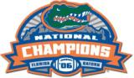
GATOR VIDEO presents :
Gator Domination

Hosted by BCS Championship MVP Chris Leak

The ultimate DVD for any sports fan.
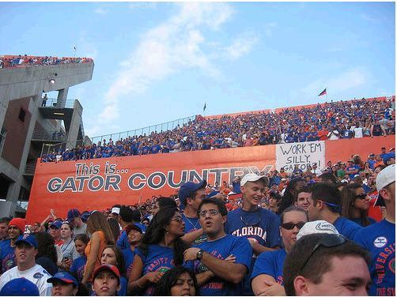
Celebrating the 10-year reunion of the 1st National Championship, Gator Domination looks into the dominating players, the crucial plays, and the excitement that surrounded the 2006 Championship game between the Florida Gators and the Ohio State Buckeyes.



Florida 41
Ohio 14
Go Gators!!

The winning quarterback relives the Gators stunning upset of #1 ranked Ohio State in the desert, with over 3 hours of actual game footage and interviews and so much more including:
- Interviews with Head Coach Urban Meyer
- Fan Interviews
- Trophy Ceremony
- Commentary from the Voice of the Gators, Mick Hubert. Oh, My!
- Albert, Alberta, Gator Cheerleaders, UF Marching Band and more!

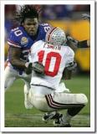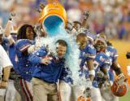
This keepsake DVD is a must for every true Gator fan.

