Date: 7/5/2007
Student: Chad J. Fralick
TA: Kevin Claycomb
Adam Barnett
Instructors: Dr. A. Antonio Arroyo
Dr. Eric M. Schwartz
Robot: WaterBot

University of Florida
Department of Electrical and Computer Engineering
EEL 5666
Intelligent Machines Design Laboratory

WaterBot
Project Report
(mid semester)

Table of Contents
Title Page 1
Table of Contents 2
Abstract 3
Executive Summary 3
Introduction 3
Integrated System 4
Mobil Platform 5
Actuation 6
Sensors 7
Behaviors 9
Experimental Layout and Results 9
Conclusion 9
Documentation 9
Appendices 9

Abstract
This report will cover the design, building, and testing of WaterBot. WaterBot will be an autonomous, household robot that will move around a room watering specific plants that have magnetic panels in front of them. WaterBot will avoid obstacles in the process of finding plants and it will return home once it is finished watering or if it runs out of water. It will follow a line to complete its task of watering.
Executive Summary
This section will include a one page description of the entire project and will be added in the final report.
Introduction
Plants are a pleasing addition to any house or patio. At the very least, they add color and interesting shapes to a bland room. Unfortunately, many plants die each year due to insufficient watering techniques. Many have seen the decay: brown, wilted leaves about to fall off their stalks. Owners either forget to take care of their precious possessions, or they just don’t know what to do with them.
Fortunately, mindless and forgetful owners will no longer be responsible for involuntary plant starvation. WaterBot, the plant-watering robot, will take over the task of adequately watering each plant at pre-determined intervals. WaterBot will find and water the plants that are scheduled for watering. It will navigate around common obstacles found at a normal home until it reaches a thirsty plant. Once confirming the plant is on the list of ‘to-be-watered plants’, the robot dispenses a certain amount of water into the plants pot. After watering one plant, it finds other thirsty plants, remembering which ones still need watering. After watering all the plants, the robot returns to its home base and waits until it is time to water plants again.
WaterBot will follow a predetermined path that will bring it in close proximity to plants. Using its magnetic sensor array, it will detect the nearby plant, line up with the plant, water it, and continue on to the next plant. A unique number will be assigned to each plant. This number will be represented with a panel of magnets. The magnets will assist the robot in lining up with the plant and confirming each plant’s identity. A small database in the robot’s memory will contain the schedule and identity of the pots to be watered and if practical, the approximate amount to water each pot.
A small, electrical water pump (windshield wiper fluid pump) will deliver water from the on-robot reservoir to the pot. A tube will direct the water from the pump to inside the pot. Once the robot exhausts its water supply, it will return to its home base and await refilling.
This report contains a detail description of all the parts of WaterBot. First, the Integrated System describes the overall system and the general theory of operation. Next, the physical subsystems are described in greater detail: Mobile Platform, Actuation and Sensors. Following that, WaterBot’s Behaviors are described followed by Experimental Layout and Results.
Integrated System
WaterBot’s Micro Controller is the Atmel ATmega 128 on a Maverick IIB board. All the electrical components of WaterBot will be connected to this board (see Figure 1).

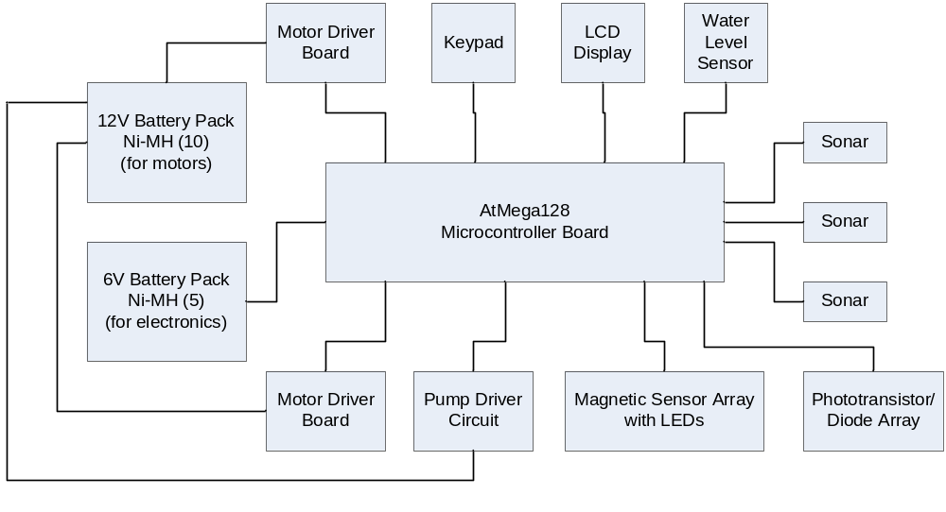
Figure 1 Electrical Components

The electrical components include:
- 1 AtMel Maverick 2B AtMega 128 Microcontroller board
- 2 battery packs (one for motors and one for electronics)
- 3 sonar modules (Devantech SRF05)
- 1 telephone keypad for input
- 1 LCD display
- 1 Water level switch
- 2 bump switches
- 4 phototransistor/diode pairs
- 3 motors with appropriate driver circuits
- 8 magnetic sensors
- Several LEDs

A concept schematic top and side view of WaterBot is shown in Figure 2. Instead of RFID, however, WaterBot will use its magnetic sensor array to find, line up with, and identify plants.
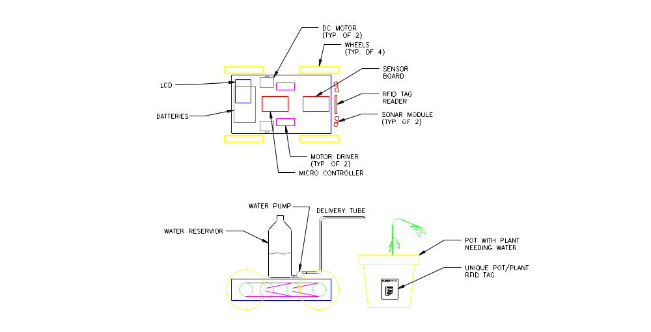
Figure 2 Concept schematic

Mobile Platform
WaterBot’s platform is a box slightly larger than a cereal box. All the sides of the box, except for the top have been cut from wood. It will house all the electronic components including the motors and batteries. The top of the box will be a clear pane of plexiglass. This will allow all the components inside to be seen from the outside while still being protected from water in the event of leaking or spilling. The top will be help approximately ¼” off the frame to allow for adequate ventilation.
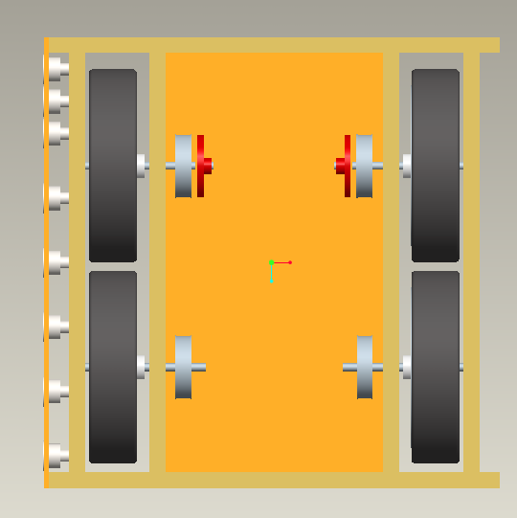
Figure 3 Top View Platform

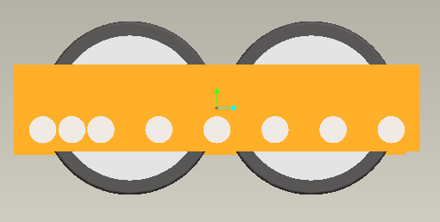
Figure 4 Side View Platform

The four, 6” diameter wheels of WaterBot will be attached on two opposite sides of the rectangular box. They are driven like tracks on a tank: the two wheels on each side are connected and spin at the same speed as each other. The water reservoir will be secured on top of the pane of plexiglass.

Actuation
Two DC motors will provide torque to the four, 6” inch diameter wheels. The motors are small DC motors that were included with the gearboxes ordered from Polulu. They will give the robot a top speed of about 6 inches per second.
The two wheels on each side of the robot will spin together; they will be mechanically connected. WaterBot will have three options for each side: both wheels spinning forward, both wheels stopped, or both wheels spinning in reverse. Turning WaterBot will require spinning the wheels on each side at different speeds or directions.
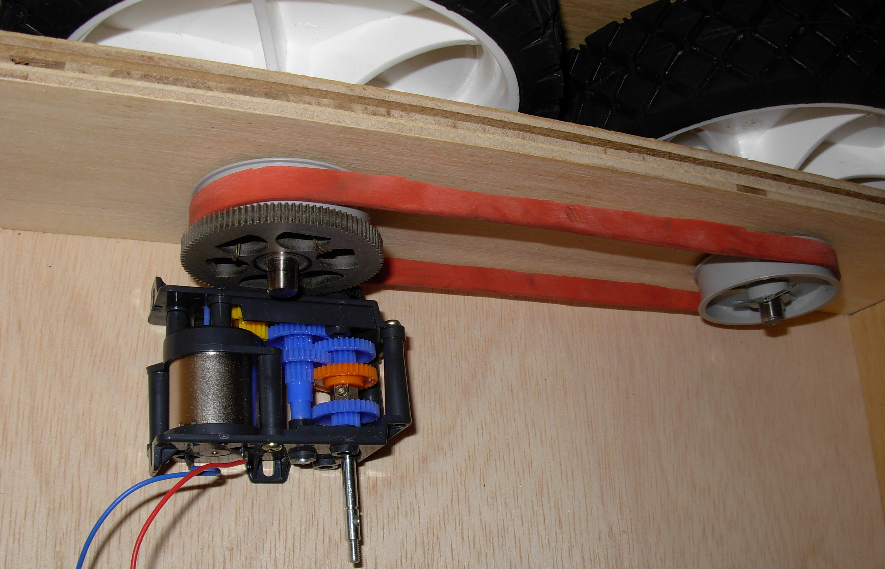
Figure 5 Gearbox, wheels, pulleys, and shafts

Sensors

Sonar
WaterBot has three sonar modules looking forward. They sense objects in the path of WaterBot and help him move around them. The sonar modules keep WaterBot from bumping into objects that are in front of him. Preliminary tests reveal the sonar’s linear characteristic when comparing the distance from the wall to the module (see Chart 1).
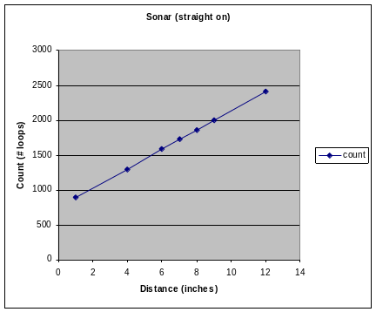
Graph 1 Sonar Loop Count vs. Distance
The test was conducted with a vertical board held at different distances away from the sensor. For this experiment, I placed the board directly in front of the sensor.
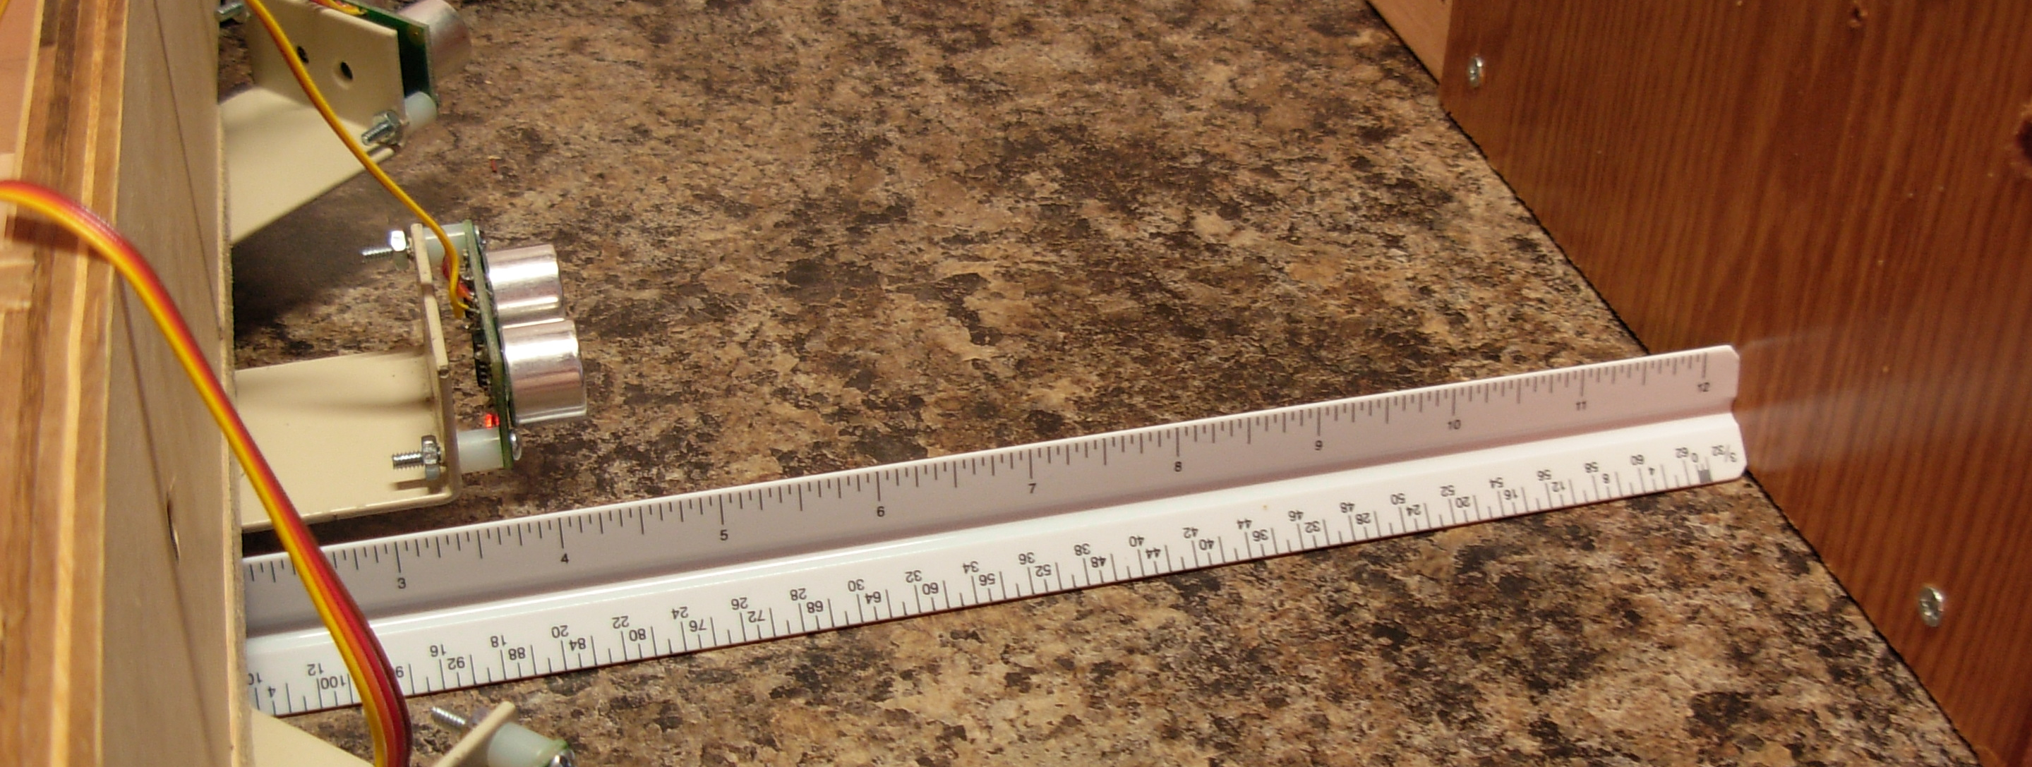
Figure 6 Sonar Test

Bump Sensors
WaterBot will have at least 2 bump sensors in the rear so it will know when it runs into something while going in reverse.

Magnetic Sensor Array
A magnetic sensor array located on WaterBot’s right side will be used to uniquely identify each plant and line up with it. The range for an actuator and a magnet is 1” along the axis of the sensor. It has a radius around the sensor of ½” where magnets will still be sensed. WaterBot, when passing close by a plant with a magnetic panel, will recognize and identify the pot after lining up with it and decide whether or not to water it.
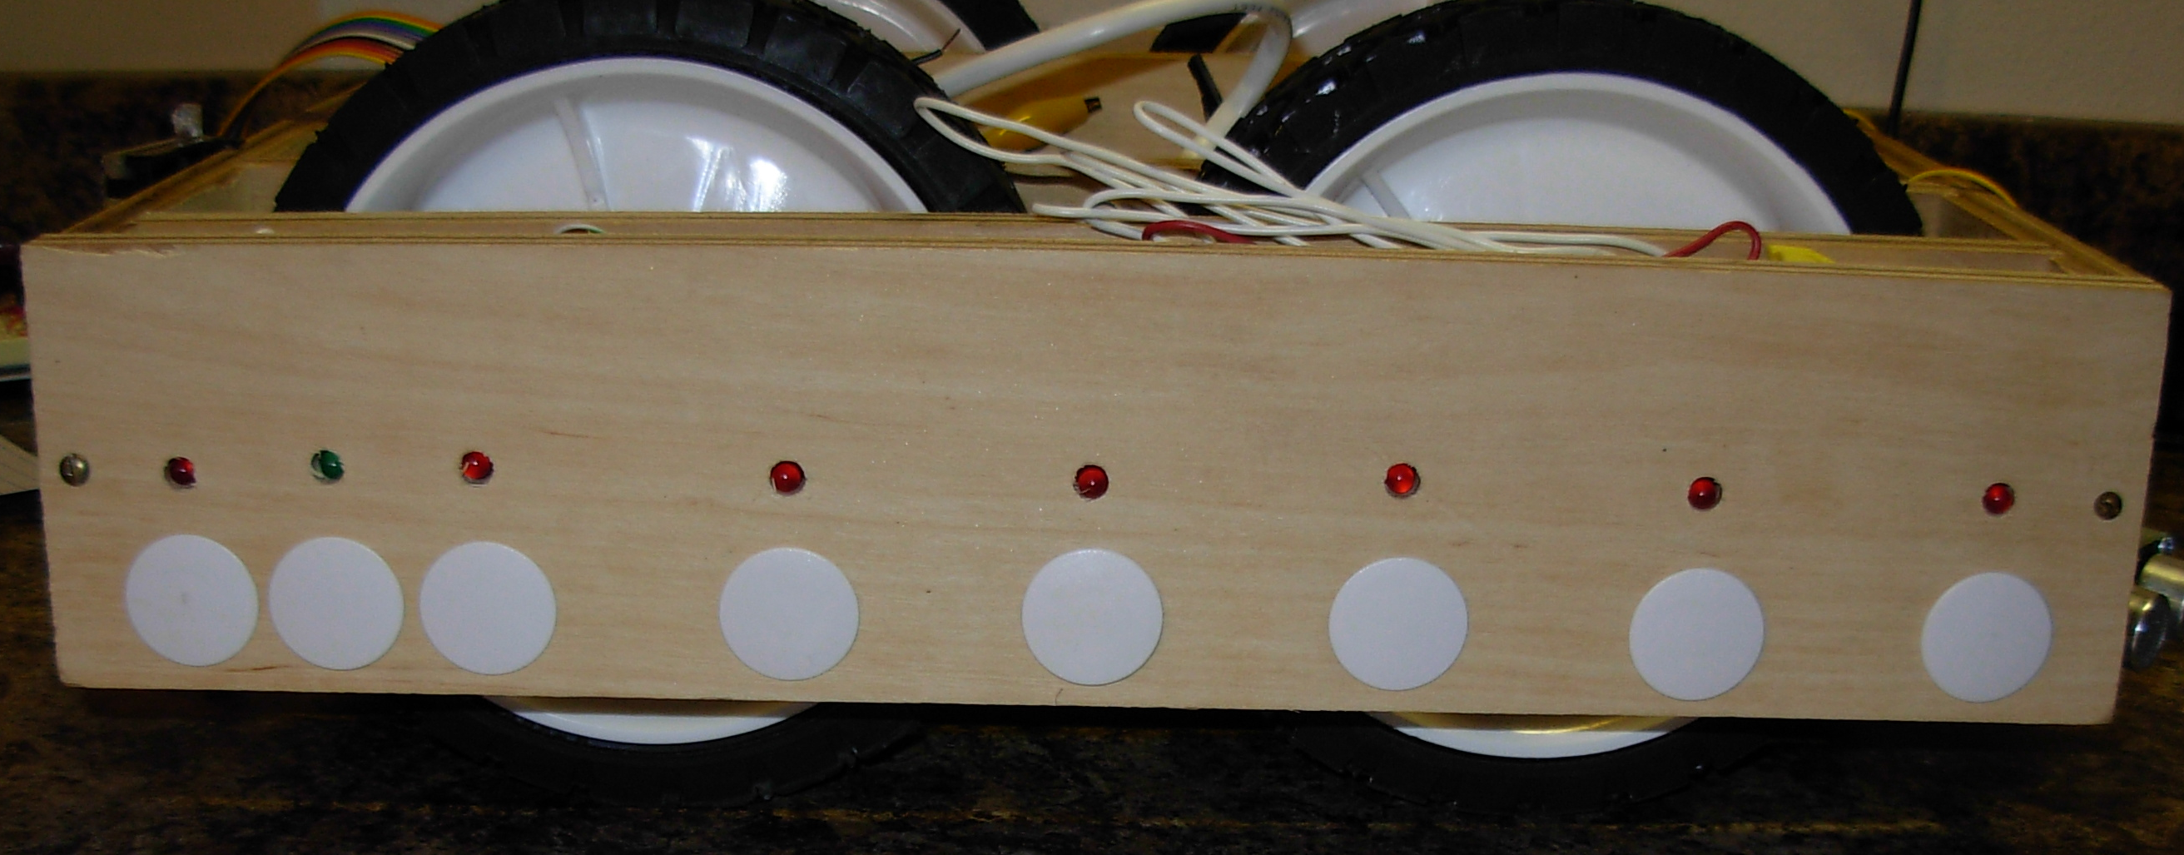
Figure 7 Magnetic Sensor Array with LEDs above sensors
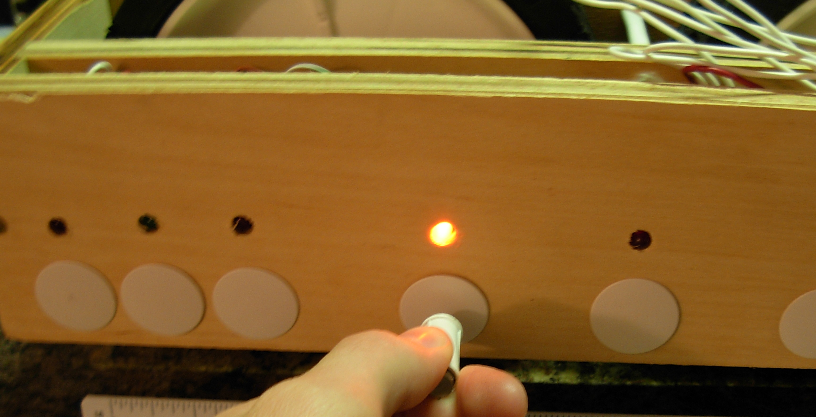
Figure 8 Magnetic sensor in use

Water Level Detector
A water level sensor is in the water container to alert WaterBot when it is almost empty. It includes a bobber, a string, and a micro-switch. The weight of the bobber engages the switch once the water drops too low.

Phototransistors/Diodes
Diodes and phototransistors are used to keep WaterBot following a line. 4 sensors are mounted on the bottom of WaterBot. They detect the presence of a dark line, which will be ¾” wide electrical tape for WaterBot.

Behaviors

Lining Up
WaterBot will have to line up with each plant to ensure that water will not be spilled on the floor. The magnetic sensor array will be used to accomplish this. One magnet, the first one, on each plant’s panel is used solely for alignment. WaterBot will sense the magnet on bit 0 of PORTE as it drives into position. It will sense the magnet as it goes from bit 0 all the way to bit 6. The three closely spaced sensors near the rear of WaterBot, bits 5-7 are solely used for aligning with each plant’s panel. The goal is to activate only bit 6 of the three bits. A magnet can activate two sensors at one time, so WaterBot must drive forward and reverse as needed to ensure that only the bit 6 sensor is engaged.

Experimental Layout and Results
I will expand this section as the semester progresses to completion.

Magnetic Sensor tests
The magnetic sensors were tested by hooking them in series with an LED circuit and moving a magnet around the sensor. Along the axis of the sensor, the contact engages when the magnet is 1” away from the sensor. Within this distance, the magnet can also be moved a maximum of ½” from the center axis of the sensor. This range is the fudge range associated with the sensor and is used to the advantage of the robot when lining up.

Sonar range tests
The sonar modules were attached to the robot and tested with a wall at varying distances in front of it. The results can be found in the Sonar section above.

Conclusion
I will complete this section at the end of the semester.
Documentation
I will expand this section as the semester progresses.
Appendices
I will expand this section as the semester progresses.

