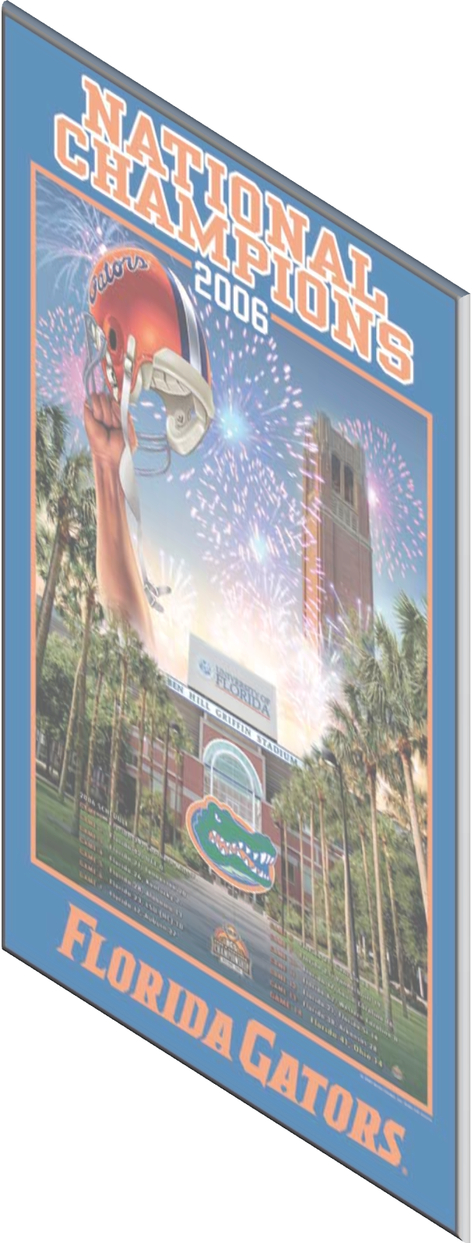
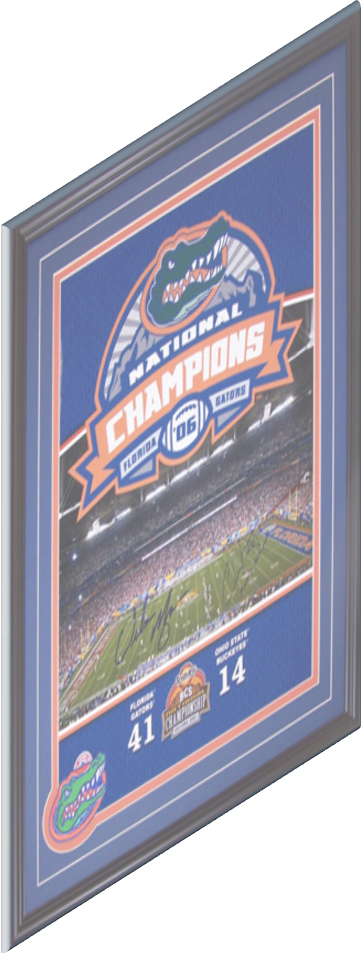
Get Your Fix of Gator
Football Flicks from 2006
Watch Jesse Palmer talk about the Gators’ National Championship team and view a walk down memory lane!

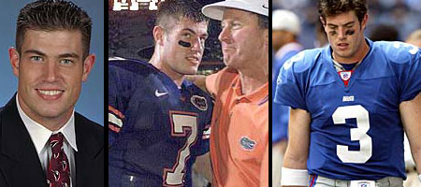

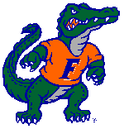
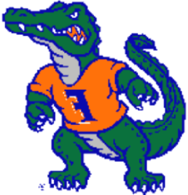
Available soon in DVD & Blu-ray formats at retailers everywhere!

