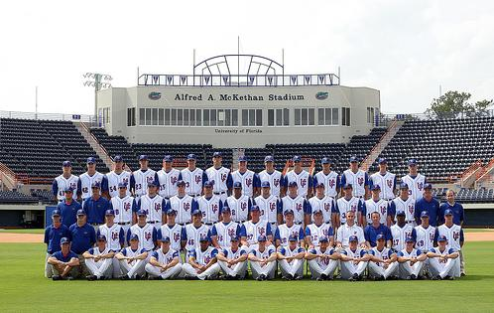
Featuring Gator Great:
Matt LaPorta


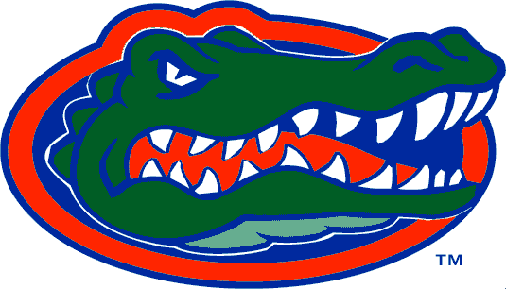

SEC Player of the Year and Division I home run leader (26)

- The Gators finished the season 48-23
- UF brought home its 10th SEC regular-season crown and 18th Eastern Division title.
- The Gators advanced to the NCAA College World Series for the first time since 1998.
- UF became the first SEC team to advance to the College World Series Championship final.
