Problem Statement

What cools down and warms up faster, soil or water?



Materials

Water

Soil

Heat Lamp

Refrigerator

2 cups

Thermometer

Conclusion
Soil warms up and cools down faster than water.

Application
In planning communities you could use bodies of water to regulate the temperature.

Results
The results are listed in the table below in degrees Fahrenheit.

Trial | Process | Starting | Ending
1 | Soil (Heat lamp) | 70 | 80
1 | Water (Heat lamp) | 70 | 76
1 | Soil (Refrigerator) | 75 | 60
1 | Water (Refrigerator) | 75 | 65
2 | Soil (Heat lamp) | 50 | 76
2 | Water (Heat lamp) | 50 | 67
2 | Soil (Freezer) | 60 | 35
2 | Water (Freezer) | 60 | 40

- Make the water and soil the same temperature.
- Put a thermometer in each cup.
- Put both cups under heat lamp.
- Wait for twenty minutes.
- Check temperature.
- Look at the difference between them.
- Record the data.
- Then even the temperature again.
- Put it in the refrigerator with the thermometer.
- Wait for twenty minutes.
- Check the temperature.
- Find the difference.
- Record data.

Procedures

Hypothesis
I think that water will cool down and warm up faster.

Bibliography
Broekel, R. Experiments With Water, Children’s Press, 1988, Chicago, pp. 31-32.



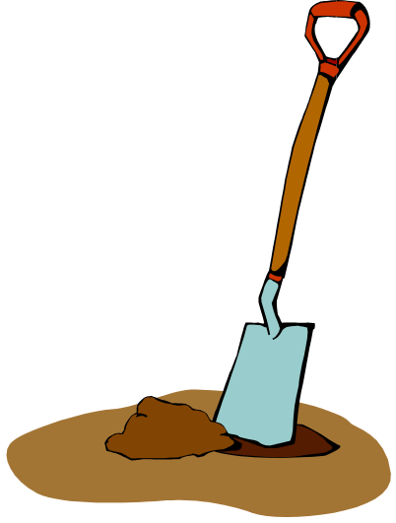

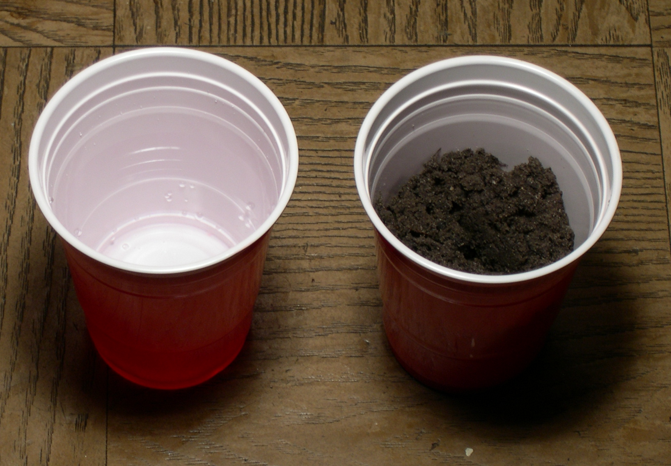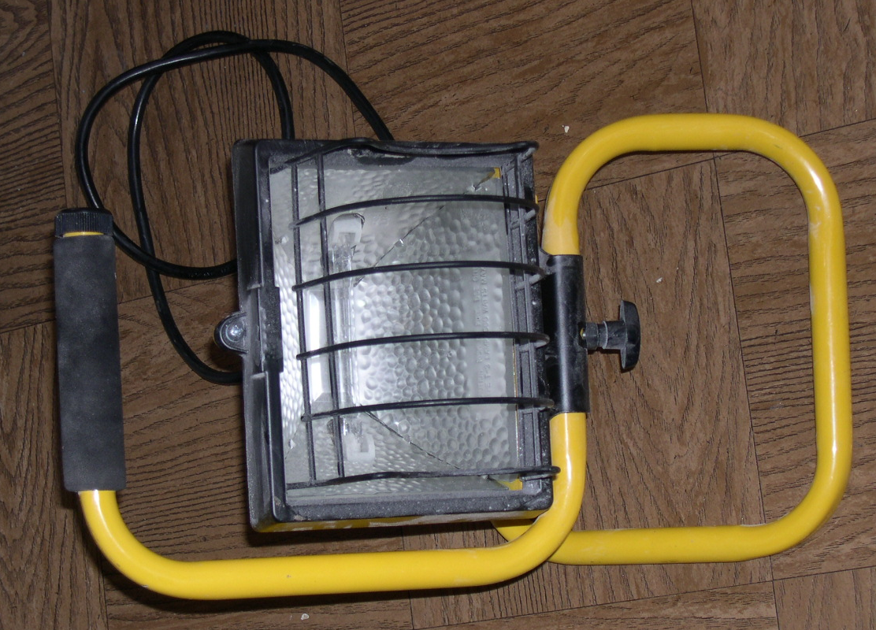

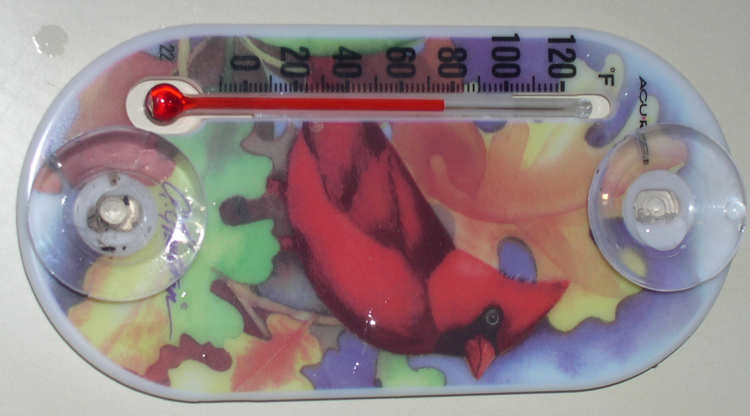

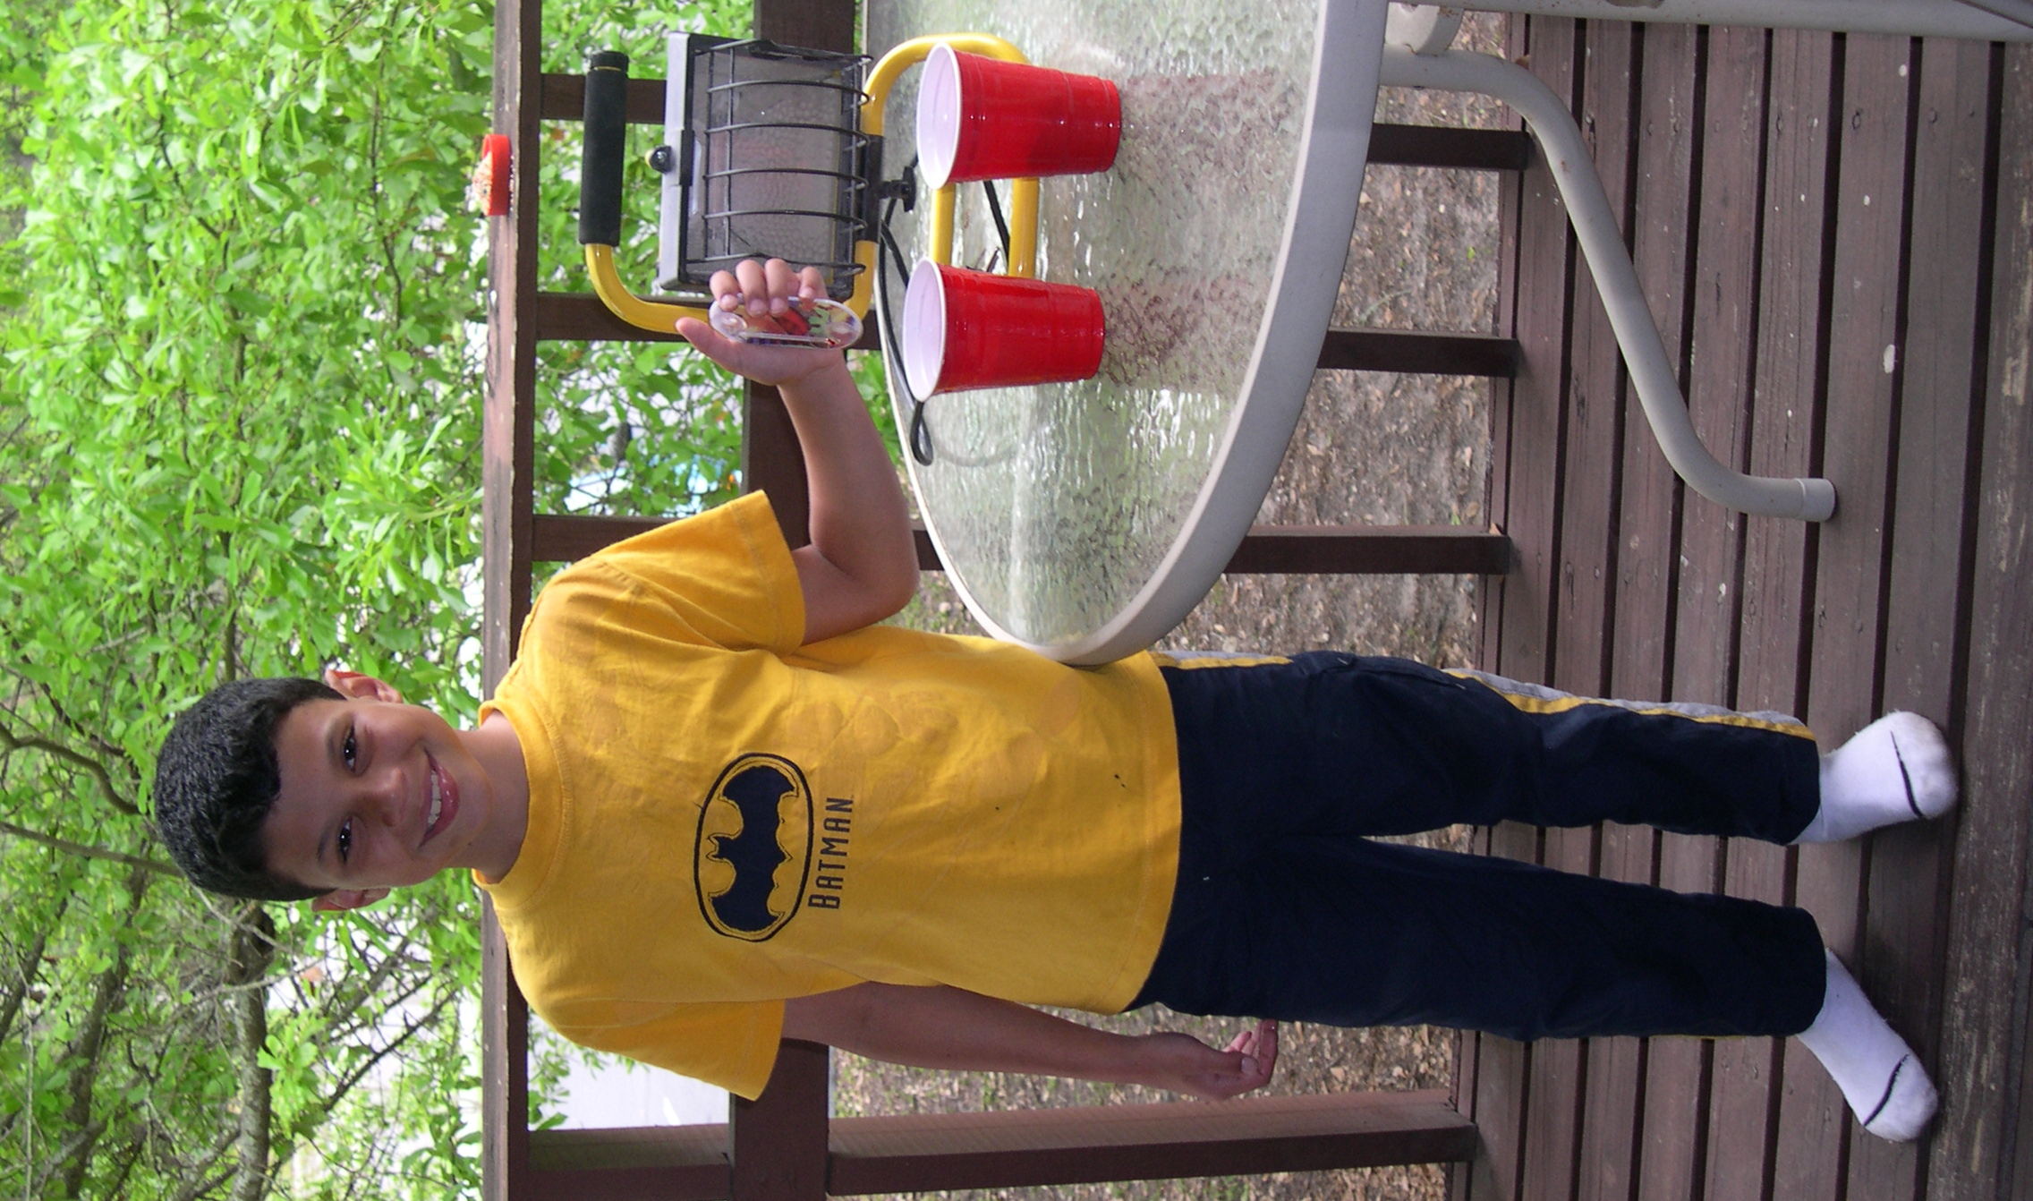

Conclusion
Soil warms up and cools down faster than water.

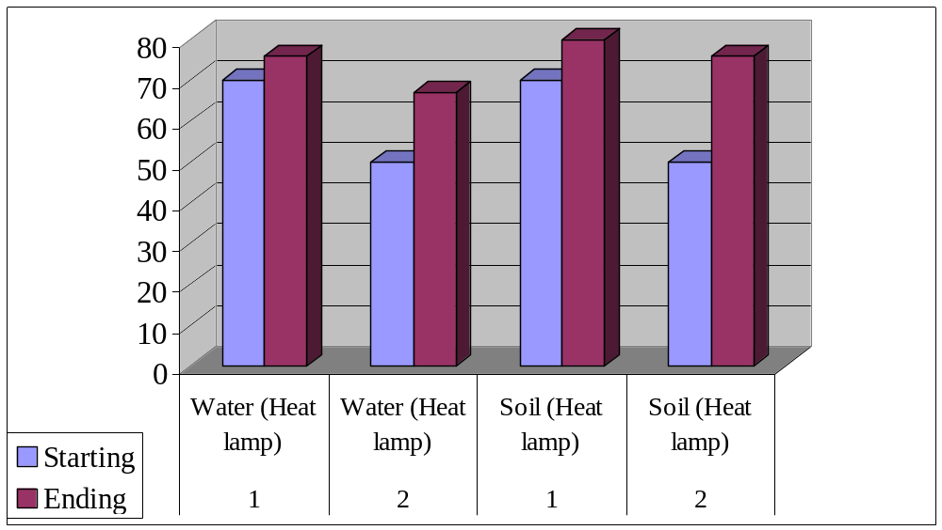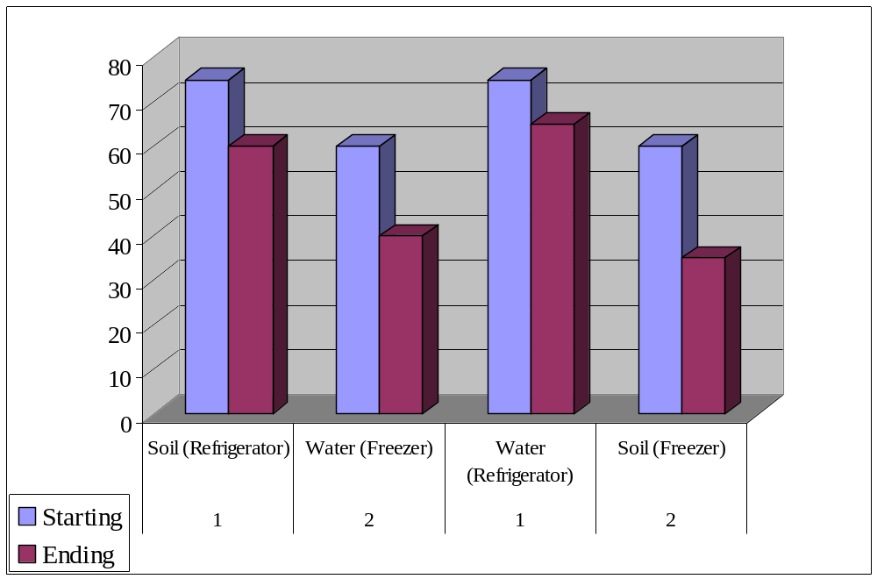Data

